Freedom of Information Response
Our reference: FOI 23-0619
Responded to: 28 March 2023
Your recent request for information is replicated below, together with our response.

1. 2023/24 IT Department Documents ;- these types of documents have detailed information on the department's future plans and strategies. These documents include:

ICT Strategy/Plan, ICT Department Plan, ICT Financial Plan
Please be advised that information regarding the Digital, Data and ICT (DDICT) Strategy is publicly available.
As such, in terms of Section 16 of the Freedom of Information (Scotland) Act 2002, I am refusing to provide you with the information sought. Section 16 requires Police Scotland when refusing to provide such information because it is exempt, to provide you with a notice which:
(a) states that it holds the information,
(b) states that it is claiming an exemption,
(c) specifies the exemption in question and
(d) states, if that would not be otherwise apparent, why the exemption applies.
I can confirm that Police Scotland holds the information that you have requested and the exemption that I consider to be applicable is set out at Section 25(1) of the Act - information otherwise accessible: “Information which the applicant can reasonably obtain other than by requesting it under Section 1(1) is exempt information” The Police Scotland DDICT Strategy is currently being reviewed and refreshed. No date has been set as yet for the refresh strategy to be published. The link below provides the current version from 2018:-
DDICT Strategy

2. ICT Org Chart ;- with names and job titles
In response to this question please see the table below. Please be advised that the Deputy Chief Officer is named Mr David Page.
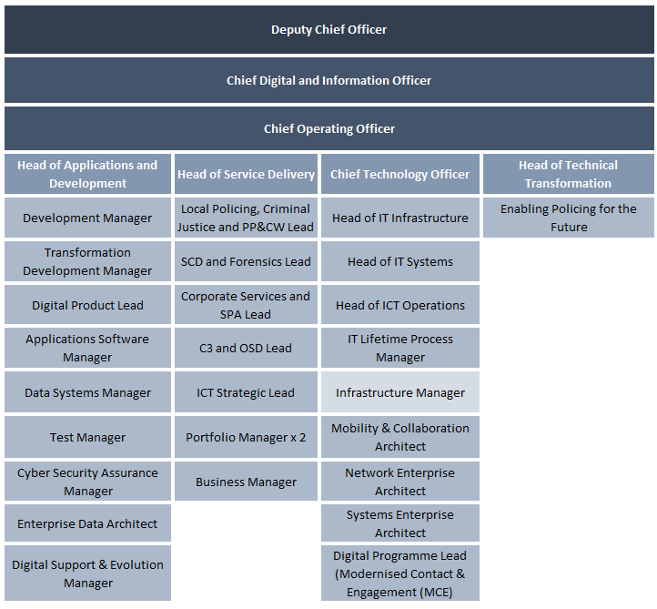

3. Corporate Procurement Strategy that covers 2023/24 and more.
In terms of Section 17 of the Act, I can confirm that the information you seek is not held by Police Scotland.
By way of explanation the current procurement strategy is dated from 2021/2023. To be of assistance, please see the link below.
Procurement - Police Scotland
If you require any further assistance please contact us quoting the reference above.
You can request a review of this response within the next 40 working days by email or by letter (Information Management - FOI, Police Scotland, Clyde Gateway, 2 French Street, Dalmarnock, G40 4EH). Requests must include the reason for your dissatisfaction.
If you remain dissatisfied following our review response, you can appeal to the Office of the Scottish Information Commissioner (OSIC) within 6 months - online, by email or by letter (OSIC, Kinburn Castle, Doubledykes Road, St Andrews, KY16 9DS).
Following an OSIC appeal, you can appeal to the Court of Session on a point of law only.
This response will be added to our Disclosure Log in seven days' time.
Every effort has been taken to ensure our response is as accessible as possible. If you require this response to be provided in an alternative format, please let us know.

