**30th June 2014 – 17,318**

**30th September 2014 – 17,267**

**31st December 2014 – 17,254**

**31st March 2015 – 17,295**

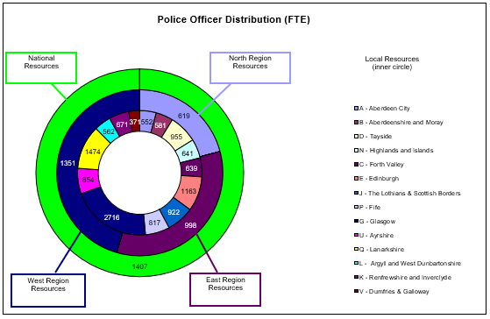

**30th June 2015 – 17,272**

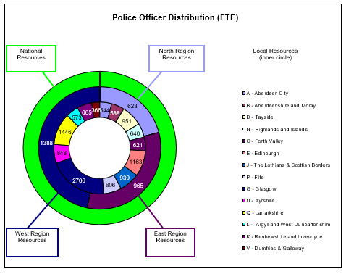

**30th September 2015 – 17,261**

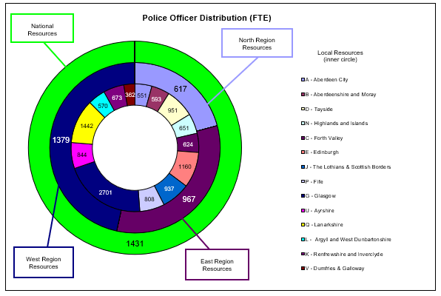

**31st December 2015 – 17,263**

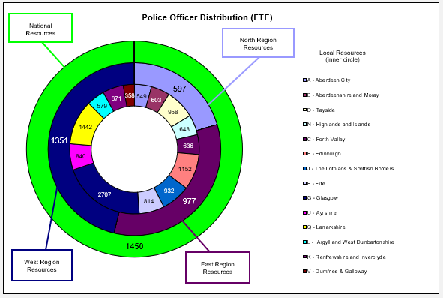

**31st March 2016 – 17,317**

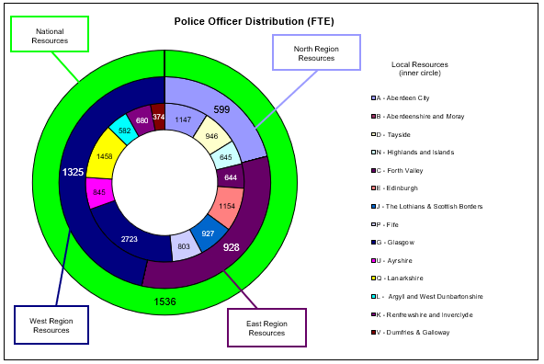

**30th June 2016 – 17,242**

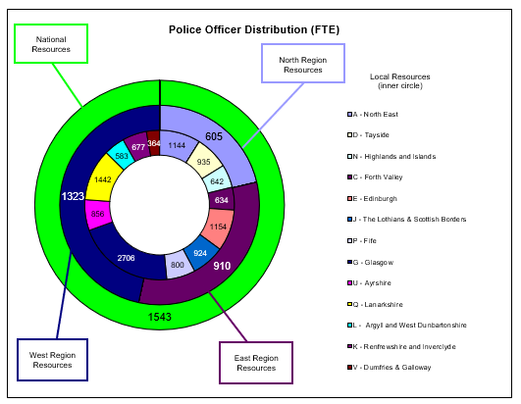

**30th September 2016 – 17,245**

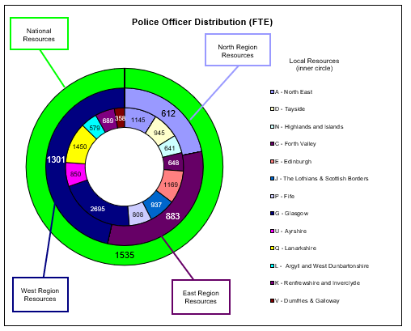

**31st December 2016 – 17,256**

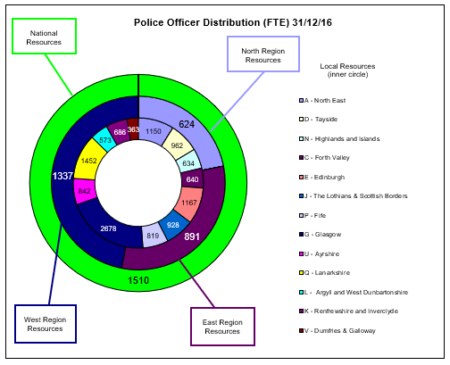

**31st March 2017 – 17,256**

