| Police Scotland logo | Freedom of Information Response Our reference: FOI 23-1625  Responded to: 13th September 2023 |
| --- | --- |

Your recent request for information is replicated below, together with our response.

**We are making a request under the above Act for information relating to Edinburgh Road, Glasgow at its junction with the B765 Springboig Road March 2022 to July 2022. An exact locus is enclosed herewith.**

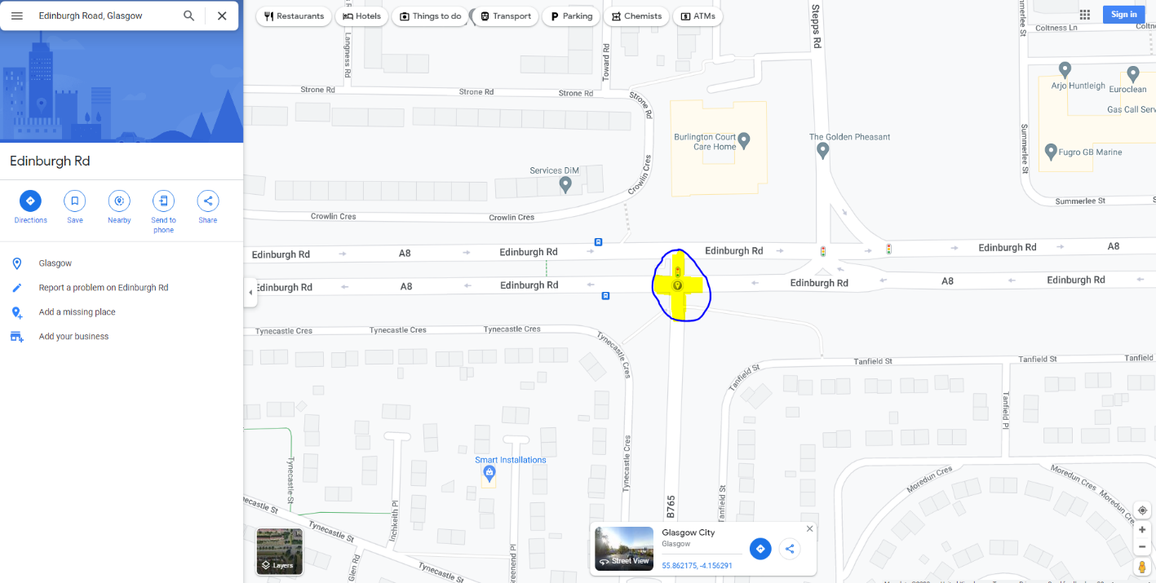

**We require the following information: -**

**Information including sight of any written or electronic communication detailing the installation, management and operation of the red light camera system at Edinburgh Road, Glasgow at its junction with the B765 Springboig Road March 2022 to July 2022**

Please find the requested information held attached.

I must advise that it has been necessary to withhold some of the information requested, therefore, in terms of Section 16 of the Freedom of Information (Scotland) Act 2002, I am refusing to provide you with the information sought.

Section 16 requires Police Scotland when refusing to provide such information because it is exempt, to provide you with a notice which:

(a) states that it holds the information,

(b) states that it is claiming an exemption,

(c) specifies the exemption in question and

(d) states, if that would not be otherwise apparent, why the exemption applies.

I can confirm that Police Scotland holds the information you have requested and the exemption that I consider to be applicable is set out at:

## Section 38(1)(b) – Personal Information

Any information that could lead to the identification of individuals has been redacted. This is in accordance with Section 38(1)(b) of the Freedom of Information (Scotland) Act 2002 –Personal Information.

In this case it relates to the name/signature of the person who signed the calibration certificate.

As such, the processing would be unfair and unlawful in respect of the individuals concerned and would therefore be in breach of the first principle of the Data Protection Act 2018. This is an absolute exemption, which does not require a public interest test to be conducted.

**Information including sight of any written or electronic communication detailing the sequencing of the red light camera system including details of the timings and variables at Edinburgh Road, Glasgow at its junction with the B765 Springboig Road March 2022 to July 2022**

Police Scotland do not hold the information requested. As such, in terms of Section 17 of the Freedom of Information (Scotland) Act 2002, this represents a notice that the information requested is not held by Police Scotland.

You may wish to consider contacting Traffic Scotland or the Local Authority.

**Information including sight of any written or electronic communication detailing all reports of faults to the red light camera system at Edinburgh Road, Glasgow at its junction with the B765 Springboig Road March 2022 to July 2022**

Police Scotland do not hold the information requested. As such, in terms of Section 17 of the Freedom of Information (Scotland) Act 2002, this represents a notice that the information requested is not held by Police Scotland.

**Information including sight of any written or electronic communication detailing which lanes of travel the red light camera system applied to at Edinburgh Road, Glasgow at its junction with the B765 Springboig Road March 2022 to July 2022**

Police Scotland do not hold the information requested. As such, in terms of Section 17 of the Freedom of Information (Scotland) Act 2002, this represents a notice that the information requested is not held by Police Scotland.

To be of some assistance however, this site currently enforces on our system as a dual carriageway enforcing westbound. We do not hold any correspondence detailing the lanes of travel for the time period requested.

If you require any further assistance please contact us quoting the reference above.

You can request a review of this response within the next 40 working days by [email](mailto:foi@scotland.police.uk) or by letter (Information Management - FOI, Police Scotland, Clyde Gateway, 2 French Street, Dalmarnock, G40 4EH). Requests must include the reason for your dissatisfaction.

If you remain dissatisfied following our review response, you can appeal to the Office of the Scottish Information Commissioner (OSIC) within 6 months - [online](http://www.itspublicknowledge.info/Appeal), by [email](mailto:enquiries@itspublicknowledge.info) or by letter (OSIC, Kinburn Castle, Doubledykes Road, St Andrews, KY16 9DS).

Following an OSIC appeal, you can appeal to the Court of Session on a point of law only.

This response will be added to our [Disclosure Log](http://www.scotland.police.uk/access-to-information/freedom-of-information/disclosure-log) in seven days' time.

Every effort has been taken to ensure our response is as accessible as possible. If you require this response to be provided in an alternative format, please let us know.