Freedom of Information Response
Our reference: FOI 23-2770
Responded to: 16th November 2023
Your recent request for information is replicated below, together with our response.
Can you therefore please provide me with any information you have regarding public safety issues, particularly on-street night-time crime statistics, along the stretch of Gogar Station Road outlined in red on the below map?
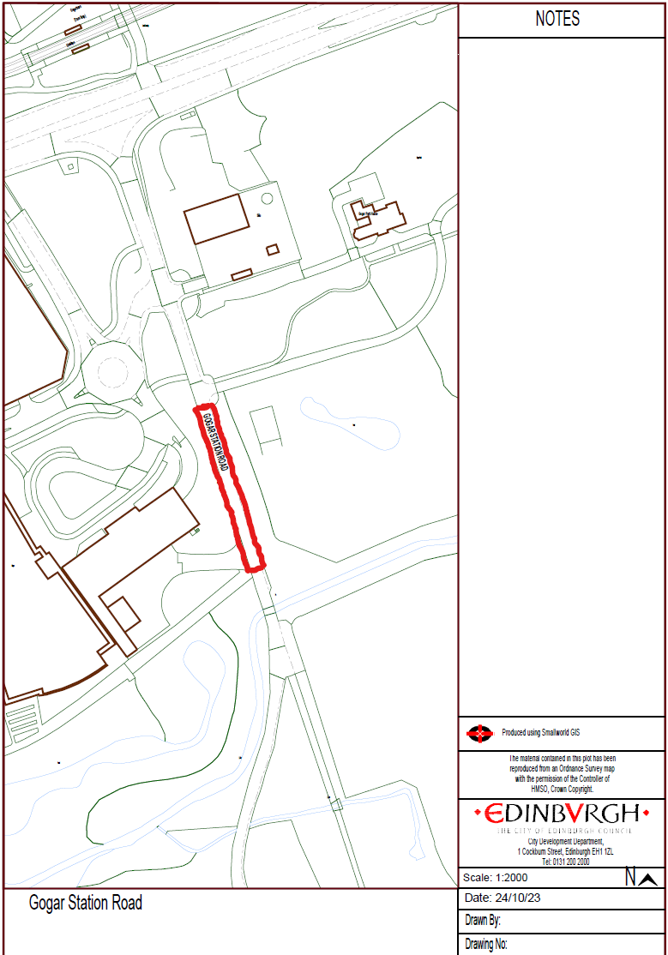
Following a clarification request you confirmed that a search for crimes recorded for a period of 5 years would be sufficient. You also confirmed that providing the time of each crime returned would be acceptable as Police Scotland do not have a marker for “night-time” crimes.
I can confirm that we have conducted a search for any crime reports recorded between 1st January 2018 and 31st October 2023 within the general area requested and following this the 39 results were manually reviewed.
None of the crimes recorded indicate they took place in the section highlighted on the map.
I would however advise that a number of road traffic offences recorded (7 in total) did not hold sufficient information to determine whether they occurred within the highlighted section or elsewhere on Gogar Station Road.
If you require any further assistance please contact us quoting the reference above.
You can request a review of this response within the next 40 working days by email or by letter (Information Management - FOI, Police Scotland, Clyde Gateway, 2 French Street, Dalmarnock, G40 4EH). Requests must include the reason for your dissatisfaction.
If you remain dissatisfied following our review response, you can appeal to the Office of the Scottish Information Commissioner (OSIC) within 6 months - online, by email or by letter (OSIC, Kinburn Castle, Doubledykes Road, St Andrews, KY16 9DS).
Following an OSIC appeal, you can appeal to the Court of Session on a point of law only.
This response will be added to our Disclosure Log in seven days' time.
Every effort has been taken to ensure our response is as accessible as possible. If you require this response to be provided in an alternative format, please let us know.

