Freedom of Information Response
Our reference: FOI 24-1342
Responded to: 19 June 2024
Your recent request for information is replicated below, together with our response.
How many road accidents has there been in Lochaber figures by year from 2019 to 2024.
How many of those were fatalities?
From those figures how many were on the A82.
[Lochaber clarified as the area highlighted below - map provided by applicant]
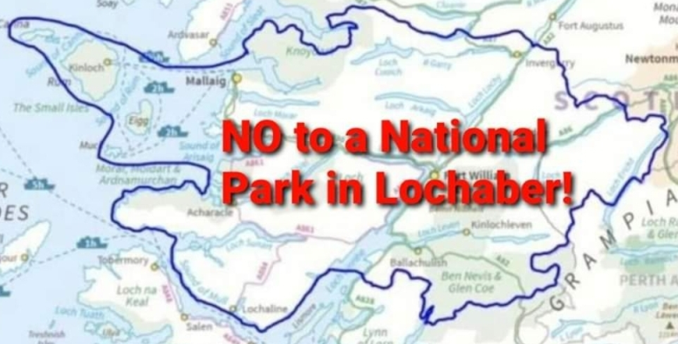
A breakdown of the 233 road traffic collisions (RTCs) within the area specified between 1 January 2019 and 31 May 2024 is provided in the tables below.
RTC Severity | 2019 | 2020 | 2021 | 2022 | 2023 | 2024 | Total
Fatal | 3 | 2 | 1 | 1 | 1 | 1 | 9
Serious | 16 | 19 | 20 | 20 | 25 | 1 | 101
Slight | 37 | 16 | 27 | 16 | 19 | 8 | 123
Total | 56 | 37 | 48 | 37 | 45 | 10 | 233

Road Name (where classified) | 2019 | 2020 | 2021 | 2022 | 2023 | 2024 | Total
A82 | 27 | 23 | 28 | 21 | 24 | 4 | 127
A86 | 4 |  | 3 | 2 | 5 | 2 | 16
A87 | 5 | 5 | 2 |  | 2 |  | 14
A828 | 3 |  | 2 |  |  |  | 5
A830 | 10 | 2 | 6 | 5 | 3 | 2 | 28
A861 | 1 | 1 | 1 | 3 | 1 | 1 | 8
A884 | 2 | 1 |  |  | 1 |  | 4
B863 | 1 |  |  | 1 | 2 |  | 4
B8004 |  |  |  | 1 | 1 |  | 2
B8005 |  | 1 |  |  |  |  | 1
B8006 |  |  | 1 |  |  |  | 1
B8007 |  | 1 | 1 |  |  |  | 2
Total | 53 | 34 | 44 | 33 | 39 | 9 | 212

Please note that 21 of the RTCs took place on an unclassified road and are not therefore represented in the table above. To be of assistance, I have provided the Eastings and Northings of those RTCs, which will allow you to plot them on a map should you wish.
Easting | Northing |  | Easting | Northing |  | Easting | Northing
215273 | 750025 |  | 198018 | 755726 |  | 213309 | 756553
181830 | 763901 |  | 218245 | 761788 |  | 164783 | 784983
198334 | 754255 |  | 208391 | 758413 |  | 214343 | 777205
208903 | 776871 |  | 209894 | 773183 |  | 212139 | 775192
209814 | 773318 |  | 212976 | 771285 |  | 216637 | 751036
210013 | 773743 |  | 215488 | 768421 |  | 212232 | 773021
209880 | 767733 |  | 230904 | 800826 |  | 209492 | 776891

All statistics are provisional and should be treated as management information.
All data have been extracted from Police Scotland internal systems and are correct as at 11/6/2024.
Data excludes non-injury collisions as per standard operating procedure.
On the 3rd July 2019, CRaSH was implemented across all Divisions within Police Scotland, replacing the existing procedures for recording Road Traffic Collisions.
Note - the data is subject to change and will be updated on the next extract of data from CRaSH on 3rd July 2024.
Specified areas have been selected using GIS Mapping.

Can you provide names?
How many were local to Fort William?
The information sought is held by Police Scotland, but I am refusing to provide it in terms of section 16(1) of the Act on the basis that the following exemptions apply:
Section 34(2)(b) - Investigation of death
Section 39(1) - Health and safety
The information requested is held for the purposes of an investigation and therefore attracts absolute exemption in terms of the Act subject to any public interest considerations. Furthermore, it is our assessment that disclosure would lead to unwarranted stress and upset to the bereaved family and friends of the deceased.
Whilst I accept that there is a public interest in better informing the public as to matters of concern in their local area, that is catered for, to a large extent, by the provision of data, as per our responses above.
Provision of detail beyond that is wholly unfair to the family and friends of the deceased who ought not to have to see their loved one’s details publicly disclosed beyond any initial press releases etc at the time of the RTC which would be done with their full co-operation and knowledge.

How many camper vans/ motor homes have been moved on from inappropriate parking areas or charged in lochaber from 2019 to 2024 and specifically what areas did the policing/ charges occur?
Unfortunately, I estimate that it would cost well in excess of the current FOI cost threshold of £600 to process your request. I am therefore refusing to provide the information sought in terms of section 12(1) of the Act - Excessive Cost of Compliance.
To explain, researching your request in terms of any informal police action would require us reaching out to every officer who had worked in and around the area over the period covered by your request in order that they check every police notebook entry for relevance.

How many charges have been done on inappropriate parking and what areas, please provide per year from 2019 to 2024.
I can confirm for your requested time period there has only been one parking charge in 2024 which was in Fort William.
There are five other parking offences recorded between 2019 and 2024 which would have been either a ticket or fixed penalty notice.
All statistics are provisional and should be treated as management information.
All data have been extracted from Police Scotland internal systems and are correct as at 11/6/2024.
The data was extracted using the crime's raised date and by using SGJD code 730800 - Parking Offences.
Please note, date was extracted for Police Beats 'NP039', 'NP250', 'NP037', 'NM029', 'NP036', 'NP035', 'NP038', 'NP041', 'NP043' and 'W74'

If you require any further assistance, please contact us quoting the reference above.
You can request a review of this response within the next 40 working days by email or by letter (Information Management - FOI, Police Scotland, Clyde Gateway, 2 French Street, Dalmarnock, G40 4EH). Requests must include the reason for your dissatisfaction.
If you remain dissatisfied following our review response, you can appeal to the Office of the Scottish Information Commissioner (OSIC) within 6 months - online, by email or by letter (OSIC, Kinburn Castle, Doubledykes Road, St Andrews, KY16 9DS).
Following an OSIC appeal, you can appeal to the Court of Session on a point of law only.
This response will be added to our Disclosure Log in seven days' time.
Every effort has been taken to ensure our response is as accessible as possible. If you require this response to be provided in an alternative format, please let us know.

