

# Gypsies/Travellers: Response to Unauthorised Encampments

National Guidance

## Notice:

This document has been made available through the Police Service of Scotland Freedom of Information Publication Scheme. It should not be utilised as guidance or instruction by any police officer or employee as it may have been redacted due to legal exemptions

Owning Department: Equality and Diversity, Policing Together.

Version Number: 1.00.

Date Published: 15/02/2022.

Contents

Gypsies/Travellers: Response to Unauthorised Encampments 1

Notice: 1

1. Purpose/Scope 3

2. Definitions 3

3. Human Rights/Equality Legislation 4

4. Local Authority and Landowner Responsibilities 4

5. Police Response 5

6. Prosecution 7

Fly-tipping 9

Scottish Environmental Protection Agency (SEPA) 10

Local Authority 10

Police Scotland 10

Public Order Legislation 10

7. Intelligence 11

8. Further Points to Consider 11

9. Key Contacts 11

Appendix A 12

Compliance record 13

Version control table 13

Feedback 14

## Purpose/Scope

This National Guidance provides advice to officers dealing with calls relating to unauthorised encampments. This supports the Police Service of Scotland (referred onwards as Police Scotland) in promoting equality and good race relations in carrying out its functions when dealing with Gypsies/Travellers, whilst ensuring that due regard is given to eliminating racial discrimination.

Police Scotland encourages a multi-agency approach when dealing with unauthorised encampments. There is a general presumption against prosecution of Gypsies / Travellers for setting up unauthorised encampments. Prosecution will only be considered in certain circumstances.

Police Scotland has a positive obligation to promote good relations between all communities and ethnic groups. When dealing with unauthorised encampments, we have a legal responsibility to work with Local Authorities and other partners to ensure Gypsies/Travellers do not suffer discrimination because of their way of life.

The role of Police Scotland is to deal effectively with any criminal matters arising, to ensure that public order and wider community safety issues are addressed and, at the same time, to work with Local Authorities and other partners to meet the needs of all communities.

## Definitions

An unauthorised encampment is one which is set up by any person without the permission of the land owner.

In 2004 the Scottish Government provided guidance recognising Gypsies/Travellers as a minority ethnic group with distinct characteristics, defined primarily by their ethnic origin, culture and/or nomadic lifestyle, and will be regarded as such for the purposes of this guidance. This applies to Romany Gypsies, Irish, English, Welsh and Scottish Travellers, but not to New Age Travellers or Show / Fairground or Circus people. This government guidance was most recently updated in 2017.

New Age Travellers are defined by the Equality and Human Rights Commission as 'People who comprise social groupings that advocate alternative lifestyles, frequently for political or issue-based reasons’. They are not, however, subject to the presumption against prosecution, as they are not Gypsies / Travellers.

For very large encampments of New Age Travellers, Section 14 of the Public Order Act 1986 may be considered, primarily if the encampment is causing serious disruption to the life of the community.

## Human Rights/Equality Legislation

When engaging with unauthorised encampments of Gypsies/Travellers, officers are reminded that any action taken must be proportionate, legal and necessary, in compliance with the European Convention on Human Rights (ECHR) and the Equality Act 2010.

The Equality Act 2010 places a duty on Police Scotland to eliminate unlawful discrimination, promote equality of opportunity and to promote good relations between persons of different racial groups. This also applies to all Local Authorities or those carrying out 'public functions', such as an Elected Member or Community Council established under Section 51 of the Local Government (Scotland) Act 1973.

It is imperative that Police Scotland can justify any actions it takes in terms of legality, necessity and proportionality. To achieve this a balanced view must be taken which respects the rights of both the Gypsies / Travellers and the 'settled' communities.

Nothing in the foregoing should prevent officers executing their duty concerning the investigation, detection and reporting of offenders for any criminal behaviour that may be occasioned during the period of the unauthorised encampment.

## Local Authority and Landowner Responsibilities

It is the responsibility of the landowner to take steps to secure, protect and reclaim their own property, be that public or private land.

The management of unauthorised Gypsies/Travellers encampments on public land is a matter for the Local Authority in whose area the encampment is established. This includes any consideration of civil eviction if the unauthorised encampment is situated on public land. In doing so, they are obliged to consider the welfare needs of residents of the unauthorised encampment. The relevant Local Authority Liaison Officer should also regularly visit the unauthorised encampment and identify any issues that may require early intervention.

If the unauthorised encampment is on private land, the Local Authority retains responsibility for monitoring it and liaising with the landowner. The landowner should be encouraged to make contact with the Local Authority to discuss the matter and explore any assistance that may be available to them.

Enquiries regarding non-criminal matters should generally be referred to the relevant Local Authority.

A Letter Template has been prepared to assist in explaining the Police position to private landowners.

This is designed to provide relevant information and to minimise the scope for misunderstanding between the Police and the landowner. Local officers should also liaise with the landowner to offer appropriate assistance and support where applicable.

## Police Response

When an unauthorised encampment is reported to or discovered by Police, officers will visit the site to engage with the Gypsies/Travellers in an effort to clarify their intentions. Where possible, this visit should occur on the first day of the encampment. The local Area Control Room (ACR) should be updated with the following information:

* The location of the unauthorised encampment;
* The number of living units making up the unauthorised encampment;
* The number and types of vehicles at the unauthorised encampment (see section 7: ‘Intelligence’ regarding proportionality in noting names and vehicle registration marks);
* An overview of the immediate effect the unauthorised encampment may have on the immediate area e.g. health and safety issues, road traffic regulation and environmental issues;
* If they intend moving to an Authorised Site in order that the Local Authority may make the appropriate arrangements;
* If they intend to move to another Local Authority area.

The process chart shown on Page 9 (Appendix A) provides a quick view of the Police response.

If informed of an unauthorised Gypsies/Travellers encampment by a landowner they should be advised that it is their responsibility to notify the Gypsies/Travellers that their presence on the land is illegal. The decision to evict will lie with the landowner, not the Local Authority. If this has been done and the Gypsies/Travellers have refused to move on, the landowner should be given details of the Local Authority Gypsies / Travellers Liaison Officer and advised to contact that person. The landowner should be further advised to report any criminal behaviour, and of the potential for recourse to civil action to seek eviction unless there are overriding public safety issues for the Police to consider.

Officers will give periodic attention to the unauthorised encampment to ensure any changes in the circumstances are notified to the Local Authority and to determine whether further Police action may be necessary. These visits must be recorded on the relevant incident log and any significant changes advised as above.

The notified point of contact within the Local Command Area is encouraged to communicate regularly with the relevant Local Authority Officer in relation to the unauthorised encampment, to identify any emerging issues at any early stage.

This will allow for appropriate intervention or preventative measures to be considered, including participation in case conferences regarding problematic unauthorised encampments. Where possible, contact relating to decisions made should be confirmed by email to provide an audit trail.

Local officers are encouraged to maintain contact with members of the settled community and businesses in their area. This will ensure they are aware of any concerns or tensions which may arise as a result of the presence of an unauthorised encampment and, where applicable, take appropriate steps to mitigate these, bringing to the attention of Local Commanders, as appropriate.

Further incident logs should be created to record individual incidents or criminal complaints relating to the unauthorised encampment. Any allegation of criminal activity will be dealt with and investigated as normal and the complainer / victim will be informed of the resultant Police action.

Where appropriate, Police officers will support Local Authority colleagues, landowners or their representatives by visiting unauthorised encampments with them whilst they serve eviction notices, or similar. The role of the police is to maintain public order. Police Officers will not play any active part in the service of any papers or the eviction process itself, unless instructed by the Court or a crime is being committed.

Policing teams are encouraged to communicate with each other and with relevant Local Authority partners (bearing in mind the constraints placed on disclosure of information by the Data Protection Act 2018) with regard to the movement of unauthorised encampments.

This is particularly important where an unauthorised encampment has created difficulties at a previous location and knowledge of the previous circumstances may assist in informing decisions.

A flowchart of the basic Police procedure for managing an unauthorised encampment is provided at Appendix ‘A’.

## Prosecution

There is no specific legislation currently in place with regard to the management of unauthorised encampments established by Gypsies/Travellers, albeit various other pieces of legislation can be relevant.

Two possible considerations are the Trespass (Scotland) Act 1865 and the Roads (Scotland) Act 1984. In exceptional cases, Sections 61 and 62 of the Criminal Justice and Public Order Act 1994 may apply.

Other than in certain specific circumstances, the Police have no authority to clear sites or to direct Gypsies/Travellers on to any land, even where prosecution may be deemed appropriate in respect of an unauthorised encampment offence.

Although unauthorised encampment is a criminal offence, in accordance with the Scottish Government Guidelines for Managing Unauthorised Camping by Gypsies/Travellers in Scotland, there is a general presumption against prosecution of Gypsies/Travellers for setting up unauthorised encampments. Prosecution will only be considered when:

(a) A suitable alternative stopping place has been identified and the Gypsies/Travellers have refused to re-locate within a reasonable time. (It is the responsibility of the Local Authority to identify the stopping place. The Police have no power to do this.); or

(b) Where the use of a particular site by Gypsies/Travellers, or the excessive size of the encampment causes a severe road safety or public health hazard; or

(c) Where the same Gypsies/Travellers have been repeatedly evicted from a site by the Local Authority and return after a short time.

Failure by a Local Authority to assess or make provision for the needs of Gypsies/Travellers will serve to reinforce the presumption against prosecution. However, the presumption may be overridden by other public interest considerations arguing in favour of prosecution. This may include serious disruption to businesses and / or members of the public as a result of offensive or criminal behaviour by Gypsies/Travellers.

In practice, this means that the Police will only apply legislation to move unauthorised Gypsies/Travellers encampments in very specific circumstances, namely where Sections 61 and 62 of the Criminal Justice and Public Order Act 1994 apply.

These restrictions on Police action only apply to the establishment of the unauthorised encampment. Officers will respond to and investigate other reported crimes or offences in the normal way, regardless of who is alleged to be responsible.

The Procurator Fiscal (PF) may also advise on the course of action to be taken, dependent on the particular circumstances in each case, but the decision would generally be an operational matter for the Police, having regard to the general presumption against prosecution and the Lord Advocates Guidelines relating to liberation.

Time limits for prosecution under the Trespass Act are usually short and the purpose of the prosecution would be to deal with one of the three sets of circumstances outlined above.

A degree of urgency may therefore be required and the use of an undertaking (if considered appropriate under the circumstances), rather than custody, is likely to be the best option.

PFs are in possession of Crown Office guidance on this subject that directs them in relation to the presumption against prosecution, but still allows them discretion where the public interest serves to override the presumption.

### Fly-tipping

Fly-tipping is a criminal offence and one of the key grievances raised by some members of the settled community in respect of Gypsies/Travellers unauthorised encampments.

Fly-tipping should not be regarded as a normal feature of an unauthorised encampment, nor should it be subject to the presumption of non-prosecution. This matter can be dealt with either individually or jointly by the Police and the Local Authority.

There are three agencies who deal with Fly-Tipping. If there is evidence of anyone dumping rubbish illegally, the public are encouraged to report to the Dumb Dumpers Stop Line online report: www.zerowastescotland.org.uk/DumbDumpers

### Scottish Environmental Protection Agency (SEPA)

If the incident is ongoing and it is believed to be a hazardous nature or is near a watercourse, the information would be passed to SEPA or Police Scotland as appropriate.

### Local Authority

If the incident is not urgent or the waste concerned is non-hazardous, the information should be passed to the local authority for investigation.

### Police Scotland

If the incident is on-going then the Police still have a duty to investigate.

In most circumstances the Environmental Protection Act 1990 will be the appropriate legislation to use, with particular references to Sections 33, 87, 88 and 92.

### Public Order Legislation

In some circumstances, Sections 61 and 62 of the Criminal Justice and Public Order Act 1994 can be used to remove unauthorised encampments and take possession of vehicles. Use of these powers should only be considered in exceptional circumstances, not routinely, and only when negotiation and civil means pursued by the Local Authority or land owner have been exhausted or the particular encampment requires immediate removal on undue public nuisance or public safety grounds.

These powers would only be considered where the unauthorised encampment was causing severe road safety concerns, a public health hazard or significant disruption. The PF will normally be consulted before this legislation is used and it should be regarded as a last resort.

Even in these exceptional circumstances, consideration would have to be given by the Local Authority as to where the unauthorised encampment would be moved to.

## Intelligence

Where the information gathered/received relates to intelligence about crime, this should be captured on the Scottish Intelligence Database (SID).

## Further Points to Consider

When considering reporting Gypsies/Travellers for any offences relating to an unauthorised encampment, advice should normally be sought from the relevant PF.

Depending on the nature of the unauthorised encampment, it may be appropriate to consider a Community Impact Assessment. Implementing such a tool should ensure that community tensions are monitored and that the rationale for justifiable action is properly recorded and fully auditable. Further guidance can be found in the Community Impact Assessment Divisional Guidance.

These guidelines are designed to complement policy and guidance produced by each Local Authority in Scotland. Whilst Local Authorities will take a lead role in the management and service response to unauthorised encampments, the role of the Police will remain balanced and consistent with the overriding principle of support for the Local Authority, to ensure that the peace is maintained.

Sheriff Officers – If in attendance at an encampment where Sheriff Officers are to execute a civil warrant (eviction), the Police role will solely be to ensure that the peace is kept, and not to become involved in the eviction.

## Key Contacts

For further advice and assistance, please email

Information has been removed due to its content being exempt in terms of the Freedom of Information (Scotland) Act 2002, Section 30 Prejudice to effective conduct of public affairs.

## Appendix A

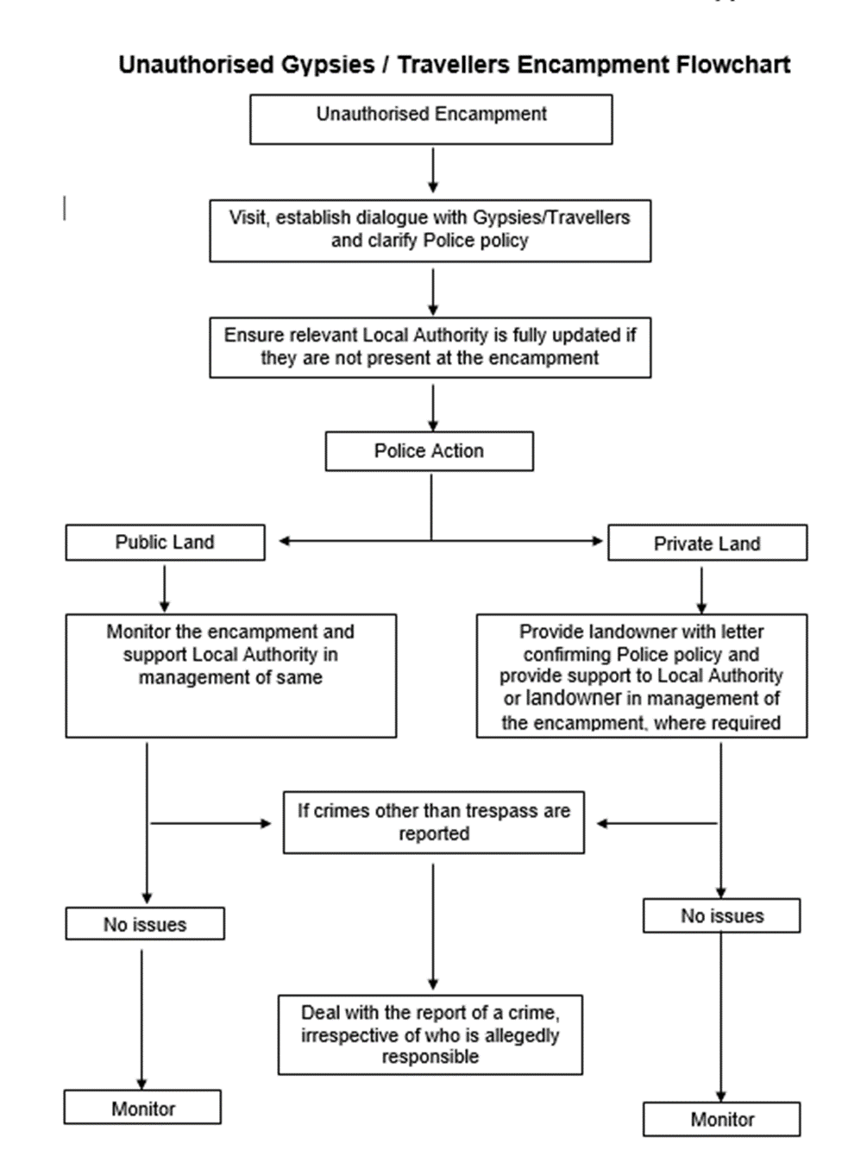

1. Unauthorised encampment present. Progress to next step.
2. Visit, establish dialogue with Gypsies/Travellers and Clarify Police policy. Progress to next step.
3. Ensure relevant Local Authority is fully updated if they are not present at the encampment. Progress to next step
4. Police Action for Public land go to step 5. Police Action for Private Land go to step 7.
5. Police Action for public land: Monitor the encampment and support Local Authority in management of same. Go to step 7.
6. Police Action for Private Land: Provide landowner with letter confirming Police policy and provide support to Local Authority or landowner in management of the encampment, where required. Go to step 7.
7. If no issues monitor. If crimes other than trespass are reported go to step 8.
8. Deal with the report of a crime irrespective of who is allegedly responsible.

## Compliance record

EqHIRA completion/review date: 16/11/2021

Information Management Compliant: Yes

Health and Safety Compliant: Yes

## Version control table

| Version | History of amendments | Approval date |
| --- | --- | --- |
| 1.00 | Initial Approved Version | 15/02/2022 |

## Feedback

All Police Scotland service delivery Policies, Standard Operating Procedures (SOPs) and National Guidance are subject to regular reviews. It is important that user feedback is considered when documents are reviewed.

If any officer / staff member wishes to provide comment, or make suggestions for improvements to this or any associated document, a Service Delivery Policy and Procedure Feedback Form (Form 066-014) should be used.