Police Scotland

Chief Constable’s Assessment of Policing Performance

2023/24

Contents
Chief Constable’s Foreword 3
Joint Strategy for Policing 7
Key Insights 9
Progress towards Strategic Outcomes 14
Overall Activities Progress 14
Strategic Outcome 1: Threats to public safety and wellbeing are resolved by a proactive and responsive police service 15
Strategic Outcome 2: The needs of local communities are addressed through effective service delivery 21
Strategic Outcome 3: The public, communities and partners are engaged, involved and have confidence in policing 25
Strategic Outcome 4: Our people are supported through a positive working environment, enabling them to serve the public 29
Strategic Outcome 5: Police Scotland is sustainable, adaptable and prepared for future challenges 33
Appendix I – Activity Status Updates 36

Chief Constable’s Foreword
This is my first end of year assessment of policing in Scotland, having taken command of Police Scotland in October 2023.
I knew Police Scotland was a highly credible public sector organisation, known for its compassion and operational competence and that it attracts strong public support.
Since appointment, I have been consistently impressed by the professionalism and commitment of our officers and staff as I’ve met teams across the country.
Police Scotland is a national asset for Scotland, delivering effective policing for our communities at a much reduced cost to the public purse compared to legacy arrangements.
A changing, ageing population; a cost-of-living crisis driving vulnerability and pressure on other services; civil unrest; new laws and increasingly complex investigations all contribute to growing community need and increasing contacts to policing from the public, with almost 2.2m 999 and 101 calls and over 190,000 emails through contact us during 2023-24.
At the same time, the acute pressure on public finances will continue and the Scottish Police Authority has been clear delivering balanced budgets for policing is a priority. I share that commitment to financial discipline and the interim financial position shows that a balanced budget was delivered in 2023-24.
This was achieved by significant focus right across the Service, driven by the Force Executive, to reduce a forecast pressure of around £19m through action including a pause on staff recruitment; a delay in officer recruitment; and by having a very tight grip on overtime spend. This has been extremely challenging and has had operational implications.
Our Quarterly Performance reports illustrate how policing delivered on our strategic outcomes, highlighting key challenges, successes and impact during 2023-24.
I’ve been clear that my operational focus is in three areas - first, addressing threat, harm, and risk; second, prevention, problem solving and proactivity; and third, looking after the wellbeing of officers and staff so they can deliver for the public.
During 2023-24, increases in violent crime have been driven by common assaults as well as threats and extortions, such as sextortion. The number of serious assaults and attempted murders recorded were at their lowest number in recent years while homicides continue to be at a historically low level and Police Scotland’s detection rate for homicides remains very strong.
Threat, harm and risk in the digital world continues to grow, including online child sexual abuse, exploitation and fraud, most of which has a cyber element. This underlines our need to ensure policing has the capability and capacity to keep people safe in the public, private and virtual spheres.
One example of where technology can help policing keep people safe more effectively is the introduction of facial matching for the Child Abuse Image Database, meaning cases which would typically take days to review can be reviewed in an hour, helping to identify victims and safeguard children.
We will use new methods in an ethical way in line with our values but I am clear on our positive duty to the public and victims of crime to use new technologies to enhance our investigative opportunities and to keep people safe in the digital world.
More broadly, our Policing in a Digital World Programme is driving transformation in how we respond to the evolving threat of cybercrime, through investment in our officers and staff, new capabilities and partnership working.
During 2023-24, there was a welcome reduction in the number of people killed on our roads compared to the year before, however road collisions continue to result in loss and tragedy for too many individuals and families.
As part of a crucial partnership approach, officers are out every day educating road users and carrying out enforcement. We will continue to do all we can to improve road safety in support of the Scottish Government’s Road Safety Framework.
Our performance reporting strengthens my passionate belief in the value that policing brings to our communities: keeping people safe from harm, protecting the vulnerable, bringing criminals to justice, solving problems and reducing offending. We stand up for, and with, our communities, which strengthens them, improves their wellbeing and allows them to prosper. That value must be for all our communities.
People from all communities must know that when we talk about keeping people safe, we mean them. All communities must feel able to speak to the police, to report a crime or to share information. I want people from all communities to see policing as a potential career.
To that end, our Policing Together programme drives action for meaningful change across four strategic pillars - leadership; training; professionalism and prevention; and communications. We’re empowering leaders to build inclusive teams; improving education around equality laws; focusing on our values and standards and delivering a clear and consistent message that there’s no place in Police Scotland for those who reject our values. Our success will be measured by improved experiences of our officers and staff and the public we serve.
During 2023-24 we’ve continued a focus on the safety and wellbeing of officers and staff, who are the key to the success of policing and, at times, put themselves in harm’s way to keep others safe. Assaults on officers have increased slightly year on year but remain below the five-year average, while the proportion of assaults resulting in injuries has shown a decline.
This illustrates the value of our Service-wide focus through Your Safety Matters to encourage a culture where officers and staff report assaults so they get the support they need and deserve and that we continue to send a clear message that being assaulted is not part of the job.
We also introduced two new services; a new Employee Assistance Programme and improved Occupational Health provision to provide help when officers and staff need it, whether that’s health, including mental health, or financial or relationship challenges.
As Chief Constable, my overall assessment of policing in Scotland for 2023-24, is that our communities continue to be well served and protected by their police service. Against a challenging financial context, Scotland continues to be a safe place to live and work, with historically low levels of crime.
I’ve been clear since taking command of Police Scotland that we will be willing to challenge ourselves so that we continually improve; and so that we are high performing.
Our performance focus must revolve around effective prevention, problem-solving and proactivity which is synonymous with demand reduction.
For 2024-25, we have introduced a new approach to performance reporting which will help us to better understand and explain our level of service, using hard data across key measures to also inform how we deploy resources and enable effective scrutiny and benchmarking to drive a culture of accountability and continuous improvement.
Police Scotland must focus intensely on our core duties and what matters to the people we serve. If what we do doesn’t protect the vulnerable from harm, prevent crime or support our officers and staff, we will challenge that and redirect resources to prioritise the front line.
At the same time, I’ll continue to work with partners across the wider criminal justice system and those who support people suffering from poor mental health.
Criminal justice reform must be prioritised across the system to support better and quicker court outcomes for victims and to provide efficiency and value for the public.
Court citations for officers on rest days or annual leave when they do not go on to give evidence has a significant impact on wellbeing, our duties in communities and on overtime budgets. This is not a sustainable position financially, or operationally, and these challenges also affect other witnesses, including victims of crime.
Policing must reset the parameters of our role in responding to people living with poor mental health. Officers deploy to a mental health related incident every three to four minutes on average - the equivalent work of between 500 and 600 full time officers.
Policing has a duty to support vulnerable people but I want key partners, including the third sector, to help us find a balance around the care, support and monitoring that officers are too often picking up.
Resetting those parameters will help policing to evolve to live within projected funding and with an operating model that’s fit for the challenges of today, and those coming down the line.
My aim is to bring the frontline of Scottish policing to the strongest position possible within the resources available and that we tackle threat, harm and risk and move from being reactive to high volume but lower risk incidents towards greater prevention and problem solving.
Jo Farrell
Chief Constable
Jo Farrell
Chief Constable

Joint Strategy for Policing
This report fulfils the requirement under section 39(4) of the Police and Fire Reform (Scotland) Act 2012 that the Chief Constable provides the Scottish Police Authority (SPA) with a report setting out her assessment of performance of the police service during the reporting year. Police Scotland works closely and continuously with the SPA who provide scrutiny, support and challenge to policing, having an integral role in maintaining and improving the service. The Scottish Government has overarching responsibility for communities, public safety and justice in Scotland. Police Scotland provides evidence to the Scottish Parliament Justice Committee at regular hearings with regards to law enforcement and public safety.
The infographic on the next page shows the strategic and policing priorities that have informed the development and agreement of the Joint Strategy for Policing which was updated in 2023 and set the direction for the 2023/24 Annual Police Plan.
This report describes progress against the achievement of these strategic outcomes and the associated objectives set out in our Joint Strategy and Annual Police Plan. Updates have been provided on a selection of activities under each outcome to evidence the progress made in each area, alongside case studies illustrating work undertaken.
In addition, and in line with the 2023/24 Performance Framework, this report contains an overview of public confidence in policing throughout the year.
Our Quarterly Performance reports show how we are delivering on our strategic outcomes, highlighting key challenges, successes and impact. For further detail reports can be accessed here.
We have just published our Annual Police Plan for 2024/25 along with the Performance and Accountability Framework 2024/25, and work is ongoing to continue to build on our success and mature our approach to Performance Reporting.

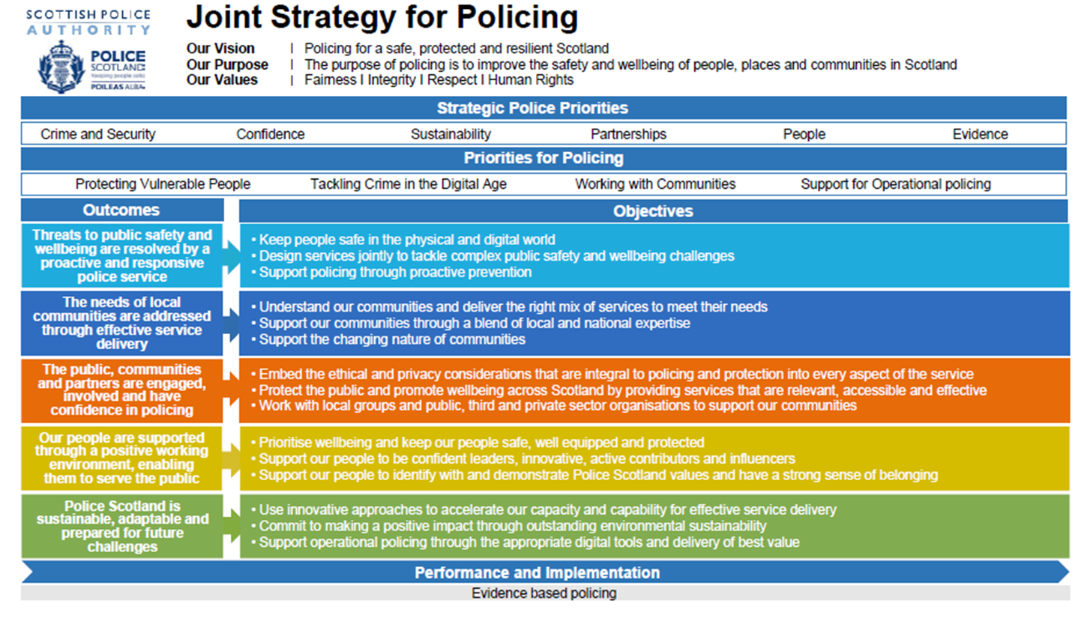

Policing during 2023/24
The following table and graph shows overall recorded crime for 2023/24, compared with the previous year and the five-year mean.
Crime group | 2023/24 | 2022/23 | 5-year Mean | % change from 5-year Mean | % change from 2022/23
1 – Non sexual crimes of violence | 11,323 | 10,321 | 9,333.6 | 21.3 | 9.7
2 – Sexual crimes | 14,517 | 14,551 | 14,038.2 | 3.4 | -0.2
3 – Crimes of dishonesty | 111,596 | 102,306 | 100,866.6 | 10.6 | 9.1
4 – Fire-raising, malicious mischief etc. | 41,219 | 43,088 | 45,502.2 | -9.4 | -4.3
5 – Other (pro-activity) crimes | 61,986 | 58,849 | 62,720.4 | -1.2 | 5.3
Total Groups 1-5 | 240,641 | 229,115 | 232,461.0 | 3.5 | 5.0
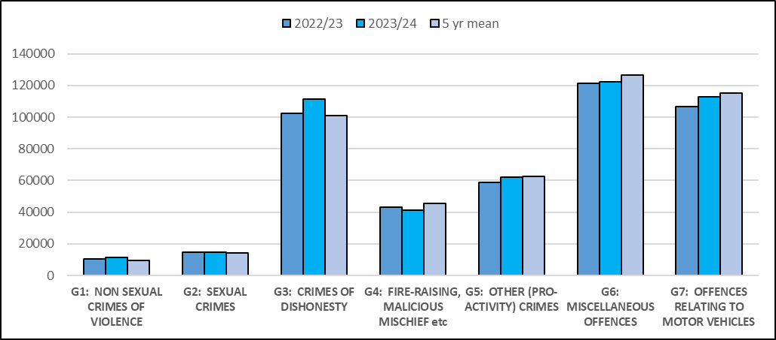

Key Insights
Throughout 2023/24, we highlighted a number of key performance insights, changes in crime trends, key challenges and successes in our quarterly performance reports. This section reflects on some key insights throughout 2023/24 and shows how these areas have concluded at year-end.
In Quarter 1 we featured a key insight into the injury rate of assaults on officers and staff.
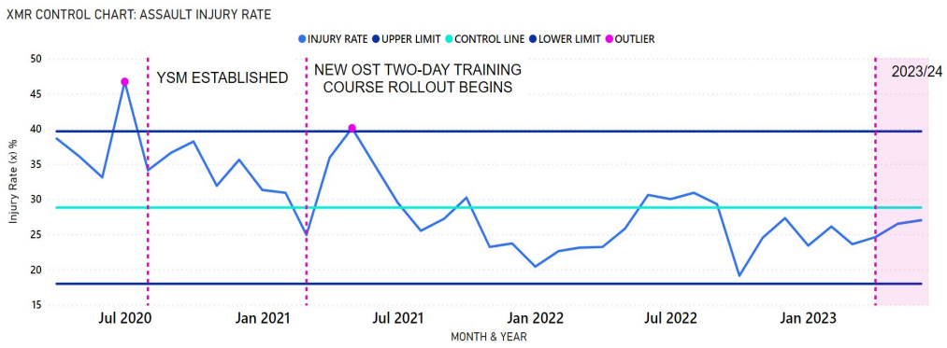
Police Scotland’s injury rate in 2023/24 was 26.0%, 6.2 percentage points below the three-year rate (32.2%). The injury rate had remained below the control line (three-year rate) for nine consecutive months and analysis through the Your Safety Matters group had highlighted the Officer Safety Training two-day training as a contributory factor to the decrease in assault related injuries. Research showed that within the first 30 days of completing the training officers/staff were 40% less likely to be injured.
However when an officer/staff was assaulted a year after completing the training, the estimated effectiveness of the training decreased to 7% (less likely to be injured compared to someone who has not received the training). Operational Safety Training worked to incorporate these results to assist in improving the safety of officers and staff.
At the end of 2023/24, there was a total of 6,702 assaults on officers/staff. This was an increase of 44 (0.7%) assaults compared to the previous year and an average of 18 assaults on officers/staff per day. Compared to the five-year mean this was a decrease of 165 (-2.4%). The top three methods recorded for assaults on officers/staff were kick, spit, and punch.
To proactively address assaults on officers/staff Police Scotland has been sharing best practice with fellow police services across the UK during the ‘All Performance Group’ meeting. Police Scotland showcased their utilisation of the Your Safety Matters PowerBi dashboard suite that has been developed, illustrating our commitment to data-driven decision-making and how we have used these dashboards to enhance our understanding of assaults on officers and staff. The Your Safety Matters team will continue to monitor and analyse data to increase our understanding and better protect our staff.
In Quarter 2 a key insight was on the high levels of Theft of Motor Vehicle crimes.
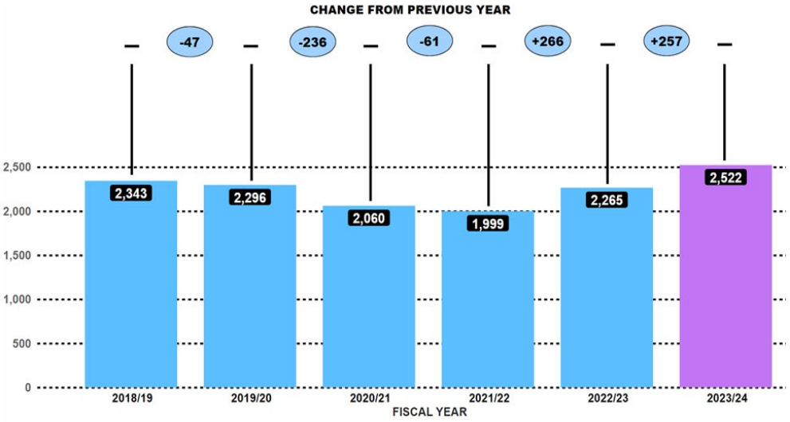
Theft of Motor Vehicle showed a consistent year-on-year rise over the past two years, having increased by 266 (up 13.3%) in 2022/23, followed in 2023/24 by an additional 257 (up 11.3%) crimes. The 2,522 crimes were the highest number recorded over the reporting period with an average of 14 thefts of motor vehicles a day.
Criminal intelligence analysis highlighted keyless entry as the predominant method for motor vehicles theft. Through tactics like relay/jamming devices, on-board diagnostics (OBD) key programming devices, OBD emergency start devices, and lock key decoders, offenders are able to gain keyless entry to vehicles. Analysis also highlighted new advancement keyless entry devices that work through the offender touching the door handle of the target vehicle and the device can process the signal from the vehicle and calculate an unlock code. The device is also capable of starting the engine and does not require other equipment such as a relay device.
At the end of 2023/24, the number of thefts of motor vehicles was 4,630, a decrease of 69 (-1.5%) compared to the previous year. This was however an increase of 262 (6%) on the five-year mean. The number of detections for this crime type increased by 121 (6.4%) compared to the previous year, and also increased on the five-year mean by 103 (5.4%).
Operation ENZONE is Police Scotland’s coordinated response which has intensified efforts to combat keyless thefts of vehicles. The operation has focused on the disruption of identified crime groups through targeted operations and has contributed to improving our insight and response into emerging trends. This includes the provision and publication of vehicle security advice offering suggested preventative measures that can be adopted. Analysis highlights that the total number of persons who have committed repeat motor vehicle crimes has decreased 3.1% when compared with 2022/23 figures, while the total number of crimes committed by each of these repeat offenders has also decreased year on year.
In Quarter 3 there was a key exception reported on the number of 999 calls answered in under 10 seconds using UK benchmarking data.
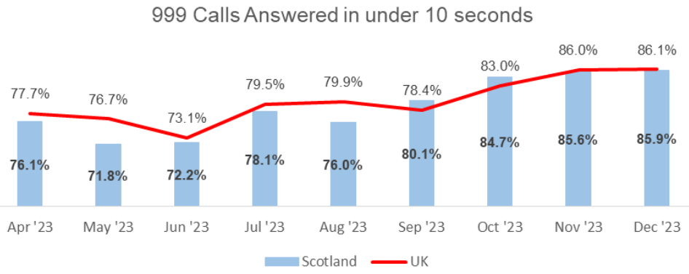
The National Police Chiefs Council (NPCC) had noted record high 999 call volumes experienced by emergency services across the UK. Police Scotland aim to achieve an average speed of answer for 999 calls within 10 seconds, a target which is also required by all 44 UK Police Forces. During this Quarter Police Scotland achieved an answer time of 10 seconds, which was the same as that achieved the previous year. The percentage of 999 calls answered within 10 seconds by Police Scotland saw a gradual increase since May 2023 with a high of 85.9% recorded in December 2023.
Due to the increase in 999 call volumes we prioritised emergency calls over non-emergency 101 calls. Consequently, the performance of 101 average speed of answer has been affected as the same advisors answer all call types including ‘Contact Us’ emails. Efforts continue to signpost callers to more appropriate methods of contact, including via ‘Contact Us’ and the online reporting facilities via the force website.
At the end of 2023/24, the average time to answer 999 calls was recorded as nine seconds, which is the same time recorded for the previous year. The average answer time for 101 calls increased by one minute six seconds to a total of five minutes 33 seconds; this was due to the prioritising the increased numbers of emergency 999 calls.
In Quarter 4 we drew attention to receiving a total of over 2 million calls, increasing by 0.3% compared to last year. 999 calls increased by 9.9% compared to last year however 101 calls decreased by 4.6% (down from 1,443,125 to 1,376,079).
The use of Contact Us emails has continued to grow during 2023/24. Despite there being a reduction in our 101 call volumes, there was an increase of 1% in all contacts handled by the Service Centre when compared with the same period last year due primarily to the increase in contacts via email. Emails and online reports are assessed in the same way as telephone calls using the THRIVE Risk Assessment.
Several factors have attributed to the increase in 999 call volume during 2023/24, including periods of good weather throughout July, August and September, the management of large scale events including the UCI Cycling World Championships and summer festivals. During October, November and December inclement weather was experienced including Storm Babet & Storm Gerrit resulting in an increase in weather related incidents. In February 2024, there were changes to legislation for XL Bully dogs which caused additional contacts from members of the public seeking advice and guidance.
Our call volumes and trends continue to be monitored closely to ensure that we are prepared to maintain an average speed of answer of under 10 seconds for emergency calls.
Finally, in Quarter 4 we drew attention to our Road Policing Festive Drink/Drug Drive Campaign which took place between 01 December 2023 to 02 January 2024.
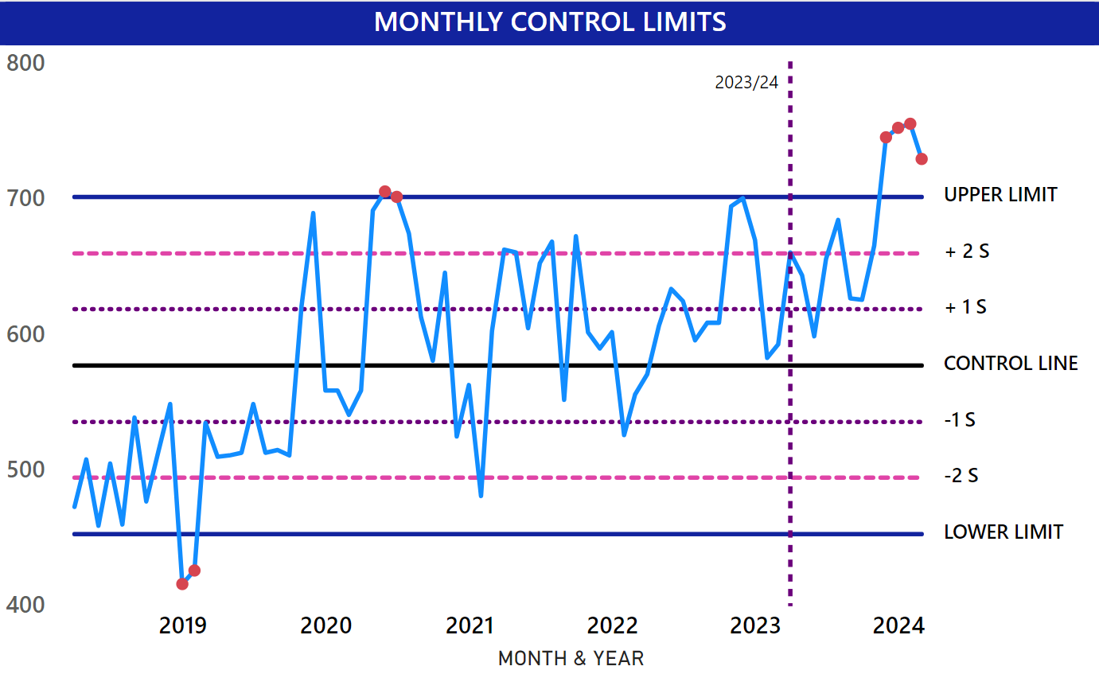
The above graph shows a large increase in the number of offences for drink, drug driving offences at the time of the campaign, the highest number recorded. The campaign was led through analysis and intelligence to assess the best locations and times with support provided by our Corporate Communications team to promote the campaign through social media. A total of 3,700 roadside tests were conducted, with 831 drivers detected for drink or drug driving offences. This was an increase of 109 detections compared to the same campaign which we ran the previous year. Our success in this area of proactivity are evidenced in the graph above which shows the upwards trend in drink and drug driving offences over the last few years, with the December/January period usually the highest due to the efforts of our yearly Festive Campaign.

Progress towards Strategic Outcomes
Police Scotland continues to make progress towards our five strategic outcomes, measured by progress marked against the operational and change activities outlined in the Annual Police Plan 2023/24. While the majority of activities remain ongoing or in progress, reflecting the nature of policing in these areas, a number have been completed this year. This section takes each outcome in turn, providing narrative updates on important activities, adding additional context, and utilising key impact pieces to illustrate work undertaken. It is intended to provide an overview of our progress and successes aligned under each outcome, utilising a selection of operational and change updates provided by divisions and departments.
This report is complimented by the Bi-Annual Progress Report, released in December 2023, which provides a detailed update on each activity, and the Quarterly reports, which provide a full breakdown of the Measures of Progress. These products complement each other and, taken together, provide a comprehensive overview of Police Scotland’s performance.

Overall Activities Progress
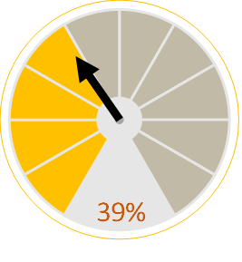 | 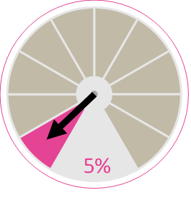 | 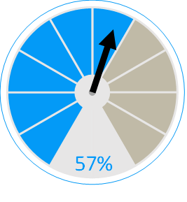
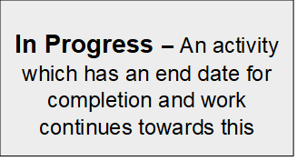 | 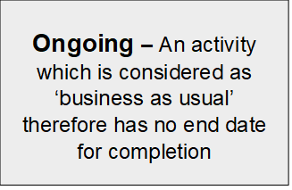 | 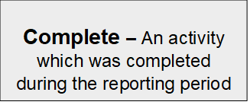
A full breakdown of activity progress can be found within Appendix I.

Strategic Outcome 1: Threats to public safety and wellbeing are resolved by a proactive and responsive police service
Police Scotland’s objectives are to:
- Keep people safe in the physical and digital world
- Design services jointly to tackle complex public safety and wellbeing challenges
- Support policing through proactive prevention
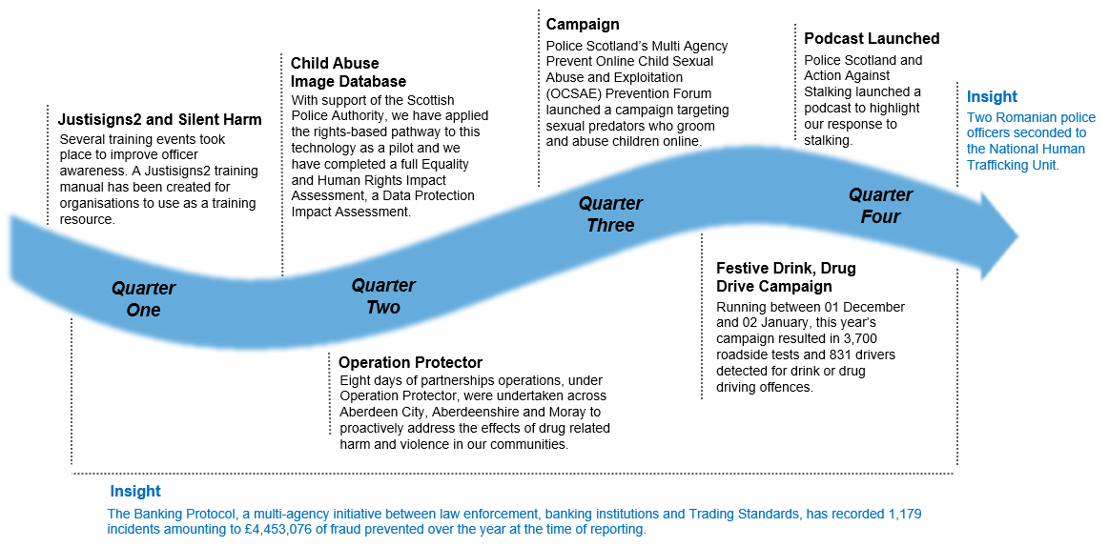

Campaigns
Police Scotland’s Multi Agency Prevent Online Child Sexual Abuse and Exploitation (OCSAE) Prevention Forum continues to meet quarterly where there is focus on innovation, public safety awareness, as well as recognition of streamlining media activity and campaigns.
During Quarter 3, the group supported the launch of the latest campaign, targeting sexual predators who groom and abuse children online. The campaign ran for four weeks and was designed to prevent online child sexual abuse and encourage contact with Stop It Now! Scotland. This was achieved through development of a short video which was promoted on paid digital channels to engage with the campaign audience.
Part of the campaign strategy included providing information for anyone affected by Child Sexual Abuse (CSA) and signposting to relevant support services.
Awareness raising campaigns remain a focus, particularly in support of tackling Violence Against Women and Girls (VAWG) and domestic abuse. We recently collaborated with Action Against Stalking (AAS) to create a podcast which will feature on Spotify. This highlights Police Scotland's response to stalking, what victims should expect when reporting and our multi-agency approach to stalking. The podcast launch coincided with National Stalking Awareness Week 24 – 28 April 2024. Internal communications have been developed around Stalking Screening Questions (SSQ) and Stalking and Harassment Toolkit and Corporate Communications will review and publish statistics.

Domestic Abuse – Partnership working
Numerous engagements have taken place throughout the year with partner organisations, to tackle domestic abuse. Scottish Government facilitated an LGBTQ+ roundtable discussion around the barriers faced by the LGBTQ+ community in reporting intimate partner violence.
We have worked with Hermat Gryffe to develop a new Honour Based Abuse (HBA) video, which includes lived experience from survivors’ groups and will be used in domestic abuse training.
We also worked with Heriot Watt University (HWU) on projects Justisign2 and Silent Harm. Justisigns2 highlighted the significant challenges deaf women face when making a report to police as well as the complexities around using an interpreter, especially in rural areas. Following the success of this project, further funding secured the Silent Harm project which aimed to improve access to support for deaf women reporting domestic abuse in rural areas.

Technology – Child Abuse Image Database
Our aim is to maintain and build the crucial bond of trust with our communities. The purpose of the Rights Based Pathway is to support decision making and maintain public trust and confidence in the organisation in respect of its adoption and use of technology.
The Child Abuse Image Database (CAID) is managed by the Home Office and contributes to the fight against Online Child Sexual Abuse and Exploitation (OCSAE). It helps identify and safeguard victims, makes investigating Child Sexual Exploitation and Abuse faster and more effective and supports international effort to remove images from the internet. As part of the continuous improvement of CAID, a ‘Facial Matching’ (FM) capability was introduced. In simplistic terms, FM seeks to automatically identify if the image of a person is present within the database, when uploaded by a law enforcement agency.
The introduction of this capability has brought about efficiencies in respect of taking less time to review images. A case with 10,000 images would typically take up to three days. Now, after matching images against CAID, a case of a similar size can be reviewed in an hour. This has helped shift the balance between reviewing images to identifying victims, with the overarching aim of safeguarding children.
Police Scotland understands the need to ensure public confidence and appropriate safeguards in utilising advancing technologies, however the challenge is to balance this against our statutory obligations in keeping the public safe, whilst making best use of available technologies to assist us in this mission. A Data Ethics Triage process has been implemented that will assess all related data and data driven technology projects.
The triage process will identify where ethical challenges may lie, provide a pathway to enhanced internal and external scrutiny and provide advice to projects to ensure that data and data driven technology is used legally and ethically. The triage process is an integral part of the Rights Based Governance Pathway to ensure that Police Scotland can demonstrate a consistent and proportionate approach to assessing data ethics and public interest considerations.

Child Exploitation
Between 04 and 10 March 2024, Police Scotland took part in a UK wide County Lines Intensification Week which resulted in significant collaborative working, educational events and safeguarding messaging across Scotland. During this focus week, 22 vulnerable persons were safeguarded, 24 safeguarding address visits were undertaken, 15 warrants were executed, and 16 persons arrested including two juveniles. In addition to commodity recoveries, over 1,070 members of the public were engaged with, around 100 of which were juveniles, during community events and leafleting, partnership days of action, along with school inputs and partner agency training.
On 29 and 30 January 2024, Interventions and the North East Child Protection Partnership hosted two multi-agency awareness training events relating specifically to County Lines based Child Criminal Exploitation. The training was delivered to 210 multi-agency staff including local authority, social work, NHS, police and third sector agencies.
Police Scotland Children and Young People Team jointly launched a collaborative Child Exploitation learning resources on the I AM ME Scotland online interactive platform. A publicity launch day took place on 18 March 2024 to mark the annual national Child Exploitation Awareness Day. The resource is aimed to tackle exploitation, by empowering young people with the knowledge and understanding to help make informed choices or know how and where to get support.
Operation Protector – The North-East monthly multi-agency partnership days of action continue to successfully drive the exploitation message across the division. Approximately 100-200 multi-agency staff are deployed during these days of action. Over 300 safeguarding address visits were undertaken to individuals who are at risk of drug related harm or violence. In addition, high visibility patrols took place in hot spot areas and dedicated support hubs were set up across various areas impacted by County Lines, resulting in over 300 interactions with members of the public and a number of individuals brought into service and given immediate support.
During Quarter 3 a snapshot report into Child Sexual exploitation (CSE) trends in Scotland was circulated internally. This identified similar data to those previously established and confirmed strong national support to existing divisional structures in relation to CSE.

Human Trafficking
National Human Trafficking Unit (NHTU) colleagues have also introduced Partners Intelligence Protocol (PIP) to Care Sector, which has been identified as an area of increased Human Trafficking (HT) threat and has a high volume of vulnerable female employees. As such we are hoping to increase opportunities for safeguarding potential victims of labour exploitation and target the businesses and individuals involved in perpetrating same.
Dundee PIP trainers have also rolled this out to Local Authority bodies in light of ongoing concerns around sexual and labour exploitation within the Bulgarian community in Tayside Division. This has been very successful in raising awareness and improving collaborative work between Police Scotland and partner agencies in respect of safeguarding, intervention and disruption of some of the associated issues. In addition, Renfrewshire and Inverclyde Division colleagues have been driving roll out of PIP to Education partners, and are in talks with Residential Care Establishment Kibble, who are keen to progress roll out to their employees. This will be monitored and if successful the intelligence dividend would be recommended for replication in other divisional areas, given they are housing some of the most vulnerable children in Scotland, at risk of exploitation.

Insight – Partnership working with Romanian Police
Under reporting of trafficking and sexual exploitation for prostitution of Romanian females is a particular problem encountered in Scotland resulting in a high number of potentially vulnerable females not engaging with Police and other authorities. The National Human Trafficking Unit (NHTU) have successfully applied to the Romanian Modern Slavery Fund administered by the Home Office and Romanian Embassy in London for funds to second two Romanian Police Officers to NHTU for six months beginning 08 January 2024. This secondment aims to increase reports of trafficking of Romanian Nationals and provide culturally sensitive information on rights and exploitation to encourage reporting when victims are at a stage in their journey to survivorship to come forward to report exploitation.

Fraud
Fraud is a significant global issue recognised as the most prominent crime type within the UK, with national reporting of frauds rising whilst detection rates are falling. A previous Scottish Crime and Justice Survey (SCJS) and other insights continue to tell us that the public are deeply concerned about the risk posed by fraud.
Police Scotland’s recorded fraud crime reports have increased by 87% in the past five years with our detection rate falling by 19% over the same period. Additionally, a significant proportion of fraud is now online and it has become synonymous with cybercrime. It is also believed that this crime is hugely under-reported.

Insight – The Banking Protocol
The Banking Protocol is a multi-agency initiative between law enforcement, banking institutions and Trading Standards. Its aim is to identify vulnerable victims at the earliest opportunity, who are in the process of being defrauded of funds from their bank accounts by unscrupulous criminals and to intervene to prevent these crimes. The Protocol is designed to provide a standardised method for how these concerns are dealt with and reported to police and to stop multiple victimisations.
At the time of reporting in 2023/24 the Banking Protocol has recorded 1,179 incidents, amounting to £4,453,076 of fraud being prevented. This initiative continues to succeed in protecting the vulnerable victims of fraud and its success demonstrates the value of the public/private partnership model.
Policing in a Digital World (PDWP) are responsible for coordinating the enhancement of Police Scotland’s ability to tackle cyber fraud. This group aims to consider the future membership of Fraud and Cyber crime Reporting and Analysis Service (FCCRAS) to enhance the reporting, intelligence development and supporting victims of Fraud, alignment to the UK Fraud Strategy and a more agile and scalable police operating model for Fraud.
In support of this and to enhance stakeholder engagement, Police Scotland and partners have commenced a Multi-agency Fraud Triage Hub pilot, with the objective of ensuring that we work in collaboration to tackle and prevent this escalating threat.
Since its inception, this collaborative approach has grown and has had some good outcomes as a result, including incidents of fraud valuing over £10million having been collectively worked on and £3million of this has been either stopped or recovered. In addition to the proactive work instigated by the group, a result of the real time sharing of information and intelligence around emerging fraud trends and methods has helped identify innovative and effective disruption, intervention and prevention opportunities whilst safeguarding and identifying appropriate support for victims. This approach ultimately reduces demand on front line policing resources, partner resources and has improved criminal justice outcomes.

Technology – Crypto Currencies
Cybercrime (Policing in a Digital World Programme) secured £200,000 funding to increase the organisation’s capability and capacity in relation to Crypto. This funding has significantly increased our capability moving forward and expands our collective capability from one specialist unit with limited capacity to an expanded capability across local and specialist teams to increase resource, knowledge and capability. Once embedded, this will significantly improve our service delivery and assist in meeting our policing priorities.
Procurement of 24 track and trace cryptocurrency licenses across two software tools was completed in March 2024, utilising Scottish Government grant funding. This will be rolled out across Cybercrime Investigations, ECFIU and divisional Financial Investigators, significantly increasing Police Scotland’s capability. Police Scotland ICT and Procurement have indicated an intention to jointly procure Crypto licences with NPCC from mid-2025 and this will be subject to ongoing funding by Digital Division.

Road Safety
All road safety campaigns outlined within our updated National Calendar of Road Safety Activity 2023/24, compiled in consultation with our road safety partners, were completed. Campaign work has continued the strong focus on protecting Vulnerable Road Users and/or targeting motorists committing Fatal 5 offences. Our Engage/Educate/Enforce approach has been enhanced by Corporate Communications/Social Media support for all campaigns this year.
During Quarters 3 and 4, in addition to daily patrol enforcement activity, we have undertaken two national speed campaigns and our Festive Drink Drug Drive Campaign. Our Vulnerable Road User Campaign in Quarter 4 also included a focus on speeding in busy, pedestrian rich areas and at previous collision locations, speed being the main determinant of injury severity/survivability. Our 2024/25 campaign calendar will continue in this vein, the opening Fatal 5 Campaign focusing on adverse driving behaviours that put all road users, particularly the vulnerable, at risk.

In-depth Fatality Study
A new road fatality database was established for this project, enabling a review of all fatalities on Scotland’s road network between 2015 and 2020. This research affords a strong insight into fatal collision causes and outlines countermeasures toward the reduction of future collision risk and harm. Following a working group review, the full report and accompanying executive summary were published in Quarter 3 and work continues to progress its recommendations collaboratively with key partners.

Strategic Outcome 2: The needs of local communities are addressed through effective service delivery
Police Scotland’s objectives are to:
- Understand our communities and deliver the right mix of services to meet their needs
- Support our communities through a blend of local and national expertise
- Support the changing nature of communities
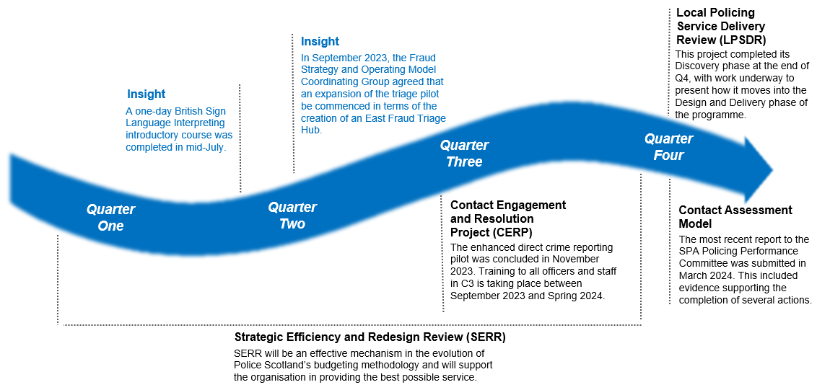

Improving our Effectiveness
Police Scotland is committed to ensuring that the organisation is as efficient and effective as possible to live within the funding available. As part of our journey to deliver the right mix of services to meet the needs of Scotland’s communities we are implementing a Strategic Efficiency and Redesign Review (SERR). SERR will be an effective mechanism in the evolution of Police Scotland’s budgeting methodology and will support the organisation in providing the best possible service. The Review and Redesign (R&R) workstreams will be overseen by the Enabling Policing for the Future (EPF) programme board, and a briefing paper will be developed to advise of how R&R will be progressed. The overarching approach is to work with the supplier to develop methodologies and tool sets that enable the organisation to take forward R&R activity in-house. Looking forwards, depending on how effectively we can acquire the necessary knowledge and skills there may be scope to limit the documented expenditure on R&R activity.

Insight – British Sign Language Interpreting Services
A Short Life Working Group (SLWG) has met with interpreter providers to identify ways of improving provision of interpreting services. The group has hosted a number of one day British Sign Language (BSL) introductory courses which is open to anyone whose purpose is to improve service delivery and be a more inclusive employer. Other areas being reviewed is the use of video interpreting to improve service provision.
We are also working on delivering the Contact Engagement and Resolution Project (CERP). CERP will improve standards of service through Police Scotland’s response to vulnerability, risk and public need at the earliest opportunity. When the public contact Police Scotland they will be given options, where appropriate, in resolving their issue. This will maximise opportunities for resolution using appropriate agencies which should see a reduction on local policing demand. Currently, local policing deal with many incidents that are often better placed with our agency partners, such as Local Authorities, NHS24 and Scottish Ambulance Service. CERP has been created to address this and will put robust processes in place to ensure the public get the right service at their time of need. As part of the Modernising Contact and Engagement programme, CERP divisional engagement and training continues alongside preparation for commencement of external stakeholder engagement. The Mental Health Pathway evaluation has commenced to assess its efficiency.

Assisting Communities
We are continuing to review and recalibrate the model for delivery of policing services in Scotland, ensuring we work for the public and communities. Our Local Policing Service Delivery Review (LPSDR) is ongoing with the first stage of 'discovery' now complete. The adoption of this Service Design led approach to this work has resulted in the development of a 'Discovery Report' which is currently being finalised. This report will provide valuable insights into how we currently deliver policing services within Local Policing and clearly define areas where we can improve our services to ensure better services for the public and communities within Scotland.
The completion of the ‘Discovery Report’ in conjunction with a number of other key products within the created LPSDR has allowed for the development of a range of options to take forward into the next phase of this work. These options are currently being explored in more detail as we move towards the design phase. This will result in the development of a number of prototypes which will enable us to recalibrate the model for the delivery of local policing services. This includes the piloting of a Local Resolution Team Model, a range of options being presented for the development of a Local Policing Model, a review of some of our high demand non crime services and a review of next steps following on from the outputs of the User Research report.
In remote and rural areas, a hub redesign is being adopted to merge Criminal Investigations Department (CID) and Public Protection Unit (PPU) into an omni-competent resource. This provides enhanced coverage and less officer travel (therefore less time wasted) through the implementation of a three-team omni-competent shift pattern. Resource Deployment Unit (RDU) input is awaited to formalise any change of shift patterns, thereafter formal consultation with Scottish Police Federation/Staff Associations will take place before implementing any change and a year-long trial period. Qualitative and quantitative feedback from staff will form part of this evaluation.

Insight – Preventing Fraud in the East of Scotland
The multi-agency financial triage hub project was proactively set up to tackle the upward trajectory of fraud reporting, predominantly across the cyber enabled/dependent landscape. Specialised officers work daily to link fraud crimes and associate these to existing or emerging crime groups, allowing for proactive and preventative work to be carried out. The hub is resourced from policing divisions in the East of Scotland, with plans to expand this in the future to the rest of Scotland. It will improve the victim experience and satisfaction, as well as reducing demand on policing and partner resources. With proactive fraud capability in line with Police Scotland’s Cyber strategy and acknowledgement that prevention will play a pivotal role, we have developed a partnership approach to fraud that will deliver successful outcomes to our communities and enhance Scotland’s resilience.

HMICS Recommendations
His Majesty's Inspectorate of Constabulary in Scotland (HMICS) provides independent scrutiny of both Police Scotland and the Scottish Police Authority (SPA). Our Contact Command and Control (C3) Division provides frontline advice, support and assistance to both the public and the police. C3 have been fully engaged in all recent HMICS inspections, including the Missing Persons and Mental Health inspections. The Governance and Improvement department is acting as a single point of contact for all the HMICS engagements, enabling a coordinated approach to effecting change and improvement in response to recommendations made by HMICS inspectors. Significant Progress has been made in relation to the C3 focused Assurance Review of the Contact Assessment Model (CAM) and the C3 Division are now looking at submitting evidence to discharge the remaining recommendations going forward.
The plan of work to achieve this has involved significant colleague engagement, including;
- Workshops in the review and re-design of Local Policing Appointments.
- A refreshed communications and engagement strategy which considers everything from ICT change to deployment of the bespoke CERP 1-Day training that will enhance C3’s performance in relation to Threat Harm Risk Investigation Vulnerability and Engagement (THRIVE).
- And signposting and the response to more complex, high-risk investigations.

Training will also form the basis of a dedicated e-learning module that is currently being designed in order to provide both an annual refresher for C3 staff and a valuable means through which Force-wide training can be enabled.
At the time of writing, the HMICS CAM review is at the current steps:
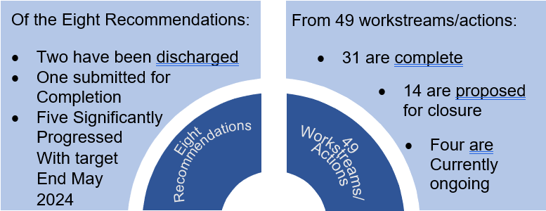
The existing, established governance structure, including tactical group meetings, under the direction of a Chief Superintendent, continues to operate. This ensures the future completion of all actions and conclusion of all recommendations. A further review and evaluation is built in via CERP training and scheduled thematic quality assurance.

Strategic Outcome 3: The public, communities and partners are engaged, involved and have confidence in policing
Police Scotland’s objectives are to:
- Embed the ethical and privacy considerations that are integral to policing and protection into every aspect of the service
- Protect the public and promote wellbeing across Scotland by providing services that are relevant, accessible and effective
- Work with local groups and public, third and private sector organisations to support our communities
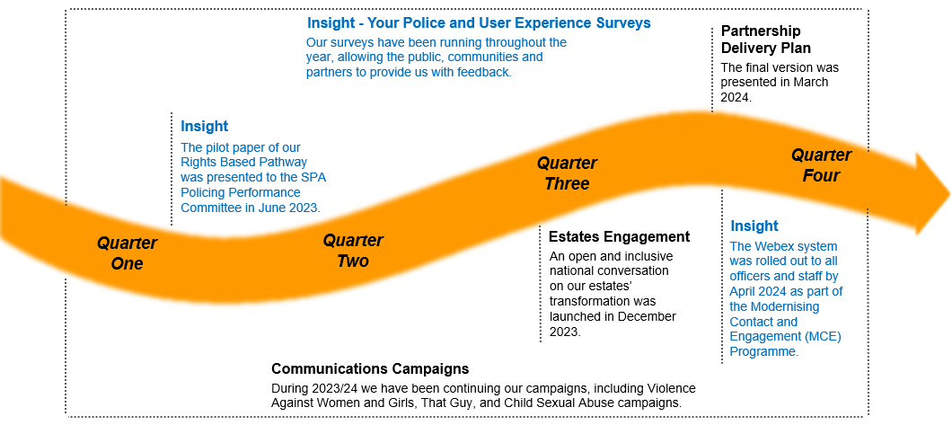

Public Confidence in Policing
The communities served by Police Scotland should feel confident that our service provided maintains our policing values of fairness, integrity, respect and human rights. Public confidence in policing impacts how safe individuals feel. The safety and wellbeing of the people we serve are enhanced by providing services that work efficiently whilst listening and seeking to understand the changing needs of diverse communities.

Police Scotland continues to measure and enhance understanding of public confidence, trust and user experience within local and specialist policing – delivering engagement and insights for performance, scrutiny, local police planning and service improvements. This work includes keeping public, colleagues and communities engaged and involved with financial and proposed service changes so that the service can continue to police by consent and ensure our policing model meets the needs of communities. We know that confidence is closely affected by how policing is experienced and perceived locally. Our analysis of public feedback shows confidence in police is shaped by experiences and perceptions of local policing. How effective local policing is perceived in keeping communities safe is strongly associated with perceptions and expectations of police visibility and accessibility in the physical, online and virtual spaces, keeping communities engaged and informed and how we demonstrate police values and behaviours.

Insight – Your Police Survey
Our local Police Survey is a continuous process throughout the year to allow the public, communities and partners involved in policing to provide feedback and influence local policing in their area through survey participation with communication campaign promotion enrolled to ensure that the sample of people completing the survey was statistically relevant and as representative of our community as possible. This year it has continued to receive a robust and representative response from the public and communities. The responses and feedback are used to better understand public confidence and where improvements can be made. The survey is also available in an easy read version and in British Sign Language.

Insight – User Experience Survey
The User Experience Survey is our independent survey to capture data relating to a user’s contact experience as well as the response and service they received from Police Scotland. The survey receives approximately 1,200 responses each month and is completely anonymous. Regular analysis of the feedback provided assists the Service to better understand what drives a positive experience with the police and allows for continuous learning and improvements to be made.

Partnership Delivery Plan
The Partnership Delivery Plan is Scottish Police Authority, COSLA and Police Scotland committed, through a partnership agreement signed in 2023, to strengthen collaboration across four priority areas, as well as promoting and supporting overall partnership working. The agreement, and underpinning priorities, builds on a history of collaboration across local government and policing focused on serving, protecting and enhancing local communities. The final version of the Partnership Delivery Plan was presented at the last COSLA, SOLACE, Police Scotland, and SPA Engagement Session in March 2024.

The four priority areas identified for delivery over the lifetime of the partnership agreement are:
- Local Scrutiny and accountability
- Prevention and early intervention
- Health and wellbeing
- Resource and investment

Police Scotland continues to enhance its approach to stakeholder engagement with support provided to a number of groups and forums. These groups provide a platform and structure for public and private sector partners, academia, and subject matter experts to contribute informed views to a range of strategic issues.

Areas of focus during 2023/24 have included, our Rights Based Pathway, the VAWG Implementation Plan and Data Sharing. Police Scotland continues to benefit from stakeholders’ constructive challenge through these forums, contributing to the improvement of the future policing services we deliver to the people and communities of Scotland.

Insight – Rights Based Pathway
We are taking the first piece of technology through the new Rights Based Pathway, with public engagement launched to gather input around the police use of this technology. The National Estates Programme is progressing, with 24 completed consultations on individual buildings so far. There have been 1,273 respondents to local consultations and 249 respondents to our National Consultation. These focused engagement activities supplement our continuous national public confidence, trust and user experience surveys which continue to achieve robust samples and the insights have been reported on a monthly and quarterly basis at the local, regional and national level - informing police planning, communications and scrutiny.

The Rights Based Pathway ensures that during the introduction of new technology, Police Scotland appropriately balance standards and safeguards for the public. It has been developed to meet commitments across a number of strategies and groups to support decision making and to maintain public trust and confidence in the organisation in respect of its adoption and use of technology.

Communication Campaigns
Across 2023/24, we delivered budgeted, behaviour change communication campaigns in the Violence Against Women and Girls and online Child Sexual Abuse (CSA) space. As part of our continuation of That Guy campaign, we engaged with ten social media influencers to more effectively deliver content to the target audience. The influencers delivered more than 70,000 views of our campaign video and our own social media content performed above our engagement benchmarks. We built on our existing partnership with Scottish Rugby who shared our content with their audiences and new partnerships were built with the Scottish Professional Football League (SPFL) and the Scottish National Men's Team.
Our domestic abuse campaign was a re-run of the previous advert, however, performed better in 2023/24 with over six million views of the advert during the campaign and over 94,000 clicks to access further information. The public were encouraged to click through to further information on the Police Scotland website where there was further signposting to the charity Respect, who look to provide behaviour change advice and assistance to perpetrators of domestic abuse. Respect - a domestic abuse organisation that develop safe, effective work with perpetrators, male victims and young people who use violence - reported that Police Scotland was their top referring website in December 2023.
The delivery of a perpetrator focused online CSA campaign, the results of which were a 161% increase in users to the Stop It Now! website when compared to the month before; the number of callers to Stop It Now! doubling in the campaign period; a 1.14% click through rate from our content to the Stop It Now! website and widespread media coverage of our campaign.

Insight – Modernising Contact and Engagement (MCE) Programme
As part of the Modernising Contact and Engagement (MCE) Programme, UCCP Project continues to progress with the introduction of Webex across the organisation. Roll out of this has started within Digital Division and a full communication strategy is in place with supporting information to provide the organisation with useful detail on the features within Webex. It is expected that this will be rolled out by the end of April 2024 and is part of the work to digitise all existing office telephony and critical communication services and ensure they are secure and resilient for years to come.

Data Sharing and Collaboration
A trial partnership between Police Scotland, Wise Group and SP Energy Network is commencing regarding sharing data regarding individuals suffering from fuel poverty. This will help support people identified by police as being in crisis and provide actual help and support and not only signposting of individuals. Together we aim to utilise data, evidence and insights to promote and deliver a collective approach, build a data collaboration, build capability and capacity for complex collaboration and transform learning experiences through sharing, inspiring and empowering.
As well as being a hub of activity and ideas, we are also a physical hub, with our base at the Edinburgh Futures Institute. This connects policing and public health practice, public health science, and academia. This is a move towards creating the conditions required for effective collaboration, challenging silo working across our organisations by efficiently galvanising our collective assets, skills, and resources.
Data Collaboration is an area under investigation with the option for a common data platform with real time data currently being discussed. Currently this is at the pre-scoping phase involving multiple partners - health, justice (police, prisons, courts), education and local authority data (e.g. social work, homelessness, care) - building on a system in operation in England (NPCC) led by Prof Stan Gilmour.
The Scottish Prevention Hub is a co-directed national partnership between Public Health Scotland, Police Scotland, and the Edinburgh Futures Institute at Edinburgh University, that aims to take a whole-system public health approach focused on primary prevention, to support the reduction of health and wellbeing inequalities in Scotland. We’ll do this by bringing together research, policy, evidence and practice.
Strategic Outcome 4: Our people are supported through a positive working environment, enabling them to serve the public
Police Scotland’s objectives are to:
- Prioritise wellbeing and keep our people safe, well equipped and protected
- Support our people to be confident leaders, innovative, active contributors and influencers
- Support our people to identify with and demonstrate Police Scotland values and have a strong sense of belonging
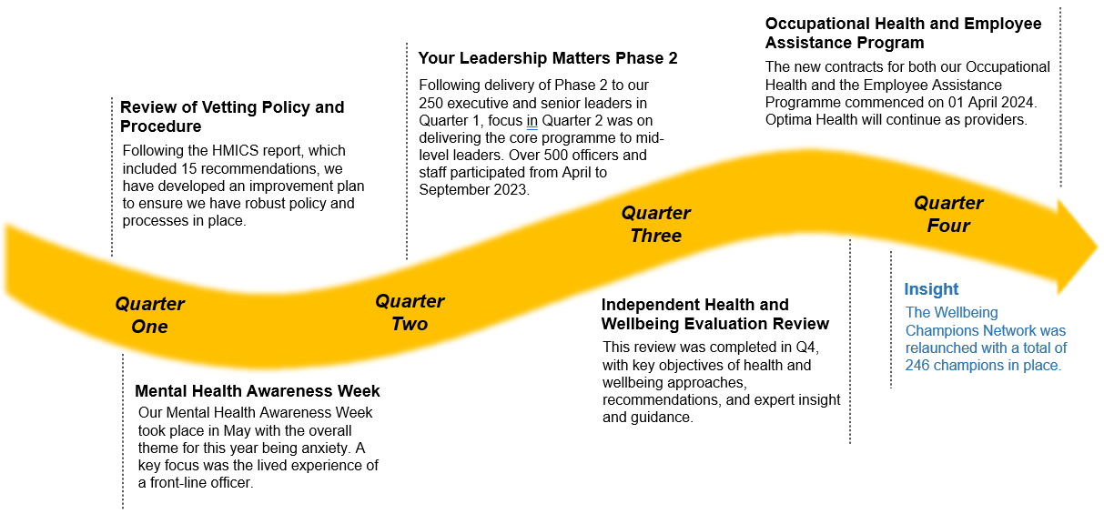

Equality, Diversity and Inclusion
Public confidence in policing is influenced by three key factors: police visibility, public and community engagement, and policing culture. Policing Together plays a crucial role in shaping the policing culture and values.
To ensure transparency and accountability, Police Scotland publishes the Equality, Diversity and Inclusion (EDI) Mainstreaming and Equality Outcomes Progress Report. This report highlights the commitments and progress made towards achieving Equality Outcomes 1-8. The report acknowledges the objectives, measures, and activities undertaken by Police Scotland, demonstrating their commitment to fulfilling their promises.
Additionally, Police Scotland publishes an annual Equality and Diversity monitoring report, which provides a statistical breakdown of representation within the organisation. This report helps identify areas of underrepresentation and supports workforce development efforts. To enhance this monitoring process, a PowerBI Dashboard has been launched, allowing senior management to review and monitor representation across divisions and make data-driven decisions for workforce development.
To promote equality and diversity within the organisation, a Diversity Staff Association collaboration group has been established. This forum provides a platform for all DSAs to collaborate and bring diverse perspectives to the table, ensuring equality across policing. In addition, individual Talk Truth to Power sessions are conducted between DSAs and their respective Force Executive Sponsors, allowing for open discussions and feedback on the Policing Together Strategy.
The Your Leadership Matters (YLM) program is designed to enhance leadership behaviours within Police Scotland. This program equips leaders with the necessary skills and tools to build effective teams that provide policing services to all communities. The program is underpinned by the Competency and Values Framework (CVF) and focuses on three key leadership behaviours: leading and learning inclusively, have the courage to do the right thing, and collaborating for growth. YLM has been rolled out to senior leaders and is now being delivered to sergeants, inspectors and police staff equivalents with line management responsibility in the coming months.
Research and Insight continue to prepare and present bi-annual updates to Policing Together governance groups to ensure strategic level awareness of trust, confidence and user experience among marginalised groups. Research, requested by the IRG, is beginning with final arrangements being made with probationer training colleagues, to enhance our understanding of the experiences of marginalised probationers during their probationary period in Police Scotland. This is a two-year programme of work.
The Policing Together Colleague Panel has not progressed for various reasons including funding, capacity and relationships with Trade Unions, SPF and ASPS being focused on Estates and VR/VER as well as other strategic priorities.
Police Scotland established a short life working group to focus on Equality, Diversity and Inclusion within the organisation. This group has developed a new EDI performance report and a prototype dashboard to track progress. The group, known as the Policing Together Performance and Impact Group, is responsible for ensuring the effective delivery of Police Scotland’s performance reporting in the area of EDI. They analyse insights and measures to monitor and measure the impact of EDI activities at both national and local levels, internally and externally.
A suite of performance dashboards is also under development, aligned with the Chief Constable’s Priorities, including Our People. These dashboards will provide a comprehensive view of performance and interconnectivity at both service and local level.

Vetting
Police Scotland have developed an Improvement Plan to address the 15 recommendations contained within the report published by HMICS following their review of vetting policy and procedure in Police Scotland in April 2023. Implementation of the recommendations will ensure that Police Scotland have robust policy and processes in place within the Force Vetting Unit to provide reassurance that vetting is granted in line with our values and standards.
It was recognised in the HMICS review report published in September 2023 that the Force Vetting Unit conduct thorough vetting checks and that the decision making process is sound with detailed rationale recorded to justify refusal. It is acknowledged that the identified recommendations, once implemented will provide further reassurance that vetting provides a sufficiently robust process to ensure that vetting is granted in line with our standards and values.
Police Scotland FVU now conduct a re-affirmation process on the first day of service for all new recruits into the organisation. This provides an additional mechanism in ensuring the integrity of officers.
A recommendation contained in the HMICS review of vetting policy and procedure report advises that Police Scotland should introduce a programme so that officers and staff who hold only Recruitment Vetting are re-vetted at least every 10 years. This process is currently being developed as part of the Improvement Plan and once in place will provide a mechanism to identify and subsequently manage risk. FVU are also developing a new list of designated posts requiring Management Vetting which will be subject to annual appraisal, providing an additional measure to identify risk. Again, a number of the recommendations contained in the HMICS review will ensure wider processes are in place within vetting to identify risk throughout the entire service of officers and staff.
Police Scotland have also undertaken a Historic Data Wash of all of the workforce, in line with other UK forces in order to identify any previously unknown or undeclared adverse information. In the few cases where risk has been identified this has been managed in line with current policy and procedures.

People Strategy
The People Strategy and Strategic Workforce Plan 2024-27 were approved by SPA on 30 November 2023 and implementation plans have been agreed and are in place. Next steps are to ensure robust governance is established to track, monitor and report on progress and delivery.
Organisational design principles have been developed and approved as part of the Strategic Workforce Plan. Next steps are to:
1. Fully embed Organisational Design approach in our Change Procedure i.e. restructures.
2. Upskill identified colleagues in Organisational Design methodology and knowledge
3. Established appropriate governance e.g. Org Design board to ensure adherence.

Insight – Wellbeing Champions Network
The relaunch of our wellbeing champions network has taken place with a new cohort of champions now in position. We have been working to achieve a ratio of one wellbeing champion to every 100 officers and staff to ensure there is proportionate representation across all divisions and departments. The network will now include an internal communications channel to share good practice as well as an ongoing Continuing Professional Development programme. The champions will also have a new monthly online network check in and a wellbeing champions SharePoint site where they can access information and track their proactive activity.

Strategic Outcome 5: Police Scotland is sustainable, adaptable and prepared for future challenges
Police Scotland’s objectives are to:
- Use innovative approaches to accelerate our capacity and capability for effective service delivery
- Commit to making a positive impact through outstanding environmental sustainability
- Support operational policing through the appropriate digital tools and delivery of best value
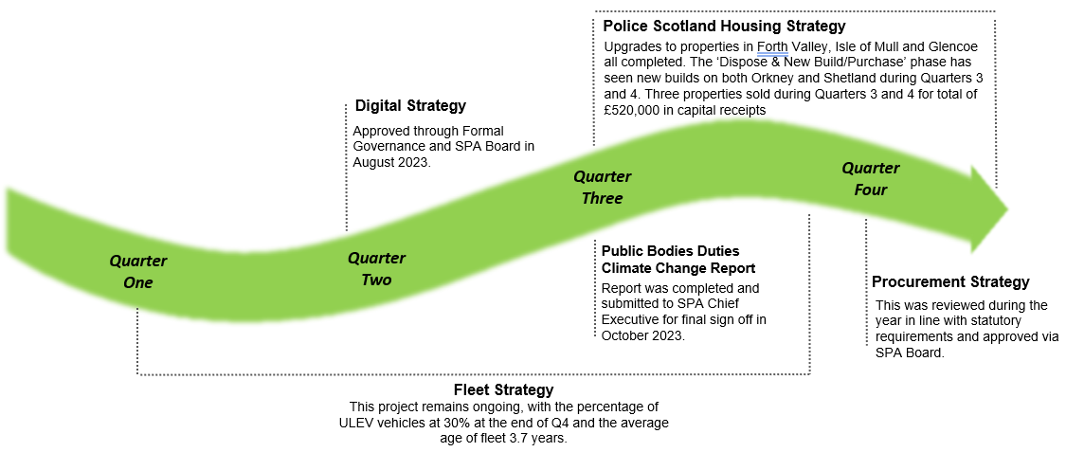
A modern police force must make the most of opportunities for innovation and development to improve service delivery and support operational policing in an environmentally sustainable way. Success in this outcome means that our estate and fleet are utilised as efficiently and sustainably as possible, our corporate services are accessible and effective, and operational policing is supported to the fullest extent across Police Scotland.
In order to fulfil the Fleet Strategy and increase the number of Ultra Low Emission Vehicles (ULEV), we will work with public bodies to phase out petrol and diesel cars and continue to support the ongoing development of charging infrastructure.
The year end fleet and estates status is as follows:

Average age of fleet | 3.7 years
Vehicle Availability | 97.2%
Percentage of ULEV Fleet | 30%
Percentage footprint of the estate which is co-located/shared with our partners | c. 23%
Percentage footprint of the estate that is in good or better condition | 89.4%
The estate has seen elemental improvements, predominantly due to the M&E Consultants works carried out. The figure of 89.4% represents an improvement, not the condition of the estate overall.
The total carbon emissions per m2 of estate at the end of Quarter 3 was 16.72kg/m2, with the reduction in CO2 emissions of 121 tCO2e in comparison to Quarter 3 last year recorded. Year-end figures are not yet available at present and will be provided for the next reporting cycle.

Police Scotland Housing Strategy
Work remains ongoing to deliver the Police Scotland Housing Strategy with the ‘Retain & Invest’ workstream continuing with upgrades to properties in Forth Valley, Isle of Mull and Glencoe all completed during the Quarter 3 period. A further property on Shetland is due to be completed during the early part of 2024/25.
The ‘Dispose & New Build/Purchase’ phase has seen new builds on both Orkney and Shetland during Quarters 3 and 4, with a further two on Orkney due for completion during Quarter 1 of 2024/25.
Further leased properties have been sourced to allow disposal of existing owned, or replace existing leased properties, but at lower cost/longer term solution including at Rothesay, Isle of Bute, and Lerwick, Shetland.
The disposal of surplus properties continues including the following;
- Three properties sold during Quarters 3 and 4 for total of £520,000 in capital receipts.
- Eleven residential properties sold since commencement of strategy delivery, a total of £1,704,000 in capital receipts received.
- One further property sale is imminent.
Work is ongoing to review and refresh the Police Scotland enabler strategies including Estates, Fleet and Public Contact and Engagement following approval of the updated Joint Strategy for Policing 2023-2026. Approaches have been discussed and agreed with executive leads. Reviews for cyber and public contact and engagement are therefore underway. Estates public consultation and planning work was initiated (originally under the Policing our Communities programme), and is ongoing alongside other key elements of Operation Evolve. Review work for estates and fleet has been paused in the interim.

Digital Strategy
The Digital Strategy was approved through formal Governance and SPA Board in August 2023. The Digital Strategy Advisory Board is now in place and meets monthly. The key purpose is to discuss, agree and provide strategic oversight of the Digital Strategy as it evolves and develops in line with organisational and policing requirements.
Funding for capital and reform has now been agreed and this allows us to consider what projects from the Digital Strategy will be taken through 2024/25. An overview of this was presented at the DSAB in March along with analysis of actual funding allocated to the Digital Strategy in 2023/24.
As part of the Target Operating Model (TOM), the Chief Data Office has now been realigned to the Digital Division and the Digital Support and Evolution Group (DSEG), the first of our product delivery teams, has now went live. However funding to support moving further forward with the development and delivery of the TOM has not been approved, alongside key tools required. A review on approach to delivery will be undertaken to identify how the Digital Division can move forward with this approved model.

Procurement Strategy
The Procurement Strategy was reviewed during the year in line with statutory requirements and approved via SPA Board. A more in-depth review of the Procurement Strategy will be undertaken during the next financial year. This will provide a strategy more aligned to the emerging transformation and change activities and organisational priorities. This approach was presented to, and agreed by, SPA Resources Committee alongside the existing strategy which was reviewed and updated to meet minimum statutory requirements.
During 2024/25 we are committed to developing a clear vision and target operating model for the future of our service which will enable us to develop our three-year plan for the delivery and prioritisation of core services alongside our journey of service and organisational transformation.

Appendix I – Activity Status Updates
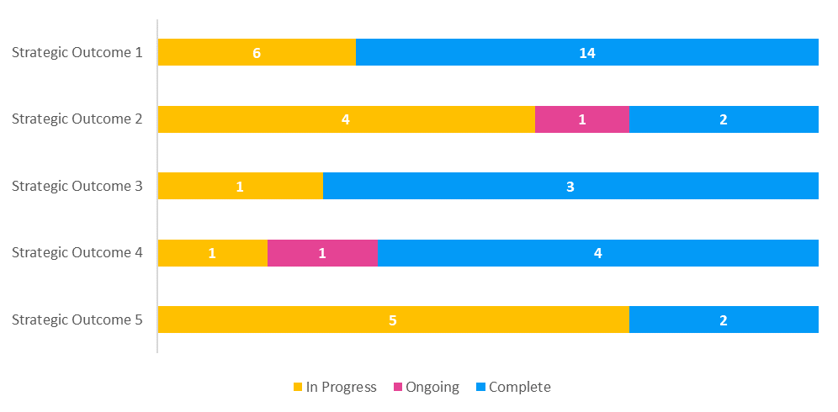
Key
Operational activity
Change activity

Strategic Outcome 1 - Threats to public safety and wellbeing are resolved by a proactive and responsive police service

Annual Police Plan 2023/24 - Activities |  |  | Status | Justification
We keep people safe in the physical and digital world | 1 | Co-ordinate delivery of our Violence Against Women and Girls strategy and respond to the introduction of any new legislation by the Scottish Government | Complete | Throughout 2023/24 Police Scotland has continued to deliver against and report internally against our VAWG Strategy. Work is ongoing to develop this further during 2024/25. Police Scotland has worked closely with partners when new legislation has been introduced.  This work is complete for 2023/24 and further deliverables are being developed for 2024/25.
 | 2 | Implement recommendations of the Public Protection Development Programme Review | In Progress | The Public Protection Development Programme Review is now in the Develop and Deliver phase. As we move into 2024/25 a number of potential solutions will be tested and piloted prior to moving into the Delivery phase. End date not specified, objective still in progress and will be carried into 2024/25.
 | 3 | Work with strategic partners to implement Bairns' Hoose in Scotland | In Progress | All off the Pathfinder Partnerships are at varying degrees of implementation, leading work through the local partnerships and accessing the relevant Scottish Government funding streams. Divisions are supported by SCD-PP-CP Policy team to ensure consistency and sharing learning. Nationally, SCD-PP-CP have organised access to Scottish Government funding to take forward new VRI equipment in the relevant partnerships. End date not specified, objective still in progress and will be carried into 2024/25.
We keep people safe in the physical and digital world | 4 | Develop our skills mix to facilitate future protest demand in line with a human rights-based approach | Complete | Over the course of 2023/24 Police Scotland conducted a scoping exercise to identify the skill profile necessary. We have developed our public order capability and are part of national NPCC groups for Protest and PO Tactics to ensure our programme of training and refreshers is current and develops skills and confidence in areas we anticipate may be required operationally.  This work is complete for 2023/24 and has become business as usual moving into 2024/25.
 | 5 | Delivery of the Cyber Strategy and Transformation Programme, Policing in the Digital World, to design and deliver new services and approaches to policing in an increasing online and digital world | Complete | A Rights Based Pathway has been developed to meet commitments in the Joint Strategy, Cyber Strategy, the Emerging Technologies Independent Advisory Group (ETIAG) recommendations and the Police Scotland and Scottish Police Authority Memorandum of Understanding (MOU).  In support of the pathway, CAID (Child Abuse Image Database) Facial Matching (FM) and BERLA were identified as the technologies which would be used as a proof of concept for the Rights Based Pathway.  This work is complete for 2023/24 and as we move into 2024/25 a framework will be devised in order to measure the use of the above technologies in terms of their effectiveness, efficiencies and impact on the wellbeing/welfare of our people. Other technologies will being considered to further test/evaluate the Pathway as it develops.
We keep people safe in the physical and digital world | 6 | Deliver increased capability and capacity for investigative, intelligence and seizure opportunities across all crypto assets to both specialist and local policing areas | Complete | During 2023/24 the Fraud Strategic Governance Group implemented a multi-agency financial crime triage pilot, which commenced in February 2023, focused on high-level threats and vulnerability. This pilot includes the early sharing of information in relation to the passage of individuals entering Scotland to setup UK limited companies and associated bank accounts and the identification of sextortion and familiarity frauds as emerging threats with sub groups established to develop joint preventative campaigns and raise awareness.  This work is complete for 2023/24 and the work of the group will continue with members, from the public and private sectors, developing existing and considering different approaches in 2024/25.
 | 7 | Design and implement Cyber Choices approaches to divert persons away from criminal behaviour | Complete | The educational and engagement work undertaken by the Cybercrime Harm Prevention team during 2023/24 is now firmly established with long term capability. The overall Cyber Choices Strategy and referral process is being progressed by the PIADW team with a dedicated Project Manager.  This work is complete for 2023/24 and will be incorporated into planning for 2024/25.
We keep people safe in the physical and digital world | 8 | Improve our response and capacity to effectively tackle fraud | Complete | During 2023/24 in support of this objective Police Scotland have commenced a Multi-agency Fraud Triage Hub pilot, with the objective of ensuring that we work in collaboration to tackle and prevent this escalating threat. This function has seen clear tangible successes and outcomes as a result.  For the purposes of the annual plan this work is complete. The development of a multi-agency financial crime triage hub is underway as we move into 2024/25 and the necessary governance and partnerships will come together to assess all the core elements of joining FCCRAS, aligning to the UK Strategy, establishing a future Target Operating Model and developing the already established multi-agency approach to Fraud.
 | 9 | Develop partnership approaches to tackle drug-related deaths, drug-related harm and improve community wellbeing, including the impact of safer consumption facilities on policing | Complete | During 2023/24 the Substance Harm Prevention team work to develop a substance awareness education package was completed. A support services directory is in use and hopes to provide an earlier form of intervention, with the aim of diverting people who use drugs into recovery and treatment, or those experiencing trauma or serious life concerns, into support prior to them reaching crisis point. In addition, Police Scotland’s Drug Strategy has been refreshed and engagement with partners is ongoing surrounding the progression of Safer Drugs Consumption Facilities and Drug Checking Services in Scotland.  Work in this area will remain a priority for Police Scotland moving into 2024/25. For the purposes of the annual plan this objective is complete for 2023/24.
We keep people safe in the physical and digital world | 10 | Lead on development of a violence prevention approach to work concurrently with that of the Scottish Government | In Progress | Discussions around the development of the Violence Prevention Strategy are taking place to support that produced by Scottish Government. Police Scotland continue to work closely with partners to discuss trends and patterns and look at preventative measures in this area. Regular strategic meetings take place to monitor and develop our collective approach.  This objective is still in progress and will be carried over into 2024/25.
 | 11 | Understand, measure and evidence demand to influence decision making at strategic, operational and tactical levels through the development of demand data dashboards and methodologies | In Progress | The Demand and Productivity Unit continue to build Police Scotland’s demand tools to improve organisational understanding of demand along with various opportunities to optimise productivity, capacity and efficiency.  The unit is now moving into their second sphere where we will specifically seek to align all analysis under Productivity, Capacity and Efficiency, with a greater focus on the interconnected nature of different demand areas, departments and processes.  This objective is still in progress and will be carried over into 2024/25.
We keep people safe in the physical and digital world | 12 | Increase the capability and capacity of Counter Terrorist Specialist Firearms Officers across the country. | Complete | There is now a sufficient pool of officers to fulfil the allocation of national courses over the coming year which will continue to support the CTSFU build within Police Scotland.  The internal drone capability is awaiting sign off and delivery of training and will be operational as we move into 2024/25. Work is also ongoing to develop a training package which will deliver the external drone capability.  For the purposes of the annual plan objective for 2023/24 this work is complete and will become business as usual during 2024/25.
Design services jointly to tackle complex public safety and wellbeing challenges | 13 | Continue to work with agencies to explore the risks around the post-pandemic recovery, the cost of living crisis and resilience, including winter resilience and to develop strategies to mitigate these risks | Complete | The Police Scotland Pandemic Preparedness Framework is in place and Police Scotland Emergency Resilience Planning remain fully engaged and embedded within resilience structures across Scotland. In addition, our severe weather plan remains in place and has been tested recently during the winter months. The multiagency de-brief from the recent weather related major incidents and any learning will be incorporated into our plan once received.  For the purposes of the annual plan objective for 2023/24 this work is complete and will be continually reviewed as business as usual during 2024/25.
Design services jointly to tackle complex public safety and wellbeing challenges | 14 | Continue to evaluate the implementation of the Naloxone Programme, share best practice with other police services and engage with key partners to continue to assist in reducing drug deaths | Complete | Naloxone rollout to officers is now complete and is continued as business as usual. Other work streams are ongoing in collaboration with key partners.  Work in this area will remain a priority for Police Scotland moving into 2024/25. For the purposes of the annual plan this objective is complete for 2023/24.
 | 15 | Design and develop participatory approaches to engage and involve the public and communities in policing services and challenges | In Progress | Work is ongoing in this area with the Dundee listening forum development in the early stages and will be continued into 2024/25. Engagement with other local divisions is also in progress and should be realised in the coming year.
 | 16 | Through the increased use of intelligence led policing and proactive engagement with all road users, reduce death and serious injury on Scotland’s road network | Complete | All road safety campaigns outlined within Police Scotland's National Calendar of Road Safety Activity 2023/24, compiled in consultation with our road safety partners, and were completed during 2023/24. The In-depth Fatality Study full report and executive summary have been published and work will continue next year to progress the recommendations collaboratively with key partners.  This work is complete for 2023/24. The National Calendar of Road Safety activity will be refreshed for 2024/25.
We support policing through proactive prevention | 17 | Design, develop and implement a Public Health Strategy for policing in Scotland | In Progress | Following discussion, the decision was taken by DCC Local Policing to prioritise work on Police Scotland's future approach to mental health in the first instance, ahead of any further work on a public health for policing strategy. A combined evidence and insights report on policing and mental health produced by Strategy, Insight and Engagement and a programme of work has been put in place to take forward recommendations from the report and support the direction set by the new Chief Constable.
 | 18 | Enhance intelligence capture and development to identify vulnerable children who are being exploited for the purpose of County Lines drug supply | Complete | County Lines will continue to be a priority for Police Scotland with partners in the Scottish Crime Campus partnership model lending their expertise and support. A full portfolio of work around county lines has been undertaken during 2023/24 including Child Criminal Exploitation Training and learning resources being released and intensification weeks and days of action.  This work is complete for 2023/24 with funding for a researcher and analyst secured to enhance work in this area as we move into 2024/25.
We support policing through proactive prevention | 19 | Enhance intelligence capture and development to identify vulnerable children who are being sexually exploited and targeted | Complete | Throughout 2023/24 collaborative work has been ongoing between Police Scotland and partner agencies in respect of safeguarding, intervention and disruption.  This work is complete for 2023/24. Police Scotland have strong national support in place for Divisional Public Protection structures in relation to Child Sexual Exploitation via child concern reports and welfare checks in relation to intelligence and work will continue in this area as we move into 2024/25.
 | 20 | Develop and implement a communications strategy that will encourage all colleagues to be more vigilant and proactive in challenging, reporting and combating, breach of professional boundaries, infiltration and other corrupt activity | Complete | This work is complete for 2023/24.

Strategic Outcome 2 - The needs of local communities are addressed through effective service delivery

Annual Police Plan 2023/24 - Activities |  |  | Status | Justification
Understand our communities and deliver the right mix of services to meet their needs | 21 | Implement Strategic Efficiency and Redesign Review (SERR) across the organisation | In Progress | This objective is still in progress. The Review and Redesign work streams will be overseen by the Enabling Policing for the Future (EPF) Programme Board as we move into 2024/25.
 | 22 | Deliver Contact Engagement and Resolution Project (CERP) | In Progress | CERP divisional engagement and training continues alongside prep for commencement of external stakeholder engagement.  Mental Health Pathway (MHP) evaluation has commenced to assess efficiency. This objective is still in progress and will be continued in 2024/25.
 | 23 | Continue to review and recalibrate the model for delivery of policing services in Scotland for the public and communities | In Progress | The Local Policing Service Delivery Review has produced a report which, in conjunction with a number of other key products within the created LPSDR, has allowed for the development of a range of options to take forward into the next phase of this work.  This objective is still in progress and further work will be undertaken during 2024/25 as we move into the design phase of this work.
Support our communities through a blend of local and national expertise | 24 | Continue to transform our existing custody estate to modern, safe places and gateways for the delivery of wellbeing, diversion and transformation services | Complete | Throughout 2023/24 a number of work streams have been contributing to this objective including SPR Quality Assurance Group, COPFS Diversion to prosecution, National Police Care Network, Criminal Justice Hubs and upgrading of custody suites.  Evaluated as complete for the purposes of the Annual Plan this important work will continue during 2024/25.
 | 25 | Develop and implement improvement plan for C3 based on HMICS recommendations and findings of short life working group | Complete | C3 have a single point of contact for HMICS engagement which enables a coordinated approach to effecting change and improvement in response to HMICS recommendations. Although assessed as complete for 2023/24 the existing, established governance structure will continue to operate, ensuring the future completion of all actions and conclusion of all recommendations.
Support the Changing nature of communities | 26 | Embed Police Scotland’s updated Equality Outcomes for service delivery across the service | Ongoing | Policing Together will continue their work to embed Police Scotland's Equality Outcomes for service delivery as we move into 2024/25. This includes development of our ‘Policing in a diverse society’ resource, which focuses on officers and staff tailoring their approach to meet the needs of individuals and communities. This work is in progress.
 | 27 | Implement the plan to deliver the HMICS Hate Crime Recommendations | In Progress | A number of the recommendations are still being progressed at the close of 2023/24. This important work will be carried over into 2024/25.

Strategic Outcome 3 - The public, communities and partners are engaged, involved and have confidence in policing

Annual Police Plan 2023/24 - Activities |  |  | Status | Justification
Embed the ethical and privacy considerations that are integral to policing and protection into every aspect of the service | 28 | Continue to lead and embed our engagement approach and framework to provide assurance that all appropriate matters are considered with the public and communities which could impact on policing legitimacy and consent, enabling key elements of democratic innovation | Complete | Police Scotland continues to enhance its approach to stakeholder engagement. Areas of focus during 2023/24 have included, our Rights Based Pathway, the VAWG Implementation Plan and Data Sharing. Police Scotland continues to benefit from stakeholders’ constructive challenge through these forums, contributing to the improvement of the future policing services we deliver to the people and communities of Scotland.  Although this objective is considered complete for the purposes of the Annual Plan this area will continue to develop into 2024/25.
Protect the public and promote wellbeing across Scotland by providing services that are relevant, accessible and effective | 29 | Provide communications services to support policing priorities | Complete | During 2023/24 we delivered budgeted, behaviour change communication campaigns in the violence against women and girls and online child sexual abuse space. Additionally, we supported the Your Police survey to ensure that the sample of people completing the survey is statistically relevant and as representative of our community as possible.  This objective is considered complete for 2023/24.
Protect the public and promote wellbeing across Scotland by providing services that are relevant, accessible and effective | 30 | Continue implementation of a new Unified  Communications and Contact Platform (UCCP) | Complete | As part of the Modernising Contact and Engagement (MCE) Programme, UCCP Project continues to progress with the introduction of Webex across the organisation. This forms part of the work to digitise all existing office telephony and critical communication services and ensure they are secure and resilient for years to come.  Further to this a new Customer Relationship Management solution will be introduced as we move into 2024/25.  This objective is considered complete for 2023/24.
Work with local groups and public, third and private sector organisations to support communities | 31 | Work with the NHS and local authorities to improve partnership working and ensure data protection is prioritised whilst continuing to protect the public | In Progress | Work is ongoing with local authorities to develop a standardised approach to data sharing. In addition, a trial partnership between Police Scotland, Wise Group and SP Energy Network is commencing regarding sharing data regarding individuals suffering from fuel poverty. At the end of 2023/24 the final version of the COSLA, SPA, and Police Scotland Partnership Delivery Plan was presented. There continues to be work ongoing in this area which will become business as usual in years to come.

Strategic Outcome 4 - Our people are supported through a positive working environment, enabling them to serve the public

Annual Police Plan 2023/24 - Activities |  |  | Status | Justification
Prioritise wellbeing and keep our people safe, well equipped and protected | 32 | Design, develop, deliver and commence implementation of a new People Strategy | Complete | The People Strategy 2024-27 was approved in November 2023 and an implementation plan has been agreed and is in place.  Although this objective is considered complete for the purposes of the Annual Plan as we move into 2024/25 Police Scotland will ensure robust governance is established to track, monitor and report on progress and delivery of this plan.
 | 33 | Design, develop, deliver and commence implementation of a refreshed Strategic Workforce Plan (SWP) | Complete | The Strategic Workforce Plan 2024-27 was approved in November 2023 and an implementation plan has been agreed and is in place.  Although this objective is considered complete for the purposes of the Annual Plan as we move into 2024/25 Police Scotland will ensure robust governance is established to track, monitor and report on progress and delivery of this plan.
Prioritise wellbeing and keep our people safe, well equipped and protected | 34 | Develop organisational design and workforce change capability to embed best practice throughout the service | Complete | Organisational design principles have been developed and approved as part of the Strategic Workforce Plan.  Although this objective is considered complete for the purposes of the Annual Plan as we move into 2024/25 Police Scotland aim to fully embed Organisational Design approach in our Change Procedure i.e. restructures, upskill identified colleagues in Organisational Design methodology and knowledge and establish appropriate governance to ensure adherence.
Support our people to be confident leaders, innovative, active contributors and influencers | 35 | Deliver the Equality, Diversity and Inclusion training programme | In Progress | Policing Together will continue their work to deliver the Equality, Diversity and Inclusion Training Programme as we move into 2024/25.  This work remains in progress at the end of 2023/24.
Support our people to identify with and demonstrate Police Scotland values and have a strong sense of belonging | 36 | Embed Policing Together across the service and enable an inclusive environment where all colleagues can thrive | Ongoing | Policing Together will continue their work as we move into 2024/25 to create an inclusive environment where colleagues can thrive.  This work remains in progress at the end of 2023/24. The Policing Together Colleague Panel has not progressed at this point.
 | 37 | Continue to ensure our vetting function enables the service to be assured all new applicants behave in accordance with and uphold the values of the organisation | Complete | During 2023/24, Police Scotland have developed an Improvement Plan to address the recommendations in the HMICS report following their review of vetting policy and procedure. We have also undertaken a Historic Data Wash of our workforce, in line with other UK forces.  Police Scotland now conduct a re-affirmation process on the first day of service for all new recruits into the organisation providing an additional mechanism in ensuring the integrity of officers. For the purposes of the Annual Plan this objective is complete and the processes will continue into 2024/25 as business as usual.

Strategic Outcome 5 - Police Scotland is sustainable, adaptable and prepared for future challenges

Annual Police Plan 2023/24 - Activities |  |  | Status | Justification
We use innovative approaches to accelerate our capacity and capability for effective service delivery | 38 | Deliver the Police Scotland Housing Strategy | In Progress | This objective is still in progress and estimated to be around 48% complete. Work will continue into 2024/25 in the 'Retain and Invest' and 'Dispose and New Build/Purchase' work streams to deliver this objective.
 | 39 | Review and refresh the Police Scotland enabler strategies including Estates, Fleet and Public Contact and Engagement following approval of the updated Joint Strategy for Policing 2023-2026 | In Progress | Approaches to this work have been discussed and agreed with Executive leads. Reviews for cyber and public contact and engagement are therefore underway. Estates public consultation and planning work was initiated (originally under the Policing our Communities programme), and is ongoing alongside other key elements of Operation Evolve. Review work for estates and fleet has been paused in the interim.  This objective remains in progress as we move into 2024/25.
 | 40 | Finalise and deliver an Air Capability Strategy to enhance support and service delivery across operational policing | Complete | This work is complete for 2023/24.
Commit to making a positive impact through outstanding environmental sustainability | 41 | Develop and implement innovative and sustainable methods to ensure Police Scotland is a sustainable organisation | In Progress | As we move into 2024/25, In order to fulfil the Fleet Strategy and our aim to have a fleet fully ULEV by 2030, we will continue to work with public bodies to phase out petrol and diesel cars and support the ongoing development of charging infrastructure. In addition, the estate has seen elemental improvements.  This objective remains in progress as we move into 2024/25.
Support operational policing through the appropriate digital tools and delivery of best value | 42 | Finalisation of a refreshed digital strategy for policing, and new operating model for Digital Division | Complete | This work is complete for 2023/24.
 | 43 | Refresh of Joint Police Scotland and Scottish Police Authority Procurement Strategy for 2024 | In Progress | During 2023/24 the Procurement Strategy was reviewed approved via SPA Board. It was intended that a more in-depth review of the Procurement Strategy would be undertaken this year. However, due to resource constraints and the high degree of change happening across the organisation, it was agreed that a fuller review would take place during 2024/25. This will provide a strategy more aligned to the emerging transformation and change activities and organisational priorities.  This objective remains in progress as we move into 2024/25.
Support operational policing through the appropriate digital tools and delivery of best value | 44 | Lead, design, develop and deliver a longer-term Policing Plan and Portfolio plans | In Progress | As referenced in the new Annual Plan 2024/25, we are committed to developing a clear vision and target operating model for the future of our service which will enable us to develop our 3-year plan for the delivery and prioritisation of core services alongside our journey of service and organisational transformation.  This objective remains in progress as we move into 2024/25.

