Freedom of Information Response
Our reference: FOI 23-1363
Responded to: xx June 2023
Your recent request for information is replicated below, together with our response.
Question 1 - I'm looking at the Policing Together report presented to the SPA by the Deputy Chief Constable, Professionalism, Strategy and Engagement. The report says that ACC Speirs "has commenced an internal publication of the outcomes of gross misconduct hearings where officers have left Police Scotland. This intranet message has been viewed more than 9,000 times by 24 April, 2023"
Can you release these?
A copy of the publication is provided at Appendix A.

Question 2 - The report also says that Corporate Communications "continue to support Professional Standards Department (PSD) with a co-ordinated schedule of communications to bring a refreshed focus on building and maintaining professional standards and boundaries, through their Values and Standards campaign. This includes a year-long focus on each of the ten legislative standards of professional behaviour, bringing attention to each standard, explaining what they mean, why they are significant and why it is critical we adhere to them; along with real examples of behaviours which can breach them."
Can this campaign also be released?
To date, the campaign has covered seven of the ten legislative standards of professional behaviour.
The associated intranet briefing articles are provided at Appendix B.
A series of related posters is also provided at Appendix C.
One document within the scope of your request is being withheld.
In terms of section 16 of the Act, I can confirm that Police Scotland hold a poster in relation to the next of the three remaining standards - not yet published internally.
The exemption that I consider to be applicable is section 30(c) - effective conduct of public affairs.
As outlined above, the poster has not yet been published internally and it is our assessment that the integrity of the campaign, which is intended for the benefit of officers and staff, would suffer as a result of public disclosure at this time.
Whilst I accept that there is a genuine public interest in openness and transparency around the steps being taken by Police Scotland in this area, that interest is wholly outweighed by the need to ensure that internal communications are made available first and foremost to our officers and staff as intended, in accordance with the campaign timetable.
We would invite you to make a further request for the remainder of the campaign at a later date once all communications have been published internally - likely in around 3-4 months.
In relation to the intranet articles provided at Appendix B, minimal content - direct dial phone numbers and email addresses - has also been redacted in terms of section 30(c).

Question 3 - The paper also mentions the findings of Police Scotland’s Sex Equality and Tackling Misogyny (SETM) survey. It also states that the publication plan included a video message from DCC Malcolm Graham; an intranet article and a line manager briefing email.
Can these also be released?
The intranet article and line manager briefing email are provided at Appendices D and E respectively.
We emailed you in relation to the video on 9 June 2023 but have yet to receive a response.
It is too large to send by email and so we have posted a disk out to you today to the postal address in the email signature of your FOI request email.

If you require any further assistance please contact us quoting the reference above.
You can request a review of this response within the next 40 working days by email or by letter (Information Management - FOI, Police Scotland, Clyde Gateway, 2 French Street, Dalmarnock, G40 4EH). Requests must include the reason for your dissatisfaction.
If you remain dissatisfied following our review response, you can appeal to the Office of the Scottish Information Commissioner (OSIC) within 6 months - online, by email or by letter (OSIC, Kinburn Castle, Doubledykes Road, St Andrews, KY16 9DS).
Following an OSIC appeal, you can appeal to the Court of Session on a point of law only.
This response will be added to our Disclosure Log in seven days' time.
Every effort has been taken to ensure our response is as accessible as possible. If you require this response to be provided in an alternative format, please let us know.

Appendix A - Outcomes of Gross Misconduct Hearings Publication
The outcomes of gross misconduct hearings where officers have left Police Scotland will be published on the intranet, Assistant Chief Constable Alan Speirs has announced.
​​​​Speaking at a conference of around 100 senior leaders at our headquarters, Tulliallan, ACC Speirs confirmed the Chief Constable had approved the Misconduct Publication Scheme as part of the Policing Together initiative​.
Details of gross misconduct proceedings against 16 police officers who left Police Scotland in 2022 are published below.
ACC Speirs said: “The onus is on us to build and maintain the confidence and consent which is critical to our legitimacy and for our ability to keep our communities and citizens safe.
“Criminality or misconduct by officers or staff damages that confidence.
“We are meeting these challenges head-on through sustained, tangible and measurable activity, driving a relentless focus on our values and standards under our Policing Together programme​.
“The vast majority of officers and staff demonstrate high standards of professional behaviour serving Scotland’s communities every day in line with our values.
“There is simply no place in Police Scotland for those who do not share these values.”
​All 16 officers were scheduled to attend a gross misconduct hearing before an independent chairperson of the rank of Chief Superintendent.
In these proceedings, two officers were dismissed without notice with 14 officers resigning or retiring before a gross misconduct hearing was due to take place. All matters had been concluded by 1 April, 2023.
All conduct within Police Scotland is governed by the Police Service of Scotland (Conduct) Regulations 2014 and measured against our 10 Standards of Professional Behaviour​.
Below are real-life summaries of the circumstances which led to gross misconduct proceedings being instigated:
- ​An officer resigned before his attendance at a gross misconduct hearing. The hearing related to matters of inappropriate behaviours towards a female colleague. Those behaviours included inappropriate comments, followed by sexualised physical contact. Behaviour of this manner falls significantly short of the standards expected within Police Scotland and there is no place in policing for inappropriate verbal harassment or physical behaviour towards colleagues.
- An officer resigned prior to his attendance at a gross misconduct hearing. ​This stemmed from a report that an officer had abused his position by engaging through social media with a vulnerable member of the public, who he had met in the course of his duty. It was reported that the officer contacted her via a social media app using a pseudonym and asked to meet for a sexual purpose.
Officers regularly respond to calls and deal with vulnerable members of the public who put their trust in the police to protect them. To decide to contact the vulnerable individual via social media using a fake name with a sexual motive is completely unacceptable and if an officer behaves in that manner, they are not welcome in Police Scotland.
- An officer was dismissed without notice following a gross misconduct hearing relating to him using racist and homophobic language. The officer was off duty and had consumed alcohol when he came to the attention of police. He used racist and homophobic language towards the officers, failing to desist when requested to do so, and causing fear and alarm.
Verbally abusing others through the use of any racist and/or homophobic language, or indeed any discriminatory language, will not be tolerated by Police Scotland whether on or off duty.
- Intelligence was received surrounding an officer using controlled drugs. As a result, a male officer was required to provide a sample. The officer tested positive for controlled drugs, namely cocaine, and was immediately suspended from duty. The officer resigned prior to his attendance at a gross misconduct hearing.
The use of controlled drugs is entirely incompatible with the role of a police officer and Police Scotland will maintain a zero tolerance approach to substance misuse.
- An officer resigned prior to a hearing for matters relating to an inappropriate relationship with a vulnerable member of the public. The officer had dealt with a domestic incident and then engaged in a relationship with the vulnerable victim, which he denied when questioned by his supervisor.
As police officers, professional boundaries are vitally important in maintaining public trust and confidence and any action that crosses these boundaries is an abuse of position.
- An officer resigned before proceedings relating to a photo they had shared on social media showing a dead body. The officer had attended the death in his capacity as a police officer and sent the photo to a member of the public via a social media platform.
Police officers must never take and share any images of crime scenes and victims, including with colleagues or members of the public. Behaviour of this manner could have a significant impact on public confidence and discredit Police Scotland.
- An officer was dismissed for giving false and inaccurate statements regarding a criminal investigation.
Police officers must always act with honesty and integrity in all their policing responsibilities and duties.
Failure to provide an honest account or purposely provide misleading information could have significant consequences.
Other gross misconduct proceedings in 2022 were cancelled as a result of officers resigning or retiring as follows:
- An officer retired having been found guilty of drink driving.
- An officer was found guilty at court of an assault on a child and resigned.
- Two officers resigned prior to a hearing relating to matters regarding inappropriately touching ​colleagues during social events.
- Two officers resigned prior to a hearing following positive drugs tests
- Two officers resigned before proceedings relating to inappropriate comments on a chat group on a social media app.
- An officer resigned prior to a hearing regarding an audio recording by a member of the public where they were heard making inappropriate comments. ​

Appendix B - Intranet Articles re Standards of Professional Behaviour
Driving our values and standards
10/11/2022
Police Scotland has today introduced action to drive values and standards under our Policing Together initiative.​
The measures include a refreshed focus on building and maintaining professional standards and boundaries and the publication of conduct outcomes; an innovative equality and ​inclusion training module​; and a communications campaign​ calling upon officers and staff to know and live our values.
The Force Executive called upon Police Scotland’s officers and staff to lead and support high standards, equality training and a focus on values at a conference of around 100 senior leaders at our Headquarters, Tulliallan.
Deputy Chief Constable Fiona Taylor, who is leading the initiative, said: “We know from reviews and inspections and through listening to officers and staff that policing in Scotland is not immune from the cultural challenges of other police services, other sectors or industries or society as a whole.
“Discriminatory behaviour and officer and staff misconduct damages public confidence in policing​. That’s why we’re held to high standards, at work and outside work.
“Police Scotland’s values and standards demand that we meet those challenges head-on to build and maintain policing’s bond of trust with communities, vital to our legitimacy.
“The actions implemented today are important steps to provide our people with the resources and tools to learn; to lead; and to deliver required change.
“It is the duty of everyone to know and live our values and to challenge our own and each other’s attitudes and behaviours, building a positive working environment where everyone feels safe and valued.
“Mistakes are part of learning. When we get things wrong, it’s important we acknowledge that as soon as possible and take necessary and proportionate action to make things right.
“Those acting with our values and standards at heart have my support, and that of the organisation. Ultimately, those who can't or won’t live our values and standards don't belong in policing.”
A training module developed with officers and staff will be available from next week and must be completed within six months and refreshed yearly. The module complements empower hour packages and the Your Leadership Matters training.
An enhanced focus on our Standards of Professional Behaviour​ also commences today, with the decision to publish anonymised details of conduct proceedings and outcomes and a monthly deep dive on each standard, beginning with Authority, Respect and Courtesy.
DCC Taylor has been leading organisation-wide work to improve how policing in Scotland reflects and serves all our communities and we published our Policing Together Strategy and implementation plan at the end of September.
Through the strategy, our Chief Sir Iain Livingstone underlined that building an anti-discriminatory Service is his ambition, direction and expectation for Police Scotland. The strategy details plans already under way to enhance recruitment, leadership and training to develop a culture which reflects our values of integrity, fairness, respect and commitment to upholding human rights.​
To learn more about the values​ campaign and the role we expect you to ​play in changing our culture, please visit the intra​net area​.

Authority, respect and courtesy
What is the standard?
We act with self-control and tolerance, treating members of the public and colleagues with respect and courtesy in line with our values. We do not abuse our powers or authority and respect the rights of all individuals.
What does this mean?
Officers and staff may have seen these standards before, but what you may not have seen is some of the underlying detail associated with authority, respect and courtesy.
All officers and staff are expected to act with self-control and tolerance, treating members of the public and colleagues with respect and courtesy at all times.
You should not abuse your power or authority and respect the rights of all individuals.
Police officers are well placed to protect individuals and groups within society. They have been given important powers and responsibilities due to the complex and difficult situations they deal with. The public have the right to expect that such powers are used professionally, impartially and with integrity, irrespective of an individual’s status.
Police officers do not harass or bully colleagues or members of the public. Challenging conduct or unsatisfactory performance or attendance in an appropriate manner would not constitute bullying.
Police officers do not, under any circumstances inflict, instigate or tolerate any act of inhuman or degrading treatment (as enshrined in Article 3 of the European Convention on Human Rights).
Police officers, recognise that some individuals who come into contact with the police, such as victims, witnesses or suspects, may be vulnerable and therefore may require additional support and assistance.
Police officers use appropriate language and behaviour in their dealings with their colleagues and the public. They do not use any language or behave in a way that is offensive or is likely to cause offence.
Like all professionals, police officers have special knowledge and experience that many others do not possess (for example what may or may not constitute an offence). Police officers do not take unfair advantage of the inequality that arises from a member of the public being ill-equipped to make an informed judgement about a matter in respect of which he or she does not have the special knowledge of the police officer.
Examples of breaches of Authority, Respect and Courtesy include:
- Making inappropriate remarks and swearing at a colleague
- Sending inappropriate social media messages
- Inappropriate contact with member of the public via social media
- Threatening to assault a colleague
- Inappropriate comments about the appearance of a colleague
- Inappropriately touching a colleague
- Making inappropriate sexually suggestive comments to a colleague
- Engaging in a verbal and physical altercation with a person in custody
- Using inappropriate language to a person in custody

Abuse of position for a sexual purpose
Abuse of position for a sexual purpose is a breach of the standards of professional behaviour under Authority, Respect and Courtesy.
The following video has been produced to provide a focus on this conduct.
Watch the Abuse of position for a sexual purpose video.
All officers and staff are encouraged to watch the video.
Video is best viewed in Microsoft Edge.
Due to software limitations this video is not compatible with Police Scotland​ mobile devices.

Standards of professional behaviour - Fitness for Duty
14/12/2022
As part of our campaign of action to drive our values and ​standards, we are undertaking a month-long focus on each of the ten legislative standards of professional behaviour​.
​The second focus is on Fitness for Duty.
The Fitness for Duty standard simply means that when on duty, or presenting for duty, a police officer must be fit to carry out the duties and responsibilities expected of their role.
Fitness for Duty​ covers issues such as being impaired for duty as a result of drinking alcohol, using an illegal drug or a substance for non-medical purposes, or intentionally misusing a prescription drug.
This standard was specifically chosen as a focus over the festive season. We understand many officers will attend more social gatherings at this time of year than usual, where alcohol will be available, so it is important you manage and regulate your behaviour.
Turning up for an early shift still under the influence of alcohol or hungover, or having an alcoholic drink with dinner before a night shift would all constitute a breach of this standard and may result in misconduct proceedings.
It is also important to remember that Fitness for Duty covers your physical health. Reporting for duty with an illness or injury may affect your ability to perform your role and may expose you and/or your colleagues to risk of injury or harm. Declaring an illness or injury enables the necessary support and adjustments to be provided so we encourage you to talk to your line manager or supervisor about this. Where there is risk of injury or harm due to not declaring an injury/illness, this may constitute a breach of the standard.
Similarly, it's important you consider your own mental health. We all struggle from time to time and that's normal. Policing is a stressful job and our officers and staff are exposed to some of life's most challenging situations on a daily basis. Looking after the wellbeing of our officers is a top priority.
In November 2021 Police Scotland signed up to the Mental Health at Work Commitment for The Emergency Services which promotes an open culture around mental health and provides mental health tools and support, such as the Mental Health Foundation, the Scottish Association for Mental Health (SAMH) and Lifelines Scotland.
It is important to seek support and speak to your line manager if you aren't feeling yourself or feel overwhelmed. Experiencing a mental health issue can impair your judgement and ability to exercise your responsibilities just as much as a physical injury.
Police Scotland has a number of ways in which we can support any officer or member of staff who has a physical injury, medical issue or mental health concern. In addition to speaking to your line manager, there is 24/7 confidential and unbiased support from counsellors via the Help EAP (Employee Assistance Programme), the Your Wellbeing Assessment psychological resilience programme via our occupational health provider, TRiM referrals and more.
Please view the Your Wellbeing Matters area of the intranet for more information.
The Policing Together intranet area​ has more information on Fitness for Duty and the other nine standards of professional behaviour. ​
An innovative equality and inclusion training m​​odule is also available to be compl​eted.​​

Standards of professional behaviour - Discreditable Conduct
16/01/2023
​As part of our campaign of action to drive our values and standards, we are undertaking a month-long focus on each of the ten legislative standards of professional behaviour.
The next focus is on Discreditable Conduct.
The Discreditable Conduct standard is about officers behaving in a ​manner which doesn’t discredit the police service or undermine public confidence. This standard applies equally to an officer’s conduct whether they are on or off duty.
Discreditable Conduct is a wide ranging standard which covers many significant issues, however, we have chosen to focus on social media and messaging apps. Recently, there has b​een a significant number of conduct cases relating to officer​s and the content of their posts/messages.
The vast majority of officers will use some form of social media and/or messaging platform to keep in touch with friends, family and their colleagues. There is nothing wrong with this, however, officers should always be mindful of what they are liking, sharing, posting or sending in messages. All of your conduct on and off duty should be aligned to our values, ethics and standards of professional behaviour.
Sharing, liking or posting/sending messages which are inappropriate or offensive, or display any form of discriminatory language and/or behaviour, is not banter. This is a breach of our standards and the values of Police Scotland, and could result in you becoming the subject of criminal and/or ​misconduct proceedings.
All officers should be aware this applies to every aspect of your personal and professional life, whether on and off duty. As police officers you should always be mindful that off-duty misconduct can undermine public confidence just as much as on-duty matters.
If offensive ‘banter’ is your ‘thing’, you don’t belong in policing.
Previous guidance has been issues advising you​ not to ​identify yourself as a police officer on social media/messaging platforms. It is important all officers understand that even if you follow this advice, and are not identifiable as a member of the police service, your activities on social media/messaging platforms can still be in breach of the standards.
Finally, Police Scotland does not, and never will, endorse the use of any messaging service for police-related matters. You should never share operational details or other policing-related information on any messaging platform, whether on or off duty. ​
You should also never take or share any images of crime scenes, victims or anything else you may encounter in the course of your duties.
The Policing Together intranet area has more information on Discreditable Conduct and the other nine standards of professional behaviour.
An innovative equality and inclusion training module is also available to be completed.

Standards of Professional Behaviour - Equality and Diversity
15/02/2023
As part of our campaign of action to drive our values an​d standards, we are undertaking a month-long focus on each of the ten legislative standards of professional behaviour.
This focus is on Equality and Diversity. ​
Fundamentally, Equality and Diversity is about officers acting with fairness and impartiality. No officer or member of staff should discriminate unlawfully or unfairly against any member of the public or one of their colleagues.
Policing has a legal and moral responsibility to respect all individuals and their traditions, beliefs and lifestyles, provided they are compatible with the rule of law.
We police by consent. This means we need the confidence and support of all the diverse communities we serve. Any kind of discriminatory behaviour damages public confidence and can create a mistrust of policing within these communities. This directly impacts on our ability to fulfil our core purpose of improving the safety and wellbeing of people, places and communities in Scotland.
Under this standard, it is not enough for you simply not to display any form of discriminatory behaviour or language. You also have a responsibility to eliminate unlawful discrimination and promote equality of opportunity and good relations between persons of different groups.
As an officer this means you have a responsibility to challenge all forms of discrimination, wherever you see or hear it. This is equally true when you are at a call or in the muster room - we must challenge our own and each other's behaviour, attitudes and actions.
Within policing we want to create an inclusive culture which enables all individuals to feel a sense of belonging, while being able to be their authentic self, and be fully able to have voice and contribute.
Over the next four weeks we will publish additional content which will show the damage discriminatory behaviour can cause your colleagues and your workplace.

If you have not yet done so, all officers and staff should complete our new equality and inclusion training module. This will help all officers and staff understand more about Equality, Diversity and Inclusion and why it is so important to Police Scotland.
The Policing Together intranet area has more information on Equality and Diversity and the other nine standards of professional behaviour.​
If you have not yet done so, all officers and staff should complete our new equality and inclusion training module​.
Standards of Professional Behaviour - Use of force
13/03/2023
As part of our campaign of action to drive knowledge of our values and standards, we are undertaking a month-long focus on each of the ten legislative Standards of Professional Behaviour.
This month's focus is on Use of Force.
Policing can be a dangerous profession and in the normal course of their duties officers and staff may be required to use a level of force, which can be justified, when making an arrest, restraining or detaining an individual, or preventing harm (this can include to yourself, fellow officers/staff, suspects and/or members of the public).
Any use of force must be reasonable based on an officer's perception of the threat they are immediately facing. For force to be reasonable it must be proportionate, legal, accountable, absolutely necessary and ethical in the circumstances.
When making the decision to use force, an officer or member of staff should be satisfied no other means of achieving their intended lawful purpose are available. De-escalation techniques should always be considered first.
However, if force is required then the minimum amount of force should be used to meet the lawful objective.
The majority of issues we see within this standard begin as criminal allegations claiming an officer(s) have used excessive force when restraining or arresting individuals or within a custody setting.
Officers and staff must always ensure they act in accordance with their training and ensure any use of force is proportionate - it should never be excessive.
Examples of what would be considered excessive force could include;
- Using force that is not justified when handcuffing a compliant arrest
- Maintaining a level of force that is no longer justified once an individual being arrested presents a reduced threat and complies
- Using unjustified force on a restrained individual​
- Pushing individuals into cars or walls
​When force has been appropriately used, officers should always consider the welfare of the individual and if medical attention is required.
Any use of force should always be recorded in a PDA/notebook along with a record of the reason for the use of force, such as the threat that was presented. A Use of Force Form (available on SCoPE) should be submitted for any force other than compliant handcuffing or come along hold. These forms are reviewed by an OST Instructor which means any issues with equipment, techniques or training can be identified and addressed.
If an officer or member of staff suffers an injury in an incident where force was used, a Violence / Accident form (also available on SCoPE) must also be submitted in addition to the Use of Force Form.
Chief Constable Sir Iain Livingstone​ QPM has outlined his commitment to reducing the impact of violence and to improve the safety of officers and staff in the Your Safety Matters Assault Pledge.
The Chief Constable has made it clear that aggressive or threatening behaviour, or verbal abuse, against Police Scotland personnel is simply not part of the job and has promised to provide improved safety and welfare support. Please visit the Your Safety Matters area of the intranet for more information.
The Policing Together intranet area has more information on Use of Force and the other nine Standards of Professional Behaviour.​

Standards of Professional Behaviour - Duties and Responsibilities
19/04/2023
As part of our campaign of action to drive knowledge of our values and standards, we are undertaking a month-long focus on each of the ten legislative Standards of Professional Behaviour.
This month's focus is on Duties and Responsibilities.
This standard is about police officers being diligent in their role and execution of their duties or responsibilities.
The public looks to the police to protect them and keep them safe. It is our duty to do this.
As a result, when on duty, we respond to calls about vulnerable individuals, for a number of reasons. This includes people experiencing mental health crises, victims of domestic abuse, or people who are intoxicated as a result of consuming alcohol or drugs.
When interacting with people in a vulnerable position, it is essential to think about your duties and responsibilities to that individual. We must do the best we can for them, and this starts from the moment we first engage with them, and the action(s) we take to ensure they are safe.
​Under this standard it is important to recognise that police officers have discretion when prioritising the demands on their time and resources.
This may involve leaving one task to do another, which, in their judgement, is more important. This is accepted, and in many cases it's essential for good policing. This is taken in to consideration when assessing if an officer has been diligent in their duties.
Other important aspects of this standard also include ensuring accurate records are kept regarding the exercise of their duties and powers as required by the relevant legislation, service policies and procedures.
A breach of this part of the standard may include an action such as not including relevant information in a statement or not submitting a VPD in respect of a vulnerable person.

Police officers also have the responsibility to exercise reasonable care to prevent loss of life, or loss or damage to the property of others (including police property).
Instances such as purposefully leaving a serious crime scene unprotected, leading to the loss of evidence or officers attending a housebreaking and leaving the property unsecured by not waiting on the joiner, leading to the further property being stolen may amount to a breach of this standard of professional behaviour.
This standard is closely aligned with the Performance Regulations​, however, it is important to distinguish the difference between poor performance and a breach of this standard which would constitute misconduct.
Poor performance is where an officer falls below the performance levels expected, either on a single occasion or over a period of time and support is provided to help the officer improve their performance and reach an acceptable level.
Misconduct is a breach of the Standards of Professional Behaviour and Gross Misconduct is a breach of these standards, which is so serious that dismissal may be justified.
ACC Speirs recently announced that the outcomes of gross misconduct hearings​ where officers have left Police Scotland will be published on the intranet. Details of gross misconduct proceedings against 16 police officers who left Police Scotland in 2022 have been published on the intranet.
Further Information and Support
All officers and staff should be aware you are not alone when dealing with conduct, performance and attendance issues.
Specific types of information and support are provided on the intranet, however, all guidance in relation to the Conduct and Performance Regulations and the supporting Scottish Government Guidance are available on the Policing Together site under the Professionalism tab.
For HR advice please contact [redacted] or log your request via the People Direct Online Portal.
The Policing Together intranet are has more information on Duties and Responsibilities and the other nine Standards of Professional Behaviour.
If you have any concerns about any ​criminal or conduct or integrity concern of an officer or member of staff in relation to breaches of this, or any of the other nine Standards of Professional Behaviour, please speak to your line management either formally or informally, contact Professional Standards Department (PSD) in person, via telephone on [redacted] or via the dedicated departmental email address [redacted]@scotland.pnn.police.uk
Alternatively officers and staff can also use our confidential reporting system, Integrity Matters to report anonymously and confidentially. ​​

Standards of Professional Behaviour - Orders and Instructions
17/05/2023
As part of our campaign of action to drive knowledge of our values and standards, we are undertaking a month-long focus on each of the ten legislative Standards of Professional Behaviour.
This month's focus is on Orders and Instructions.​
This standard states that officers should only give out and carry out lawful instructions.
Policing is a relentless profession with many competing demands which will challenge officers and staff on a regular basis. It relies on the diligence and professionalism of our people to follow all relevant regulations, policies and any lawful order given by a supervisor.
An example of this could be acting out with the approved conditions of a Business Interest Secondary Employment (BISE) or failing to submit a BISE in circumstances where one is required.
Officers and staff should always be mindful that there may be instances when failing to follow an order or instruction would not be considered misconduct. This would include an instance where an officer or member of staff reasonably believed the lawful order or instruction they have been given was, in fact, unlawful.
An officer may also not follow a lawful order if, after giving full consideration to the circumstances and possible consequences of the order, they use their discretion and follow another justifiable course of action.
The ability for an officer or member of staff to exercise discretion and follow the course of action which they consider to be the most consistent with the values of Police Scotland is fundamental to policing by consent and maintaining public confidence in the police service.
When exercising their discretion, officers and staff should always remember Police Scotland is a disciplined body. Therefore, any decision by an officer not to follow an order or instruction must be fully justifiable and proportionate.
The Policing Together intranet area has more information on ​Orders and Instructions, including what would constitute a breach, and the other nine Standards of Professional Behaviour.
If you have any criminal, conduct or integrity concerns around officer or staff breaches of this or any of the other nine Standards of Professional Behaviour, please speak to your line management either formally or informally. You can also contact Professional Standards Department (PSD) in person, via telephone on [redacted] or via the dedicated departmental email address [redacted]@scotland.police.uk
Alternatively, officers and staff can also use our confidential reporting system, Integrity Matters to report anonymously and confidentially. ​

Appendix C - Posters
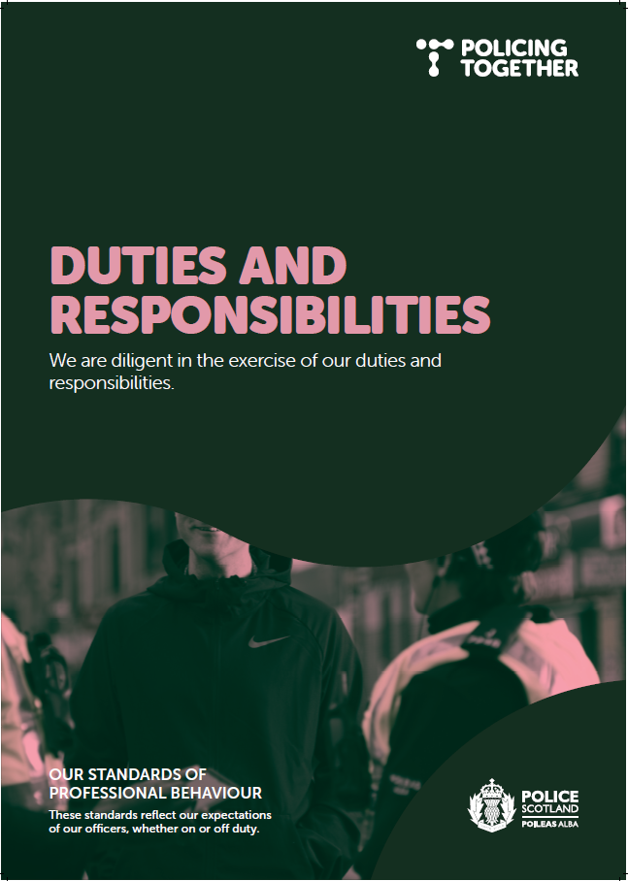

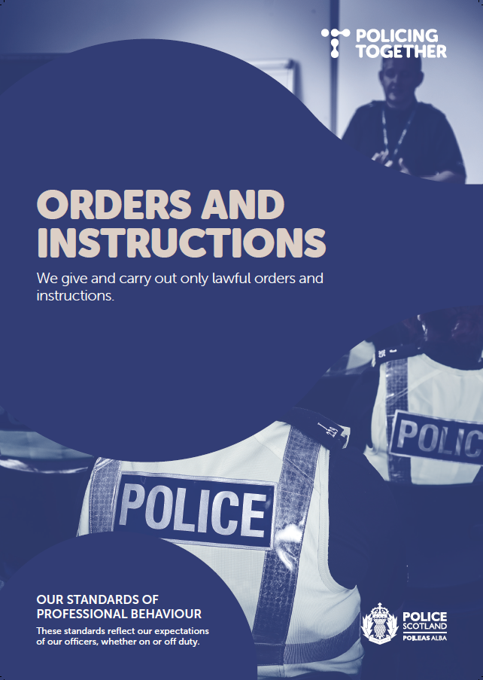

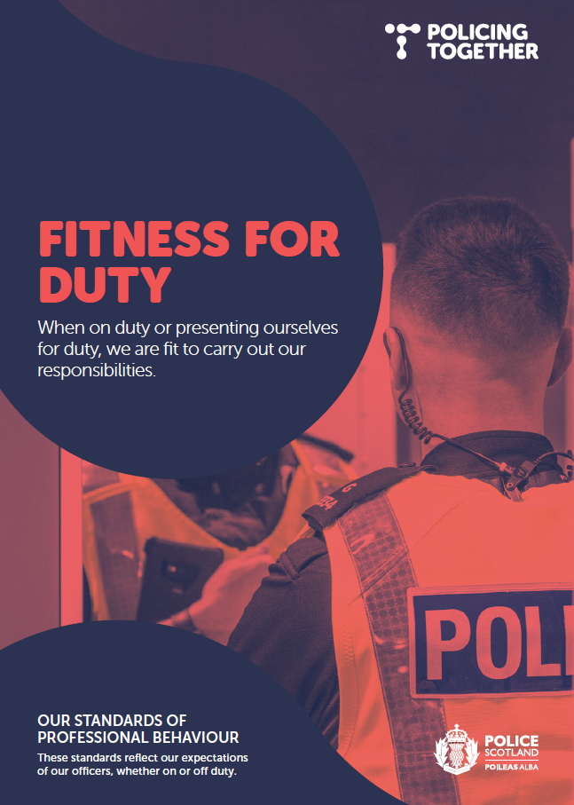

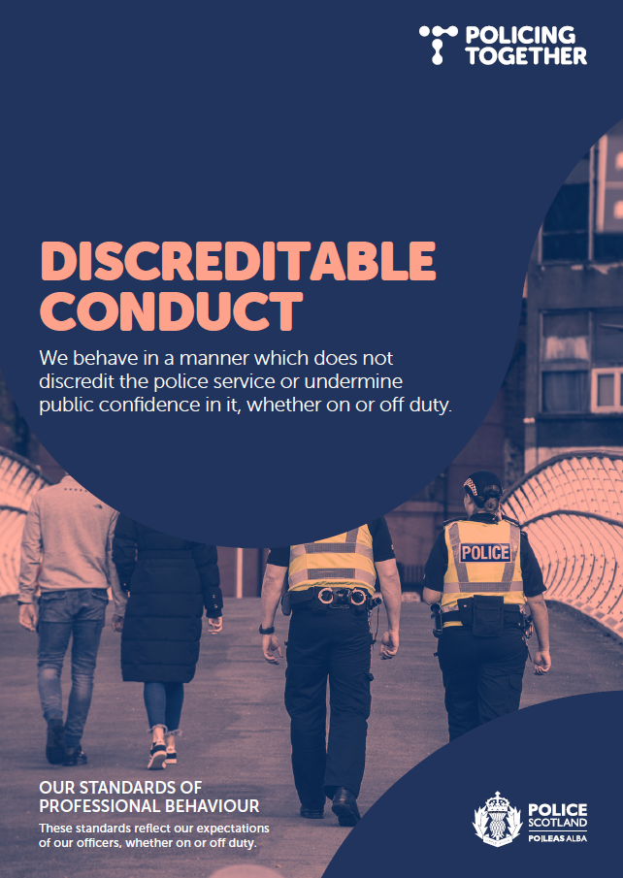
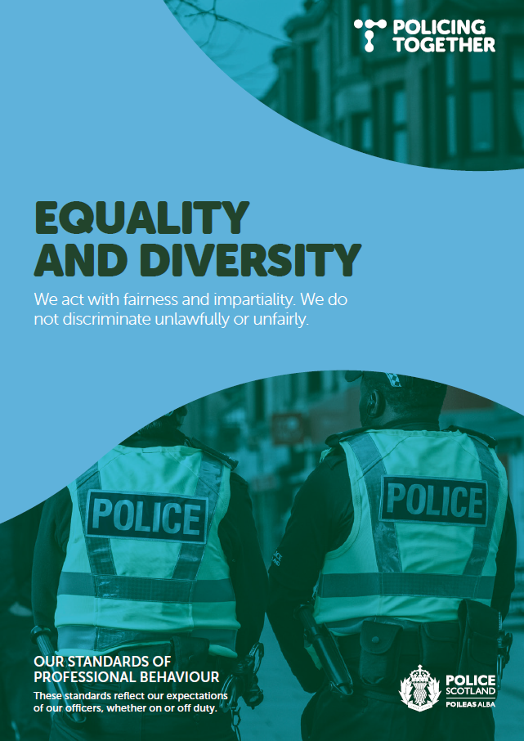

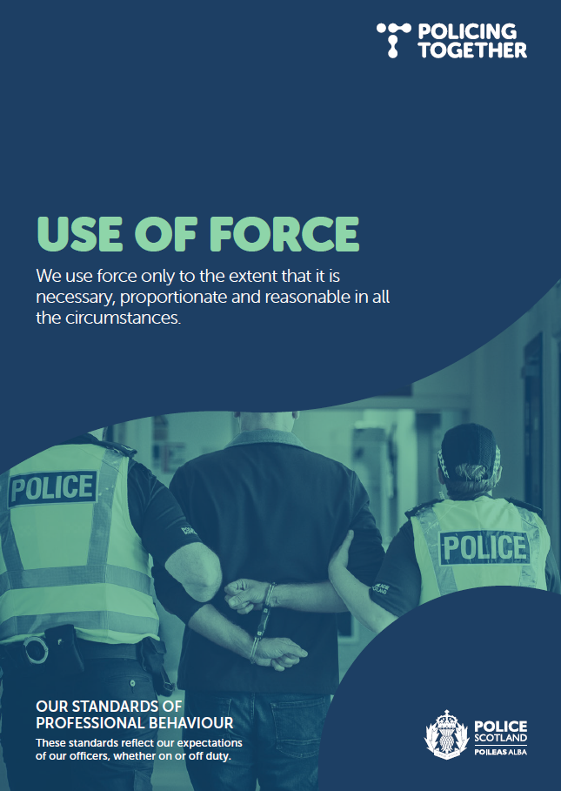

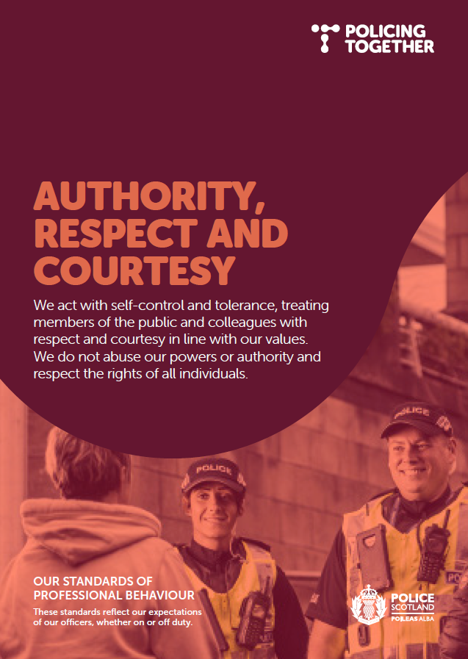
Appendix D - Line Manager Briefing Email re SETM
Findings of Police Scotland’s Sex Equality and Tackling Misogyny survey revealed
Officers and staff in Police Scotland have told the service of the impact sexism and misogyny has on individuals, teams and the organisation overall.
As part of the Policing Together initiative to drive improvements in policing in Scotland and ensure that we reflect, represent and serve all our communities, the Sex Equality and Tackling Misogyny Working Group, led by DCC Malcolm Graham, has been researching the extent of the issue and findings are now available.
The survey and ideas platform were the first step in developing an action plan to tackle sexism and misogyny and part of an ongoing programme to improve equality, diversity and inclusion.
Visit the intranet news page to learn more about your role in creating a positive working environment and to watch a video update from DCC Graham.

Appendix E - Intranet Article re SETM
Findings of Police Scotland’s Sex Equality and Tackling Misogyny survey revealed
20/03/2023
Officers and staff in Police Scotland have told the service of many shocking examples of sexism and misogyny and detailed the impact on individuals, teams and the organisation overall.
The internal survey found that 86% of women who responded had either been subjected to and/or witnessed sexism and misogyny.
As part of the Policing Together initiative to drive improvements in policing in Scotland and ensure that we reflect, represent and serve all our communities, the Sex Equality and Tackling Misogyny Working Group, led by DCC Malcolm Graham, has been researching the extent of the issue.
The working group has been using an evidence-led approach to discover how best to tackle sexism and misogyny.
Colleagues were invited to share their experience of sexism and misogyny at work through an anonymous online survey and submit suggestions on how to create a more welcoming and inclusive working environment.
Interviews and engagement sessions with colleagues also helped to build a better picture of the nature of challenging experiences and how those in a position to make a difference responded.
What issues did colleagues raise?
More than 500 people responded to the survey or shared ideas for change, with 150 opting to be involved in further focus groups and/or interviews.
This engagement is a strong, positive starting point in what will be an ongoing dialogue as we all work together to achieve long overdue and long term cultural change.
It also reflects that around half of the people who responded agreed the organisation was tackling the issue.
Below is a summary of issues that officers and staff raised:
• Sexism and misogyny impacts colleagues in all areas of Police Scotland.
  - Officers and staff highlighted examples of inappropriate behaviour, language, discrimination and unfair treatment, where colleagues have felt unsupported and unable to raise issues.
  - Female colleagues have shared experiences of sexual misconduct spanning over a number of years and of not having the confidence to report incidents.
  - Genuine concerns and clear instances of discrimination have on occasion been ignored or dismissed as 'banter' with those speaking out wrongfully being accused of not being able to take a joke.
  - Female colleagues have told of being treated differently to male counterparts and their knowledge and experience being discounted.
  - Male colleagues highlighted that they recognised inappropriate behaviour but don't always feel empowered to call it out, especially when it comes from senior officers.
  - Male colleagues have expressed how senior female management and officers have exhibited inappropriate behaviour towards them but felt it went unchecked because they were female.
  - Leaders, supervisors and senior managers have a key role to play in supporting colleagues and challenging sexist and misogynistic behaviours.
  - When it comes to recruitment, those with unacceptable attitudes towards women need to be rooted out from the start.
  - Better mechanisms and safe spaces for reporting discrimination and sexist behaviour can empower people to report without fear of detriment or victimisation.

Survey results
Of those who responded to the survey:
- 71% were officers.
- Two-thirds were women.
- Most who offered ideas or opinions had more than 15 years' service.
- 81% agree it is an issue.
- 86% of women had either been subjected to and/or witnessed sexism and misogyny.
- More than 40% of men have witnessed sexism and misogyny.
- Around 50% agree the organisation is tackling it.

What happens next?
The survey and ideas platform were the first step in developing an action plan to tackle sexism and misogyny and will help to provide a benchmark to measure progress.
This engagement with officers and staff is just one part of an ongoing programme to improve equality, diversity and inclusion in the service and to better represent communities across Scotland.
Understanding the impact of sexism and misogyny from those with lived experience is crucial in order to develop and implement strategic plans that support colleagues and encourage a positive working environment.
The Sex Equality and Tackling Misogyny Oversight Board will continue to meet regularly to agree plans and oversee progress and a Delivery Group, chaired by ACC Emma Bond, will drive forward a range of key change activities that respond to insights.
Change activities will include empowering leaders across the service to embed good practice, ensuring reports are dealt with promptly and in a supportive manner, and the capturing of data and feedback to improve outcomes and to communicate progress to officers and staff.
Although there is clearly lots to be done, colleagues also fed back that this work is a positive step and the organisation is learning from past mistakes and putting effort into change, which helps to improve colleague confidence in the organisation.
On Thursday, 23 March, our strategy to tackle violence against women and girls will be discussed at a Scottish Police Authority board meeting.
Our Violence against Women and Girls (VAWG) strategy recognises the work that needs to be done internally and outlines the actions we will take as a service to improve inclusion, which includes a zero-tolerance approach to sexism and misogyny.
We will also use every tool at our disposal to ensure that the wrong individuals are prevented from joining the police and, where appropriate, removed from the organisation.
In the coming months, ACC Bex Smith will be travelling across Scotland to hold further engagement sessions and focus groups within all divisions and will be keen to hear your ideas for improvement.
DCC Graham said: “There are no quick fixes or wins when it comes to sex equality and tackling misogyny, however the organisation is committed to eradicating discrimination.
“Anyone who does not share our values of integrity, fairness, respect and a commitment to upholding human rights is not welcome in policing in Scotland."
Learn about our new Violence against Women and Girls Strategy
[DCC Graham video]
Useful information
Learn more about more about how policing in Scotland reflects, represents and serves our communities under the Policing Together initiative led by Deputy Chief Constable Fiona Taylor.
Visit the Policing Together mini site

Have you completed your EDI training? Time is running out to complete the mandatory module.
This EDI training module is one of the key pillars of our Policing Together values campaign which seeks to address racism, misogyny and all forms of discrimination within policing in Scotland.

