Freedom of Information Response
Our reference: FOI 23-2829
Responded to: 17 November 2023
Your recent request for information is replicated below, together with our response.
Which respective areas of the island of Islay do Beat 39 Beat 40 Beat 41 cover.
In response, please find the following:
LB39:
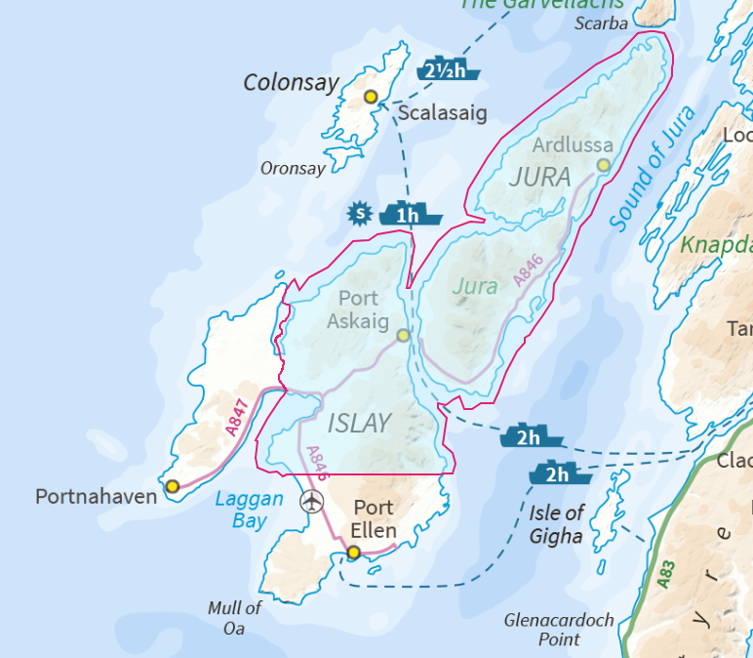

LB40:
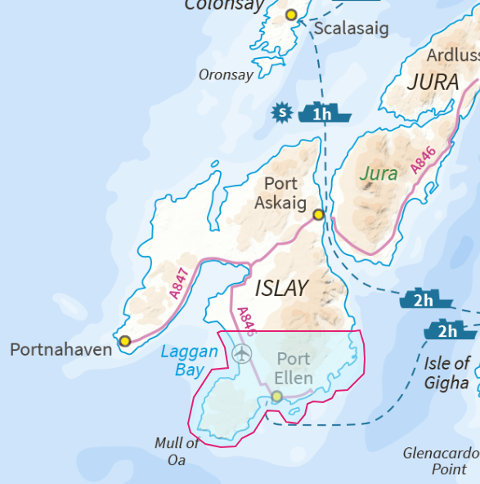
LB41:
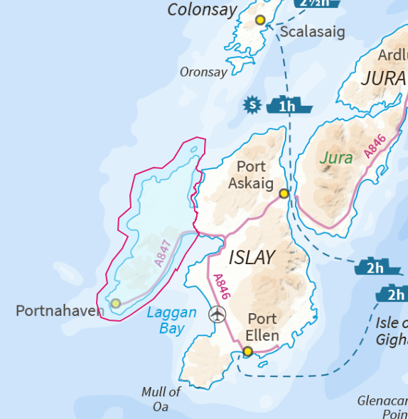
If you require any further assistance please contact us quoting the reference above.
You can request a review of this response within the next 40 working days by email or by letter (Information Management - FOI, Police Scotland, Clyde Gateway, 2 French Street, Dalmarnock, G40 4EH). Requests must include the reason for your dissatisfaction.
If you remain dissatisfied following our review response, you can appeal to the Office of the Scottish Information Commissioner (OSIC) within 6 months - online, by email or by letter (OSIC, Kinburn Castle, Doubledykes Road, St Andrews, KY16 9DS).
Following an OSIC appeal, you can appeal to the Court of Session on a point of law only.
This response will be added to our Disclosure Log in seven days' time.
Every effort has been taken to ensure our response is as accessible as possible. If you require this response to be provided in an alternative format, please let us know.

