| Police Scotland logo | Freedom of Information Response Our reference: FOI 24-1751  Responded to: 01 August 2024 |
| --- | --- |

Your recent request for information is replicated below, together with our response.

Tackling domestic abuse is a priority for Police Scotland and we are committed to working with our partners to reduce the harm it causes and ultimately eradicate it.

Domestic abuse is a despicable and debilitating crime which affects all of our communities and has no respect for ability, age, ethnicity, gender, race, religion or sexual orientation.

Police Scotland will not tolerate it.

Police Scotland will proactively target perpetrators and support victims to prevent domestic abuse from damaging the lives of victims and their families.

Police Scotland defines domestic abuse as:

“Any form of physical, verbal, sexual, psychological or financial abuse which might amount to criminal conduct and which takes place within the context of a relationship. The relationship will be between partners (married, cohabiting, civil partnership or otherwise) or ex-partners. The abuse may be committed in the home or elsewhere including online”.

Please note that the definition of Domestic abuse in Scotland differs from the definition of Domestic Violence in England and Wales which includes wider familial abuse e.g. from parents or children etc.

**1) Please provide a list of domestic abuse incidents recorded by Easterhouse Police Station (1 Bogbain Road, Glasgow, G34 9LW) between January 2021 and June 2024. Please provide data for each year separately.**

**2) Please provide the statistics in percentage: Who were the victims? What was the gender of the victims and suspected perpetrators? Where did the incidents occur? When did the incidents occur?**

It is not clear from your request whether you are seeking data regarding the incidence of Domestic Abuse in the Easterhouse area - or data regarding incidents reported in person at the police station specifically.

In terms of data for the Easterhouse area, whilst it may be a commonly used term for a suburb of Glasgow, it does not align to any of our policing areas specifically.

In terms of section 17 of the Act therefore, data for Easterhouse specifically is not held by Police Scotland.

Crime data more generally for the North East Ward area of Glasgow city (see map below) is available online: [Crime data - Police Scotland](https://www.scotland.police.uk/about-us/how-we-do-it/crime-data/)

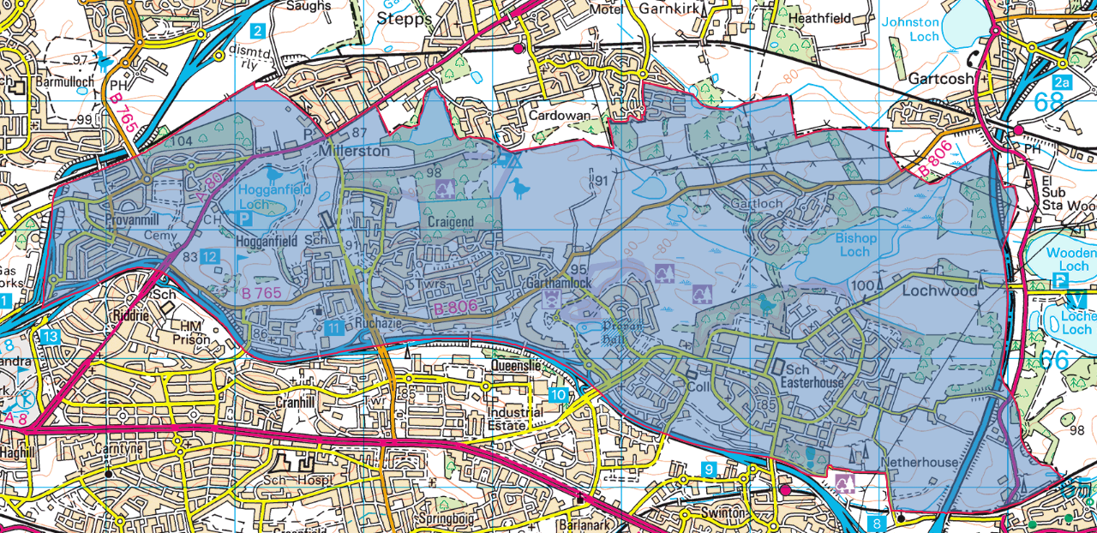

Alternatively, you could provide a list of streets/ postcodes which you would equate with Easterhouse, and we could search on that basis - but I must stress that data below the level of Local Authority Ward may engage personal data considerations.

Additionally, Domestic Abuse statistics are published annually:

[Domestic abuse: statistics recorded by the police in Scotland, 2022-23 - gov.scot (www.gov.scot)](https://www.gov.scot/publications/domestic-abuse-statistics-recorded-police-scotland-2022-23/pages/4/)

The data is broken down by local authority area to provide a broad and comprehensive overview. Easterhouse will be included within Glasow city. This approach aids in understanding regional trends and patterns without delving into specifics that could compromise individual privacy.

In terms of any incidents reported at the police station specifically, unfortunately, I estimate that it would cost well in excess of the current FOI cost threshold of £600 to process your request.

I am therefore refusing to provide the information sought in terms of section 12(1) - Excessive Cost of Compliance.

To explain, we have no means by which such incidents could be automatically identified on our systems.

As you will be aware, most incidents reported to the police are generated by 101 or 999 call or email.

If you require any further assistance, please contact us quoting the reference above.

You can request a review of this response within the next 40 working days by [email](mailto:foi@scotland.police.uk) or by letter (Information Management - FOI, Police Scotland, Clyde Gateway, 2 French Street, Dalmarnock, G40 4EH). Requests must include the reason for your dissatisfaction.

If you remain dissatisfied following our review response, you can appeal to the Office of the Scottish Information Commissioner (OSIC) within 6 months - [online](http://www.itspublicknowledge.info/Appeal), by [email](mailto:enquiries@itspublicknowledge.info) or by letter (OSIC, Kinburn Castle, Doubledykes Road, St Andrews, KY16 9DS).

Following an OSIC appeal, you can appeal to the Court of Session on a point of law only.

This response will be added to our [Disclosure Log](http://www.scotland.police.uk/access-to-information/freedom-of-information/disclosure-log) in seven days' time.

Every effort has been taken to ensure our response is as accessible as possible. If you require this response to be provided in an alternative format, please let us know.