Police Scotland Quarter 3 YTD Performance Report: April to December 2024
Contents
Deputy Chief Constable Foreword 2
Introduction 3
Performance Focus: Rape 4
Key Insight: Road Fatalities 7
Vision 2030: Less Crime 9
Vision 2030: Safer Communities 22
Vision 2030: Supported Victims 37
Vision 2030: Thriving Workforce 40
Appendix 50

This is the 2024/25 Quarter 3 performance report covering the period 01 April to 31 December 2024. All data is correct at the published date and was extracted at the start of February 2025. The data is extracted from Police Scotland internal systems which are dynamic and continuously updated as investigations progress.
This report contains the most up to date recorded crime data that was available at the start of February 2025 for Quarter 3 of the reporting year 2024/25. Due to technical issues, now resolved, and the roll-out of a new enhanced data replication solution for analytics, the data run for this report had to be delayed from the usual extraction date of the start of January 2025. Further detailed Police Scotland Management Information can be found here: https://www.scotland.police.uk/about-us/what-we-do/how-we-are-performing/

Deputy Chief Constable Foreword
Police Scotland continues to respond to the needs and vulnerabilities of our communities, as illustrated in the 2024/25 Quarter 3 Performance Report.
Our regular performance reports provide valuable insights into the increasingly complex nature of policing and the scope of work our dedicated officers and staff deal with and how it supports our strategic outcomes.
This report looks closely at the issue of rape – with levels continuing to increase and accounting for 20% of all sexual crimes – and a focus on road casualties shows that the number of fatalities across Scotland has increased.
Most people feel Police Scotland upholds its core values of integrity, fairness, respect and a commitment to upholding human rights. While there was a small decrease in public confidence during Quarter 3, overall, the majority remain satisfied or very satisfied with their experience.
Levels of violent crime and non-sexual crimes of violence have decreased with murders, attempted murder and serious assaults remaining at historically low levels and with the leading detection rate for all homicides continuing, underlining that Scotland remains a safe country to live and work.
The number of domestic abuse crimes has increased. However, during the reporting period there was a significant increase in the number of Disclosure Scheme for Domestic Abuse Scotland, Power To Tell and Right To Ask applications. This underlines an increased confidence from the public in our approach to tackling domestic abuse.
Insight shows that the number of missing persons investigations has decreased significantly – particularly involving children and care experienced young people. The number of younger children being brought into custody has seen a decrease and the number of older children in custody for over 24 hours has dropped significantly.
The report also highlights continued activity taken by officers to disrupt the activities of serious organised criminals - including pro-active operations to safeguard young people who are exploited by drugs dealers, during the national County Lines intensification week and the results of Operation Silhouette, which saw 36 arrests and the seizure of £6 million of illegal drugs.


DCC Alan Speirs KPM
Deputy Chief Constable Professionalism, Strategy and Engagement

Introduction
This is the third Quarterly report of the 2024/25 performance cycle, reporting on our Performance and Accountability Framework.
Our outcomes focused Performance Framework is linked to our strategic planning processes and aligns to the Strategic Outcomes as detailed in the Annual Police Plan 2024/25, these being:
Strategic Outcome 1: Public Safety and Wellbeing – threats to public safety and wellbeing are resolved by a proactive and responsive police service
Strategic Outcome 2: Needs of Local Communities – the needs of local communities are addressed through effective service delivery
Strategic Outcome 3: Confidence in Policing – the public, communities and partners are engaged, involved and have confidence in policing
Strategic Outcome 4: Working Environment – our people are supported through a positive working environment, enabling them to serve the public
Strategic Outcome 5: Sustainable and Adaptable Service – Police Scotland is sustainable, adaptable and prepared for future challenges
The Police Scotland 2030 Vision provides the service with a clear, aspirational direction of travel to shape the development of Police Scotland. Our 2030 Vision is for safer communities, less crime, supported victims and a thriving workforce.
The report is structured under Less Crime, Safer Communities, Supported Victims and Thriving Workforce as per the Chief Constable’s Vision 2030 report. The first section of the report provides a deep dive performance focus on rape alongside a key insight on the increase in road fatalities.
Examples of good practice/proactivity/preventative policing activity has been highlighted in the following areas:
Violence
Stealthing
Retail Crime
Cyber Choices Scotland
Promising Practices
County Lines Intensification Week
Operation SILHOUETTE (to target organised crime and drugs offences)
Road Policing Campaign Results

Performance Focus: Rape
Key Findings
Rape is at the highest level of recording and accounts for almost one fifth of all reported sexual crimes.
70% of all rapes were committed against females over the age of 16 years.
‘Recent’ rapes continue to account for the largest proportion of all rapes.
Over half of rape crimes have a domestic element recorded.
Greater Glasgow Division and The Lothians and Scottish Borders Division have the highest volume of rapes across the Force .

Background
Caveat: This section was produced with data extracted at the start of January 2025. The data below aligns with the separate paper produced by Public Protection.
Rape crimes continue to rise, and recorded figures are at the highest level since comparable figures began. Further analysis has been conducted for the period 01 April 2024 – 31 December 2024 (with comparisons to the same period in the previous years) and the detail is included below.
Rape is at the highest level of recording and accounts for almost one fifth of all reported sexual crimes
In Scotland, a total of 2,056 crimes of rape have been reported which is an increase of 286 crimes compared to the previous year. Rape accounts for almost 20% of all Group 2; Sexual Crimes.
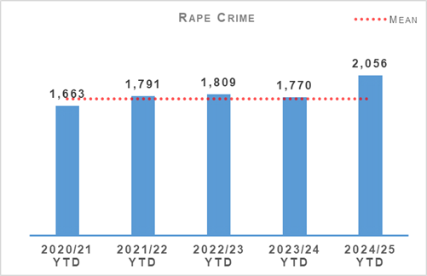
70% of rapes were committed against females over the age of 16 years
Rape of a female over 16 accounts for 70.2% of all rape and is the only classification within rape to have a year on year increase. Rape of a female over 16 has increased from 1,018 crimes in 2019/20 to 1,444 crimes in 2024/25, an increase of 41.8%.
There has been 61 crimes of rape of a male over 16 recorded in 2024/25. This is the highest volume of crimes recorded for this crime classification.
Rape of a female 13 – 15 and Rape (common law) note increases compared to the previous year, however the numbers recorded in 2024/25 is not the highest across all previous years.
‘Recent’ rapes continue to account for the largest proportion of all rapes
Recent crimes of rape are defined as being reported less than 365 days from the day the rape was committed. Non recent crimes of rape are therefore any reported 366 days or more from the day the rape was committed.
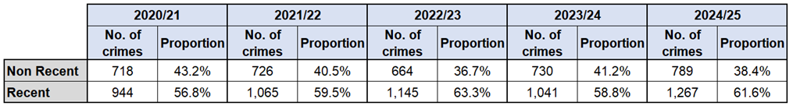
Recent rape crimes have increased by 34.2% (323 crimes) since 2020/21. Non recent crimes of rape have increased by 9.9% (71 crimes) since 2020/21. Whilst both recent and non-recent rapes have increased, it is recent rapes that is increasing at a faster rate which potentially indicates an increase in prevalence.
More than half of all rape crimes reported in Scotland have a domestic element
Out of 2,056 crimes of rape, 54.0% (1,111 crimes) have been recorded with a domestic element. However, we anticipate the number of domestic rapes to be higher due to inconsistencies in recording.
Glasgow and Clyde Rape Crisis Services report that 96% of survivors of rape and sexual assault knew the perpetrator or the perpetrator held a position of trust with them.
Greater Glasgow Division and The Lothians and Scottish Borders Division have the highest volume of rapes across the Service
Across the 13 Divisions in the Force, nine have recorded an increase in rapes compared to the previous year. Greater Glasgow (G) Division (399 crimes) and The Lothians and Scottish Borders (J) Division (241 crimes) have the highest volume of rapes across the Force and have experienced the largest increase compared to the previous year (up 41.5% and up 47.9% respectively) and the five-year mean (up 50.2% and up 44.8% respectively).
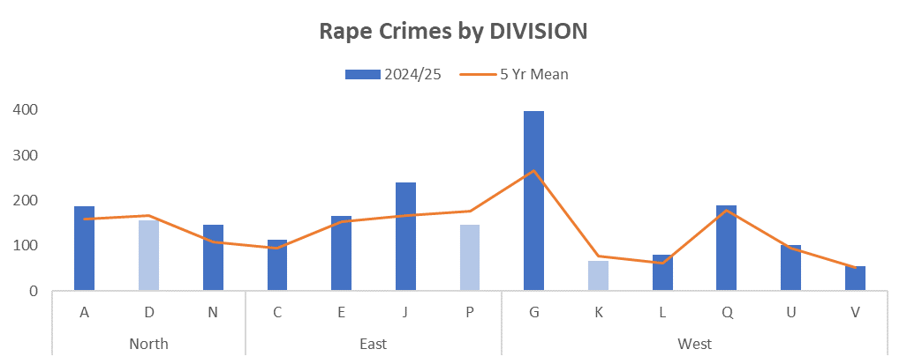
Further analysis identifies that J Division recorded an unusually high volume of rapes in the month of May 2024. This is what has driven the increase seen within J Division and since May 2024, the number of rapes recorded each month has returned to typical monthly levels.
The increase in rapes within G Division has been sustained over the period, with increases noted in every month when compared to the same month in the previous year.
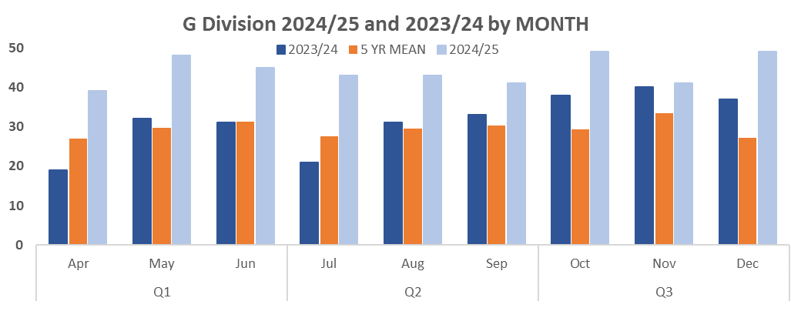
As can be seen in the chart, G Division have been consistently higher throughout 2024/25 compared to both the previous year and the five-year mean. The number of rapes reported month on month in G Division have remained relatively consistent, with an average of 44 crimes per month compared to 31 crimes per month during 2023/24.

Key Insight: Road Fatalities
At the end of Quarter 3 there was an increase of 22 (20.6%) road fatalities compared to the previous year. This was also an increase of 15 (13.2%) compared to the five-year mean. There have been increases in the number of fatalities in several months this year, most noticeably in May, June, July, September and November.
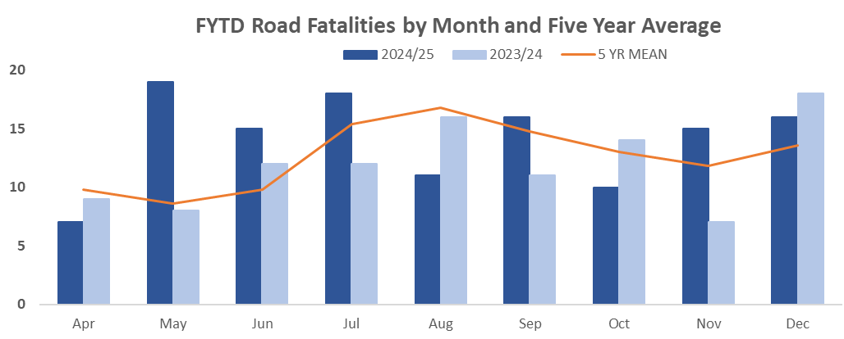
It should be noted that the 2023/24 period was the second lowest number of fatalities in the previous five years (with only 2020/21 being lower due to the reduction of vehicles on the road from COVID-19 restrictions). Whilst this accounts for some of the large increases in road fatalities, current fatalities remain the second highest number in Quarter 3 compared to the previous five years (only the 2022/23 period had more with 138 road fatalities at the end of Quarter 3).
Whilst the number of fatalities on Scotland’s roads has increased compared to the previous year, there has been a decrease in the number of child fatalities, with two children killed this year and four killed the previous year. There have also been reductions in the number of pedal cyclists killed (one in 2024/25 compared to five in 2023/24). The most significant increase in terms of casualties in the current period is passengers in motor vehicles, with 18 fatalities this year compared to two the previous year.
This increase in the number of passenger fatalities can be attributed to an increase in collisions resulting in multiple fatalities, with six being recorded to date compared to two the previous year.
There have been significant increases in the number of road fatalities in the West of Scotland, with fatalities in Renfrewshire and Inverclyde (K Division), and Lanarkshire (Q Division) the most significant. These areas have seen increases of eight fatalities each compared to the previous year.
In the North of the country, the North East (A Division) has also observed an increase of eight fatalities, whilst in the East Forth Valley (C Division) has increased by seven.
The most significant decreases have been observed in Glasgow (G Division), Tayside (D Division), and Lothian and Borders (J Division) where there have been decreases of six, five and four respectively.
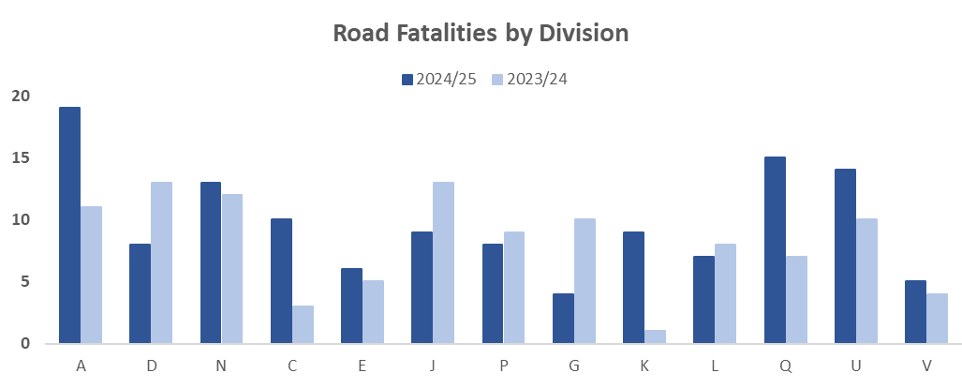
Police Scotland works in collaboration with partners such as Transport Scotland to improve road safety throughout the country and seek to prevent fatalities on our roads. Throughout the year we run campaigns designed to proactively prevent fatalities and injuries, with a strong focus on protecting vulnerable road users and/or motorists committing Fatal 5 offences (Fatal 5 offences being speeding, not wearing a seatbelt, using a mobile phone whilst driving, driving under the influence of drink and/or drugs, and careless driving). The results from these campaigns can be found in the Road Safety section of this report, as well as what upcoming campaigns and operations Police Scotland are running.

Vision 2030: Less Crime

Overall Crimes and Offences
The following table shows management information relating to Group 1-5 crimes recorded by Police Scotland at the end of Quarter 3, compared to the previous YTD and the five-year mean. The table also includes the YTD volume of detections and detection rates.
Total Group 1-5 Crimes show an increase compared to last year (up 0.4%, 942 more crimes) and against the five-year mean (up 3.5%, 7,640 more crimes). The volume of detections has also increased compared to both periods (up 4.7% and 4.6% respectively). The overall detection rate of 56.0% for Group 1-5 Crime is up 2.3 percentage points on last year and up 0.6 percentage points on the five-year mean.
Group 2, 3 and 5 crimes are all up on the same period last year whilst the rise against the five-year mean is being driven by increases in Group 1, 2 and 3 crimes.
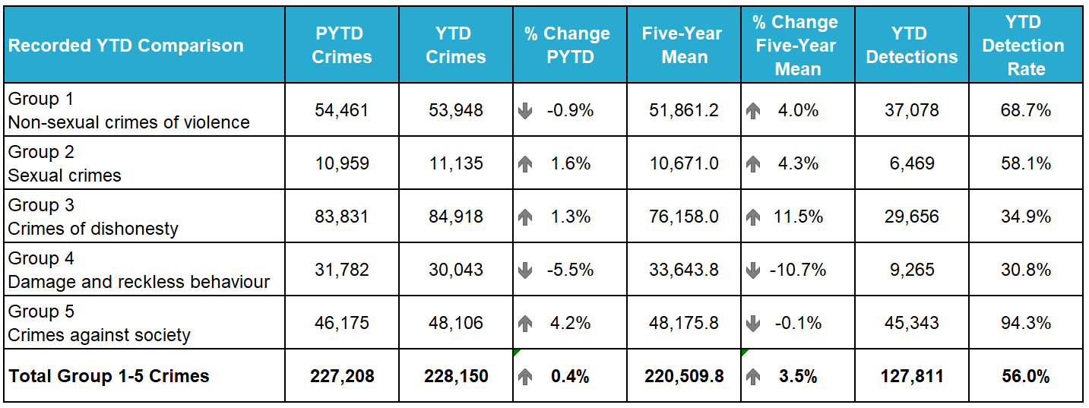
The following table shows management information relating to Group 6-8 offences, recorded by Police Scotland YTD at the end of Quarter 3, compared to the previous YTD and the five-year mean. The table also includes the YTD volume of detections and detection rates.
Total Group 6-8 offences have increased compared to last year (up 2.8%, 3,615 more offences) but decreased against the five-year mean (down 3.5%, 4,799 fewer offences). The volume of detections has followed a similar trend (up 2.9% on last year but down 5.8% on five-year mean). The overall detection rate of 83.3% for Group 6-8 offences is slightly up 0.1 percentage points on last year but down 1.9 percentage points on the five-year mean.
All three groups are up on the same period last year with Group 7 the only group to record an increase against the five-year mean.
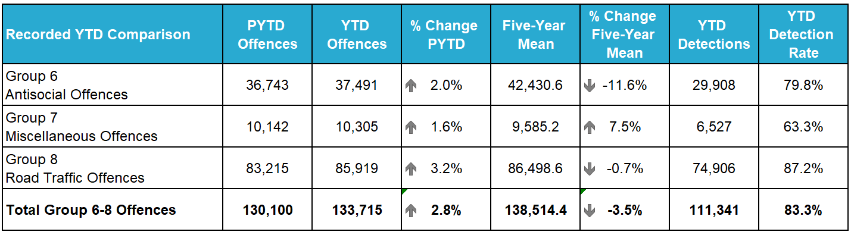

Benchmarking Overall Total of Reported Crimes
Police Services in England and Wales utilise the ‘Principle Crime Rule’ for recording, that if an incident involves multiple crimes, only the most serious one is recorded. Whereas Police Scotland record all crimes at the incident.
The most recent crime statistics (at time of writing) for England and Wales covering the 2024/25 period (April 2024 to June 2024), indicated a 0.5% increase in reported crimes. In contrast, when benchmarked to Police Scotland's data for the same period, reported crimes increased by 4.2% compared to the previous year.
Please note that a guide published by the Office of National Statistics (ONS) on comparability suggests excluding Fraud from both datasets when benchmarking. Fraud in England and Wales is not always recorded by the Police and is recorded by other agencies (e.g. Action Fraud, CIFAS, UK Finance). Therefore, between April 2024 to June 2024 after excluding Fraud, recorded crime in England and Wales decreased by 2.3%, while Police Scotland recorded an increase of 4.4% for the same time period.

Violent Crime (Strategic Outcome 1)
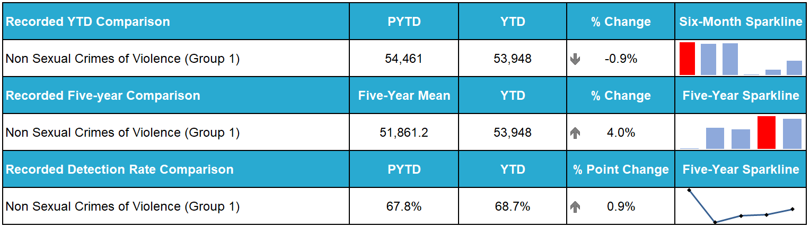
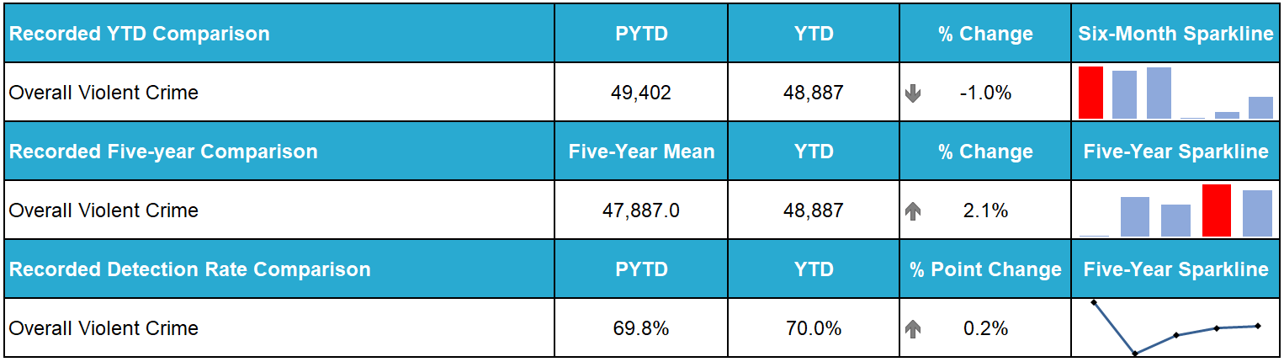
Overall violent crime, and non-sexual crimes of violence, saw slight decreases when compared to the same period last year, whilst also seeing a small increase on the five-year-mean. For both, this is largely driven by common assault figures which make up the majority of both totals. In particular, the decreased levels of common assaults during the COVID-19 pandemic led to a skewing of the five-year-mean which is the primary driver in this year’s figures being above that average.
Serious violent crimes such as Homicide, attempted murder and serious assault are all at their lowest levels for this period in recent years. There have been 34 homicides (30 murders and four crimes of culpable homicide (common law) during the April to December 2024 period.
Proactive/Preventative Policing – Violence Control Strategy
Police Scotland is developing a Violence Control Strategy anchored in the 4 P’s framework of Pursue, Prevent, Prepare and Protect. The strategy is being finalised for dissemination to local policing divisions with anticipated delivery during Quarter 4.
The Scottish Violence Reduction Unit (SVRU) has played a significant role in supporting the strategy, delivering a range of impactful projects aimed at reducing violence and addressing its root causes. These include:
- Supporting a Youth Navigator who will be embedded in Castlebrae High School, Niddrie, and serve the Niddrie and Craigmillar areas.
- Supporting Levenmouth Academy’s partnership with the Community Trade Hub (CTH). CTH helps youths (aged 13-24) overcome barriers to employment through practical training and life skills.
- In partnership with the Simon Community Scotland, SVRU is co-designing a toolkit incorporating Relationship-Based Practice and Contextual Safeguarding. Training modules, created with input from lived-experience individuals, will address trauma recovery for homeless groups, including women engaged in sex work.
- Supporting additional projects underway in Forth Valley, Greater Glasgow, Edinburgh, The Lothians and Scottish Borders, Tayside and Lanarkshire Divisions.

Case Study: Forth Valley Division Knife Crime Initiative
In February 2024, Forth Valley Division reported a 31% rise in offensive weapon-related crimes compared to the same period in the previous year. A Short Life Working Group was established to review analytical data and identify key patterns including:
- Hotspot Locations: Specific areas where incidents were concentrated.
- Weapon Types and Perpetrator Profiles: Analysis of offensive weapons used and perpetrator demographics.
- Incident Context: Detailed examination of repeat perpetrators and exact crime locations such as domestic or outdoor areas.
Implementation and Results
A three month initiative ran from September to December 2024, coinciding with key seasonal periods. Key measures included:
- Proactive Patrols: Officers deployed to disruption-focussed operations in identified high-risk areas.
- Community Education: Workshops delivered to educate communities about the consequences of knife crime.
- Enforcement Actions: Direct tasking of officers to address offenders.
Results
- 124 Charges were made involving 159 offences, with 44 cases still under investigation.
- Weekly incidents involving offensive weapons decreased from 16 to 12.
- Enhanced data driven policing, integrating perpetrator profiles and hot spot mapping.
- The initiative highlighted the value of a public health approach to crime reduction, utilising School-based officers with partner agencies including COPFS and colleagues in CJSD. Sentencing and disposal charges served as effective deterrents.
- The combination of data-driven policing, community engagement and targeted interventions underpins the success of violence reduction strategies. Moving forward, Police Scotland will continue to monitor trends and adapt these frameworks to address violence effectively.

Public Protection (Strategic Outcome 1)
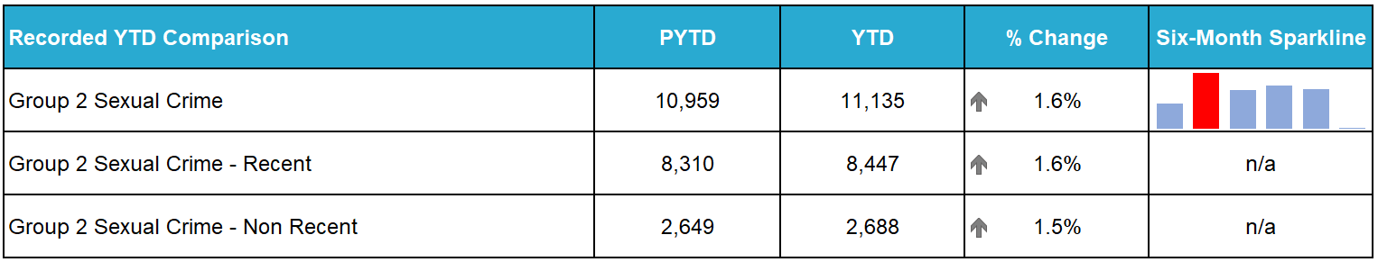
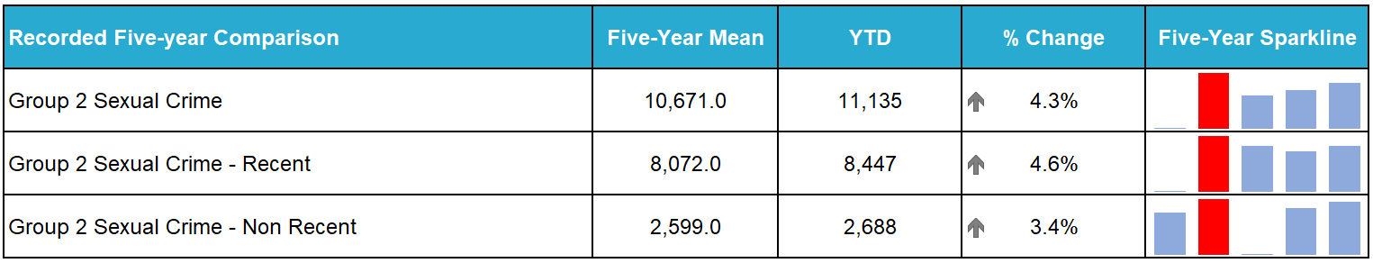
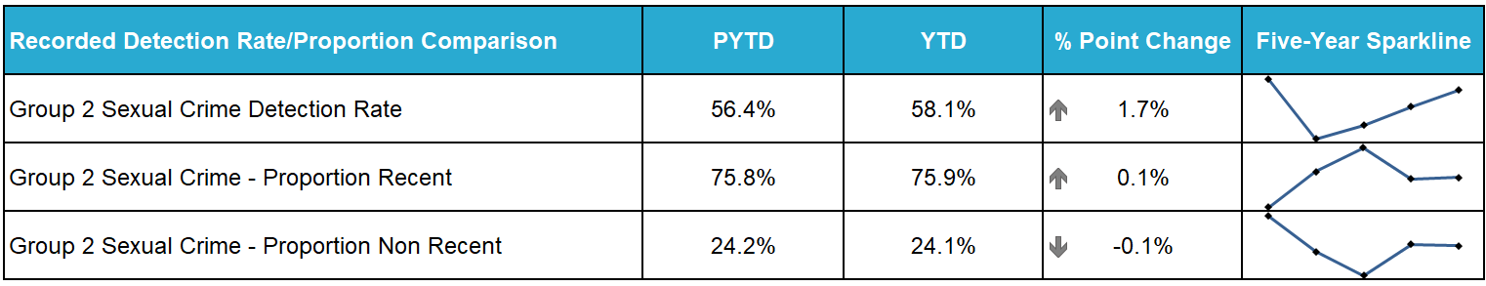
Sexual crime increased when compared to last year, up 1.6%, (176 more crimes) and against the five-year mean (up 4.3%, 464 more crimes).
The detection rate of overall sexual crime is 58.1%, an increase of 1.7 percentage points against last year.
Non-recent sexual crime accounts for 24.1% of overall group 2 and recent sexual crime accounts for 75.9%.

Rape (Strategic Outcome 1)

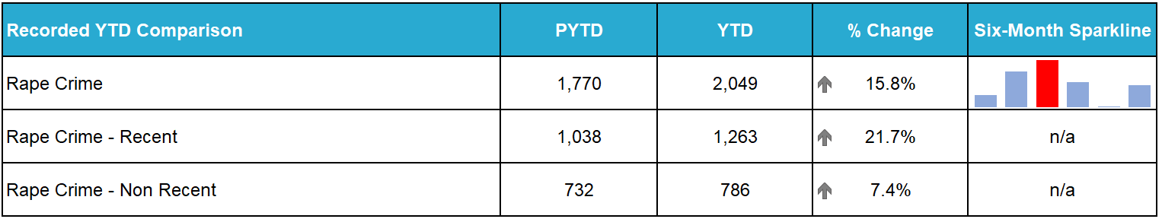
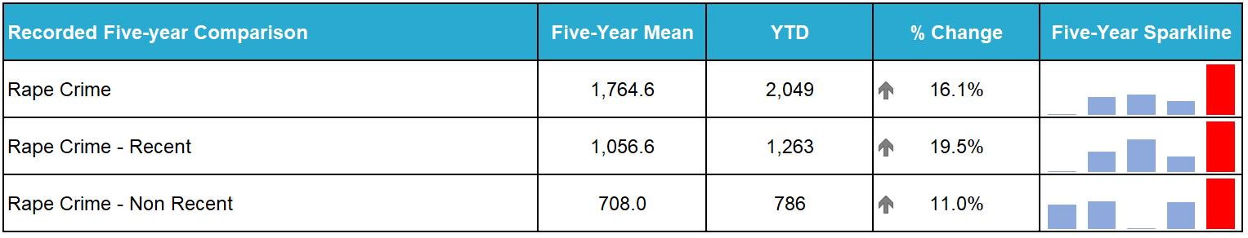
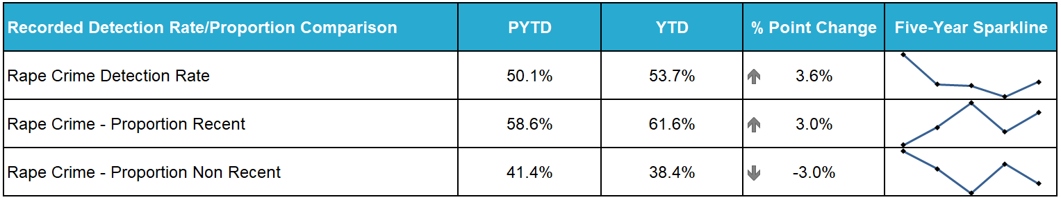
Recorded rape is at the highest level over the six year period and accounts for almost one fifth of overall sexual crime. Crimes of rape increased when compared to last year, up 15.8% (279 more crimes) and against the five-year mean, up 16.1% (284 more crimes).
Rape of a Female over 16 continues to drive the increase in rape, accounting for over 70% of all rapes.
Greater Glasgow and The Lothians and Scottish Borders Divisions continue to note the highest volume of rapes in the same period in any other year and continue to have the greatest increase compared to any other division across the Service.
Positive Outcomes – Landmark Trial in Scotland - Stealthing
Stealthing is a rape crime defined as not using a protective condom without a partner’s knowledge or consent.
In December 2024, a man was convicted of seven rapes and several other sexual offences against several women. This was a 12-year campaign of offending, targeting nine female victims. One of the rape charges involved behaviour known as stealthing and was the first conviction of its kind in Scotland. The male was given a 21-year extended sentence with 16 years in custody and his name has been added to the sex offenders register indefinitely. Non-harassment orders were also granted, banning the male from contacting or attempting to contact the victims.
Scotland’s Procurator Fiscal for High Court Sexual Offending noted the prosecution of this case. This demonstrates the Crown Office and Procurator Fiscal Services commitment to continued development in the way sexual offences are prosecuted, using every tool at our disposal to secure justice for victims.

Child Sexual Abuse Online (Strategic Outcome 1)
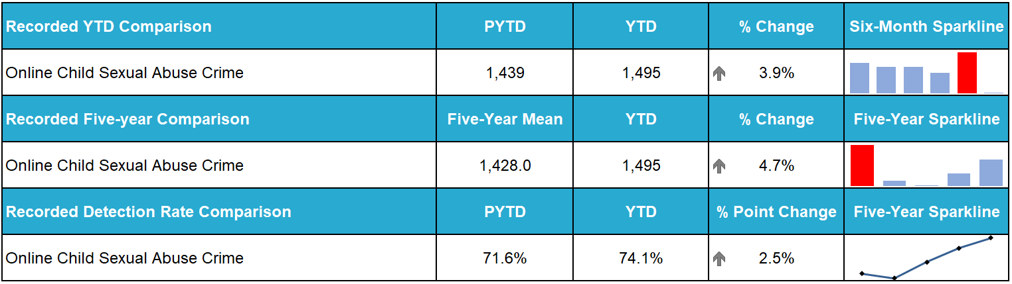
Online child sexual abuse crimes increased compared to the same period last year (up 3.9%, 56 crimes) and against the five-year mean (up 4.7%, 67 crimes).
Overall, the detection rate for online child sexual abuse is 74.1%, an increase compared to last year (71.6%) and an increase compared to the five-year mean (67.5%).
Grooming of children for the purposes of sexual offences decreased by nine crimes compared to last year and by 22 crimes against the five-year mean. Crimes of communicating indecently with a child under 13 are down 25.8% (61 crimes) compared to last year and down (69 crimes, 28.2%) against the five-year mean.

Domestic Abuse (Strategic Outcome 1)
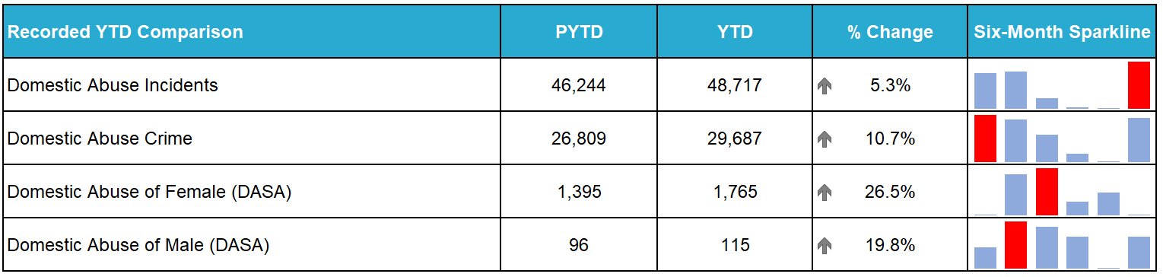
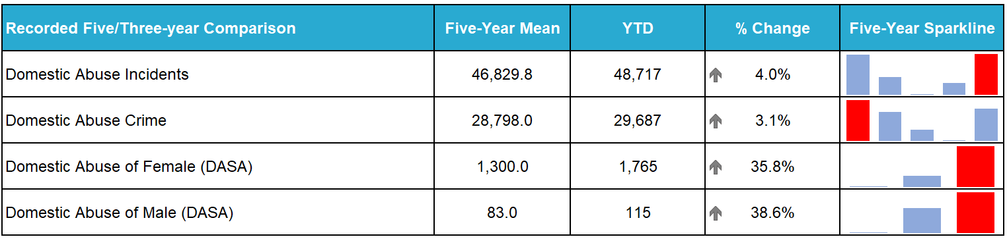
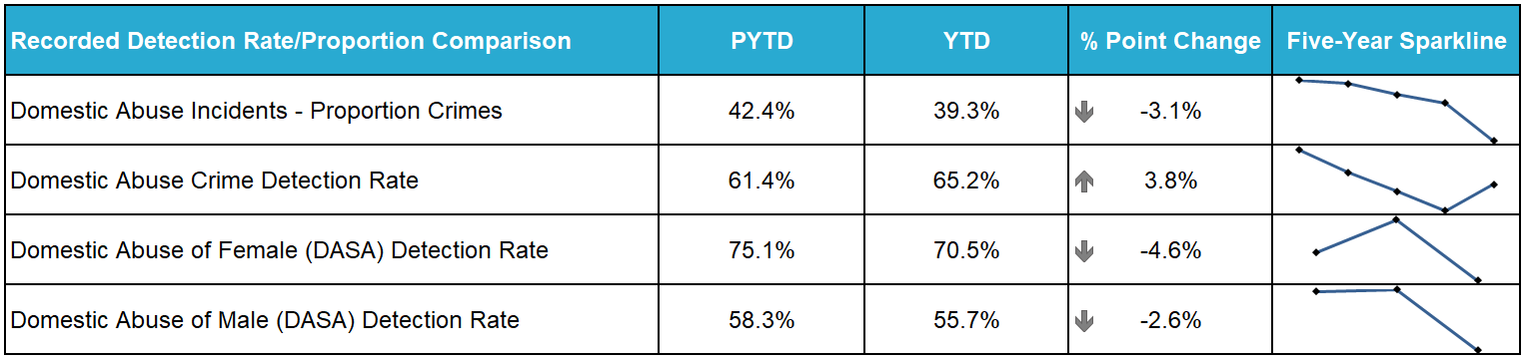
Police Scotland has moved to a new single national crime recording system (National Unifi), which is capable of recording domestic related crimes. Previously, due to limitations in legacy crime recording systems, domestic crime was recorded and counted in the Vulnerable Person Database. From 01 April 2024, all crime data (including domestic abuse) now comes from the same system. Please refer to the Quarter 1 SPA Performance Report for an example of the differences in methodology.
Domestic abuse crimes have increased by 10.7% (2,878 crimes) compared to last year and 3.1% against the five-year mean (889 crimes), Domestic incidents also noted an increase, up 5.3% (2,473 incidents) against last year and up 4.0% (1,887 incidents) against the five-year mean.
Overall DASA crimes increased by 26.1% (389 crimes) with DASA of a female increasing by 370 crimes and DASA of a male increasing by 19 crimes compared to last year.
Four domestic homicides were recorded during the reporting period, two of which were committed in Quarter 1 and two were committed in Quarter 3.

Disclosure Scheme for Domestic Abuse Scotland (DSDAS)
During the period 1 April 2024 to 13 January 2025, 5,522 DSDAS applications were submitted to Police Scotland, an increase of 30.4% overall. Power to Tell (PTT) applications increased by 18.2% (546 applications) and Right to Ask (RTA) applications increased by 59.9% (741 applications) compared to the same period last year. Although the greatest volume of applications have come through the PTT pathway, it should be observed that RTA applications have noted greater numerical and percentage increases which suggests greater awareness of the process and/or confidence in our approach to domestic abuse.

Hate Crime (Strategic Outcome 2)
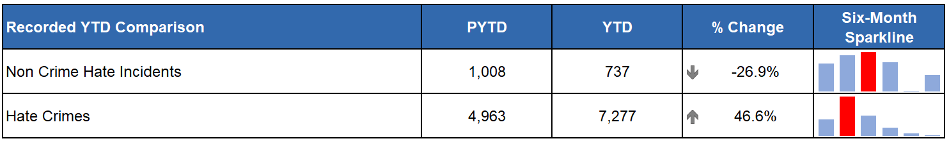
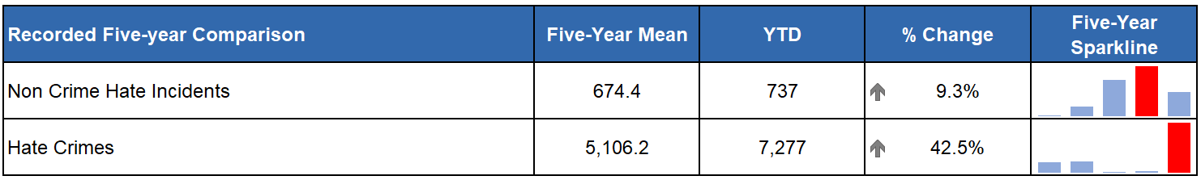
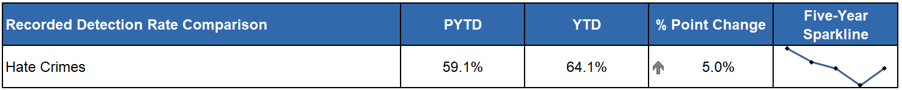
Please note due to changes in legislation introduced on 01 April 2024, direct comparisons to previous years should not be made and are for illustrative purposes only.
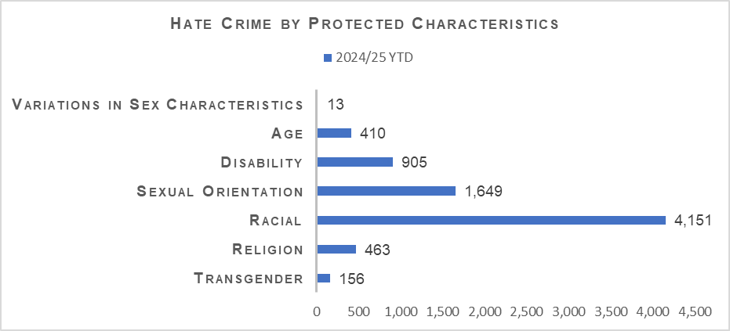
Hate crimes have reduced steadily over the past six months from a monthly high of 939 crimes in August to a low in December of 683 crimes. This peaked in August due to community tensions relating to Operation Navette (UK Disorder) and again in October 2024 due to community tensions relating to the anniversary of Operation Tarlac (Israel/Palestine conflict).
Hate crimes continue to be predominantly aggravated by racial or sexual orientation, amounting to 56.3% and 21.3% of total aggravators across the reporting period.
The majority of hate crimes related to threatening or abusive behaviour (3,224), followed by hate aggravated conduct (1,502), Common Assault (928), Community and public order offences (679), Vandalism (incl. reckless damage) (284) and Common Assault (of an emergency worker) (115).
Despite the significant increase in recorded hate crimes this year the detection rate has also increased (Up 5.0% from PYTD to 64.1%).
Following the legislation changes, age and variations in sex characteristics were added as new hate aggravator markers in April 2024 and as such we don’t yet have a baseline.

Anti-social Behaviour and Disorder (Strategic Outcome 2)
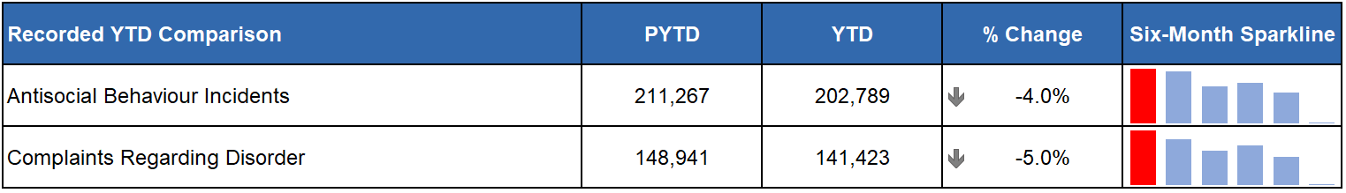
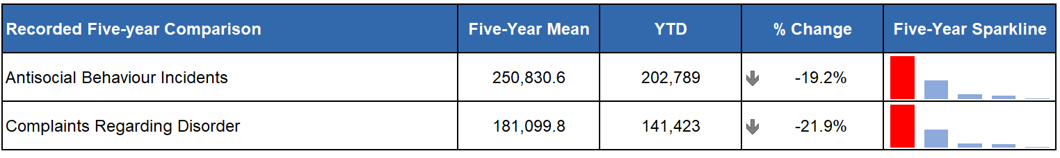
Incidents of anti-social behaviour (ASB) include disturbance, public nuisance, communications, noise, damage, neighbour disputes and drinking in public incidents. All ASB incident types decreased compared to last year except for communications incidents (which increased by 3.1% and account for 15.8% of ASB incidents) and drinking in public incidents (which rose by 1.4% and account for 0.1% of ASB incidents). Communications incidents relate to if a member of the public reports concerns over a grossly offensive, threatening or menacing communication they have received by phone, letter, e-mail, text message, social network post or face-to-face confrontation that is no longer ongoing.
Over half of all ASB takes the form of disturbances (30.7%) and public nuisance (21.8%) both of which have decreased from last year and are below their five-year-means.
Of the 31,653 anti-social offences recorded during the period, 24,908 (78.7%) were for threatening or abusive behaviour. Anti-social offences have increased by 8.9% from last year with this increase mostly driven by higher levels of breach of the peace, hate aggravated conduct, drunk & incapable, consuming alcohol in designated places, other alcohol related offences and urinating in public. Longer term, however, there has been a 9.8% decrease in anti-social offences being recorded.

Crimes of Dishonesty (Strategic Outcome 2)
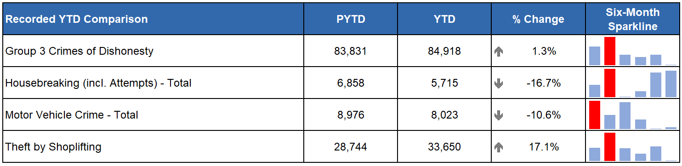
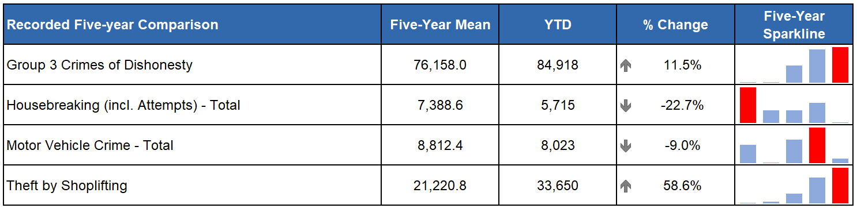
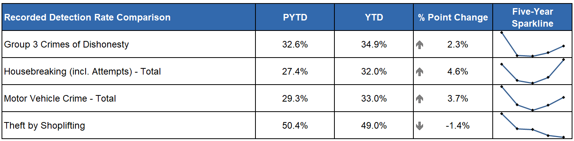
Crimes of dishonesty continue to increase compared to the previous year (up 1.3%) and the five-year mean (up 11.5%). It should be noted that the five-year mean has been affected by the COVID-19 period where there was a significant decrease in the number of crimes of dishonesty recorded. Comparing to the first year before COVID-19 (2019/20) the current figures are slightly increased (1,242 more, up 1.5%).
If Theft by Shoplifting is removed from the overall crimes of dishonesty total, there is a decrease of 3,819 crimes (down 6.9%) compared to the previous year. Aside from Theft by Shoplifting, which has risen by 17.1% compared to the previous year, there have also been significant increases in Opening Lockfast Places (not motor vehicle) which increased by 178 crimes (up 17.8%) and Attempted Theft of a Motor Vehicle (47 more crimes, up 12.6%).
Despite the overall increase in crimes of dishonesty there were decreases in Overall Housebreaking crimes, which decreased by 1,143 (down 16.7%), Opening Lockfast Places (motor vehicle), down 286 crimes (16.0%) and in Theft from a Motor Vehicle, insecure, which decreased by 367 (down 11.3%).

Shoplifting
Crimes of shoplifting account for 39.6% of all crimes of dishonesty and are continuing the upwards trend observed in the previous two years. Shoplifting crimes have increased by 9,938 (up 41.9%) compared to the pre-COVID-19 year of 2019/20. Compared to the same period last year there has been an increase of 4,906 crimes (up 17.1%) and all regions of Scotland are continuing to experience increases for this crime type.
The detection rate for shoplifting crimes has decreased by 1.5 percentage points to 49.0%. This is despite an increase in detections YTD, rising 13.6% (1,973 detections) to 16,472.
Preventative Policing – 4P Approach to Retail Crime
Police Scotland are developing a 4 P approach (Prevent, Protect, Prepare, Pursue) as per the Retail Crime Control Strategy. The Scottish Government have allocated £3m in support of this effort to tackle retail crime. Engagement with partners in the retail sector and criminal justice colleagues is ongoing in order to maximise the benefits this additional funding will provide.
Continuing to deliver upon the 4P approach to retail crime will involve collaboration with key partners and a whole system approach to recognise and account for the social complexities driving the current increases in prevalence.
Police Scotland and Retailers Against Crime (RAC) are progressing an education package for school aged children. The aim is to increase understanding and reduce offending by young persons. The package will be rolled out at engagement days in primary and secondary schools by the Children and Young Persons (CYP) engagement team.
An internal steering group has been formed and a meeting with Scottish Government has been set for late January 2025 to further develop the plan.

Housebreaking
Overall housebreaking crimes have decreased by 1,143 crimes (down 16.7%) on last year and decreased by 1,673 crimes (down 22.7%) compared to the five-year mean. When compared to the pre-COVID-19 year of 2019/20, there has been an overall decrease of 3,819 (down 40.1%) crimes.
Detections have decreased 2.8% (53 fewer detections) compared to the same period last year, leading to a 4.6 percentage point increase in detection rate which now sits at 32.0%.

Vehicle Crime
Motor vehicle crime has decreased compared to the previous year (953 fewer, down 10.6%) and compared to the five-year mean (789 fewer, down 9.0%). There has been a significant decrease in motor vehicle crime compared to the pre-COVID-19 period, with 2,137 (down 21.0%) fewer crimes. The only crime under this grouping which has increased compared to the previous year is Attempt Theft of Motor Vehicle which has observed an increase of 47 crimes (up 12.6%). Detections for motor vehicle crimes have slightly increased by 0.8% with the detection rate up 3.8 percentage points on last year.

Fraud
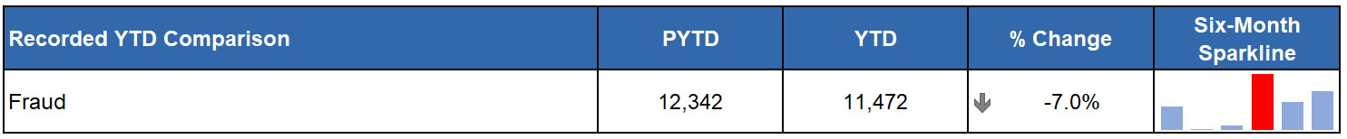
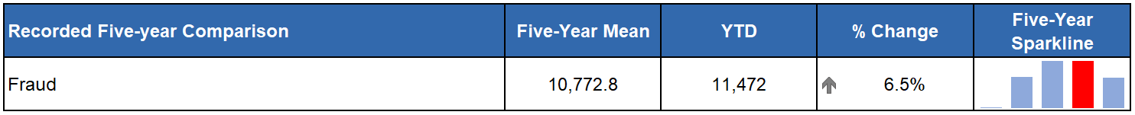
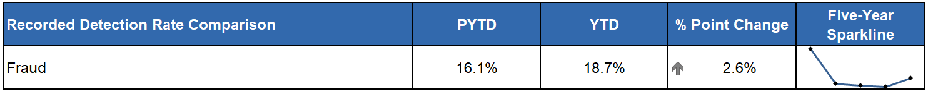
The decrease in recorded fraud crimes has continued this quarter and are now down 7.0% on the same period last year (870 fewer crimes). Compared to the five-year mean there remains an increase of 6.5% and the current total is 46.9% higher than the most recent pre-COVID-19 year (3,660 more crimes). The detection rate for fraud has seen a 2.6 percentage point increase compared to the same period last year, however remains 1.9 percentage points below the five-year mean detection rate.
Proactive/Preventative Policing - Cyber Choices Scotland
Cyber Choices Scotland (CCS) will be taken through Police Scotland Governance as Police Scotland’s response to diverting those away from Cyber criminality utilising the framework of the Cyber Choices programme in England and Wales to identify, engage and divert young and vulnerable people who may be susceptible to be drawn into cyber criminal behaviour to make more positive choices. The CCS project is firmly within the Cyber Prevent space and is being developed to be a collaborative partnership approach with CyberFirst, YouthLink Scotland, Young Scot and others. PDWP have begun preparing their updated Annual Report for 2025 which will outline the successes and next steps being taken to deliver against Police Scotland’s 2030 vision.

Cybercrime (Strategic Outcome 2)
In September 2024, Police Scotland presented our six-monthly progress report to the Scottish Police Authority on activity being undertaken under the Policing in a Digital World Programme (PDWP). At this time, Policing in a Digital World had successfully delivered Digital Evidence Detection Dogs, Digital Forensic Triage Vans and Police Cyber Alarm.
All of these capabilities support Police Scotland’s aspiration and desire to support its people and utilise emerging capabilities to enhance our ability to investigate cyber related criminality and were highlighted in PDWP Annual Report 2024.
PDWP are in the process of developing a Full Business Case that will support joining up UK Cyber and Fraud Investigation with City of London Police through their updated Fraud and Cybercrime Reporting and Analysis Service (FCCRAS).
To complement this work, PDWP has begun an internal re organisation of portfolios to align Cyber and Fraud under the one command. This will bring together key functions with the aim of creating a sustainable model to be agile to the threat posed by Cyber and Fraud.

Training
PDWP’s Cyber Training and Capability Project will work closely with colleagues in Learning Training and Development to deliver bitesize learning for all front line officers in 2025. In addition, the Cyber Training team have been delivering Nuix and Cyber Kiosk operator training across the country.
Three online training packages (Open Source / Communications data / C3 Cyber) have been developed and will begin roll out over the coming months. The Cyber and Digital Knowledge Hub was launched in December 2024 as a “one stop shop” for all Cyber and Digital guidance and operational advice.

Digital Forensics
PDWP will focus its attention and continued drive towards ISO 17025. This project is working towards having all digital forensic labs in steady state prior to United Kingdom Accreditation Service (UKAS) accreditation.

Vision 2030: Safer Communities

Drugs Harm/Supply (Strategic Outcome 1)

Naloxone Administrations
As of 31 August 2023 all operational officers in Police Scotland up to and including the rank of Inspector have been equipped with Naloxone. Funding for 2024/25 has been approved by Scottish Government and provided to local NHS Health Boards. Local Policing divisions have been advised accordingly to permit maintenance of Naloxone stocks. At the time of writing there have been 630 naloxone administrations by Police Scotland since 2021.

Drug Related Deaths
The latest Scottish Government Drug Related Deaths (DRD) dashboard was published on 10 December 2024. During the period January to September 2024 Police Scotland recorded 833 suspected drug deaths. This is a decrease of 67 (7%) compared to the same period in 2023. In Quarter 3 (being July to September 2024) there were 244 suspected drug deaths. This was a decrease of 25 (9%) compared to the previous calendar quarter and a decrease of 56 (19%) compared to the same period in the previous year.
In August 2024, the National Records for Scotland (NRS) published the drug related deaths figures for 2023, where 1,172 drug misuse deaths were registered in Scotland. This was an increase of 12% (121 deaths) compared with 2022. Whilst drug misuse deaths in Scotland have generally been increasing over the last two decades, this is the second lowest number in the last six years. The next annual drug misuse deaths National Statistics publication from NRS is due to be released in August 2025.
Databelt
Funding has been agreed with Public Health Scotland to enable the introduction of a new data management system, Databelt, to automate the process for drug related death reporting.
The system will improve accuracy, increase efficiency and release officer hours. The pilot is expected to run throughout the start of 2025 with plans for phase one national rollout in April/May.
Phase two will support enhanced features to vastly improve data collection around Naloxone administrations, drug seizures and forensic information.
Proactive/Preventative Policing – Promising Practices
Police Scotland’s Substance Harm Prevention team held a Promising Practices event on 04 December 2024. The event covered several key themes, aligned to strategic objectives, with a particular focus on stigma and input from those with lived experiences.
In addition, there was a section delivered by the High harm Drugs Intelligence Team on emerging drug harms including synthetic opioids to increase awareness across the organisation.
The event also highlighted some successful projects being delivered by colleagues across Police Scotland in Local Policing which included the D Division Non-Fatal Overdose Pathway which allows for multi-agency intervention immediately following an overdose and the Clear, Hold, Build, project being delivered within E Division to tackle Serious Organised Crime and its impact on communities.

Safer Drug Consumption Facilities
Glasgow City Health and Social Care Partnership, supported by the Scottish Government, opened Scotland’s first Safer Drug Consumption Facility (SDCF) on 13 January. The facility is based at the Hunter Street Health and Care Centre and is known as The Thistle. The Scottish Government has committed to making up to £2.3 million available per annum for the development, set up and running of the SDCF in Glasgow from 2024/25.
A Policy document has been developed to provide guidance and direction for officers in terms of policing approach, the Statement of Prosecution Policy, the Lord Advocate’s guidance, recording and reporting processes.
Proactive/Preventative Policing – County Lines Intensification Week
Police Scotland officers took pro-active action to identify and safeguard vulnerable people exploited by drug dealers - during the latest national County Lines intensification week.
During the UK-wide initiative – co-ordinated by the National Police Chiefs Council (NPCC) – officers in Scotland safeguarded 66 vulnerable people and engaged with a further 3,210 people. They visited 79 addresses – 25 were believed to be used by drug dealers as a cuckooing house. Sixty men and twenty-one women were arrested and 54 evidential search warrants were executed.
More than £180,000 of heroin, £120,000 of crack cocaine and £22,000 of cocaine were seized. Cannabis, herbal cannabis and cannabis edibles, as well as synthetic opioids, ketamine, mixing agents and more than £60,000 in cash were recovered.
A machete, an axe, four lock knives, two bottles of corrosive substance and a can of pepper spray were recovered. An electric bike, an electric scooter, four vehicles and 87 mobile phones were also seized.

Serious Organised Crime Groups (SOCGs)
Serious Organised Crime Group Mapping (SOCGM) is a tool used by law enforcement in Scotland to map the characteristics of the individuals and groups that are known through intelligence and operational activity. The following figures are reflective of the SOCGM picture in Scotland as at 2024/25 Quarter 3.
The number of mapped operations has decreased by eight since 2024/25 Quarter 2 and now stands at 100. The number of individuals being investigated by police and partners in Scotland has decreased by 9.0% to 1,248.
Between Quarter 2 2023/24 and Quarter 3 2024/25, 24 mapped operations experienced a decrease in their risk score, 22 an increase in risk score and 40 mapped operations experienced no change in score.
During this Quarter, 13 mapped operations were archived, as a result of successful operational activity, comprising seven Police Scotland led operations and six investigated by partners. The archived SOCGs had been involved in drugs, fraud, organised immigration crime, counterfeiting / forgery, cybercrime and violence.

Proceeds of Crime
Mechanism | Amount
Proceeds of Crime Act (POCA) – YTD figures for POCA represent those provided to COPFS and CRU for consideration of confiscation and forfeiture | £34,970,977
Confiscations Orders | £5,058,144
Civil Recoveries Unit | £3,986,341

Disruption Activity
There were successful outcomes in court cases this quarter. At the High Court in Edinburgh two males were convicted for their involvement in a County Lines drug operation between Aberdeen and England. The males received sentences of three years and four months and five years and three months respectively. The pair were arrested following a successful raid in Aberdeen which recovered cocaine, heroin and cannabis as well as cash and phones being used to coordinate the County Line.
A large-scale drug trafficking operation was also concluded at Glasgow High Court, with three males being sentenced to more than 18 years for serious organised crime offences. The trio were arrested as part of Operation Buggy, an investigation into drug trafficking into Scotland from Spain between March 2020 and January 2022, and Operation Escalade, a high-profile investigation into one of the country's top-tier and most prolific serious organised crime groups.
A man was jailed after he was caught with almost £2.5million worth of cocaine in Dundee. At the High Court in Inverness, the male was sentenced to five years in prison following his arrest earlier this year during which he tried to flee from officers and was later charged with drug and road traffic offences.
A man has been convicted for his involvement in serious and organised crime and the supply of controlled drugs. The male has been a prolific criminal, providing specialist counter surveillance advice, techniques and equipment to Scotland’s organised crime groups for years. He is also subject to a Serious Crime Prevention Order for a period of four years upon his release.

October 2024
Officers searched a premises in Cambuslang, Glasgow and recovered herbal cannabis with an estimated street value of £100,000.
Officers stopped a car on the M73, near Gartcosh. A search of the vehicle resulted in Class A drugs worth an estimated street value of £350,000 being discovered.
Officers executed a warrant at an address on Blantyre Street, Glasgow and recovered Cocaine with an estimated street value of £74,000 and Ketamine worth £18,000.
Police Scotland led a multi-agency day of action in Kirkcaldy in relation to an ongoing human trafficking and modern slavery investigation. One male aged 18 was arrested for Modern Slavery and Human Trafficking (MSHT) whilst a 52 year old woman and a 46 year old man were arrested for immigration offences. Representatives from His Majesty’s Revenue and Customs (HMRC), Department for Work and Pensions (DWP), the Gangmasters and Labour Exploitation Authority (GLAA) and Justice and Care were also in attendance
Two men have been jailed for more than seven years after pleading guilty to drugs offences following the discovery of a cannabis cultivation worth an estimated £1.7 million in Dundee. Earlier this year officers executed search warrants and recovered approximately 3,000 cannabis plants.
November 2024
On 28 November, officers searched premises in an industrial estate in Eyemouth. A large scale cannabis cultivation was discovered with an estimated street value of £900,000. A 47 year old male was arrested and charged in connection.
Roads policing officers stopped and searched a car on the A9 near Ralia, Newtonmore. Cocaine with an estimated street value in excess of £200,000 was recovered. The 33 year old male driver was arrested and charged.
Officers carried out an intelligence-led stop of a vehicle on the A90 near to Tealing, Dundee. A 35 year old man was arrested and charged following the recovery of heroin within the vehicle, with an estimated street value of around £25,000.
A 22 year-old man has been arrested and charged in connection with a drugs recovery following a search of a property in Bridge of Earn, Perthshire. Officers recovered Cocaine and MDMA with an estimated street value of £28,000.
A 41 year old man has been arrested and charged in connection with drugs offences after a car was stopped on the A9 in Perthshire near to Auchterarder. Herbal cannabis worth an estimated street value of £150,000 was recovered within the vehicle.
Drugs worth more than £125,000 have been seized by officers in Lerwick, Shetland. On 29 November officers stopped a van at the Ferry terminal and recovered around 1.3kg of Heroin worth an estimated street value of £65,000 and around 512g of Cocaine, worth an estimated street value of £64,000. A 31 year old man was arrested and charged in connection with the recovery.
December 2024
Drugs worth more than £700,000 have been seized in Glasgow following an OCCTU operation on 06 December. Officers searched a property in Mount Vernon, Glasgow and recovered Heroin, with a potential street value of £660,000, and cannabis valued at approximately £117,000. Two men, aged 27 and 33, were arrested and charged in connection with the recovery.
Five men have been arrested and charged in connection with human trafficking offences in Aberdeen. On 04 December, as part of an ongoing investigation, warrants were carried out at various addresses throughout the city centre.
On 02 December, officers stopped a vehicle on the M74 northbound near Larkhall. Following a search of the vehicle, five kilograms of cocaine with an estimated street value of around £200,000 was recovered. A 41 year old man has been arrested and charged in connection.
Proactive/Preventative Policing – Operation SILHOUETTE
Thirteen warrants were executed across four police divisions in the west of Scotland on 29 November, resulting in eight people being arrested in connection with organised crime and drugs offences.
The activity was a part of an ongoing OCCTU investigation, Operation Silhouette, which began 18 months ago to target and dismantle serious organised crime groups.
During this operation there have been a total of 36 arrests, and significant recoveries as part of operational activity, including: 116kgs of cocaine; 140kgs of herbal cannabis; 50kgs of adulterant; and approximately £1.5million in cash.
The controlled drugs have an estimated street value of £6 million.

Missing Persons (Strategic Outcome 1)
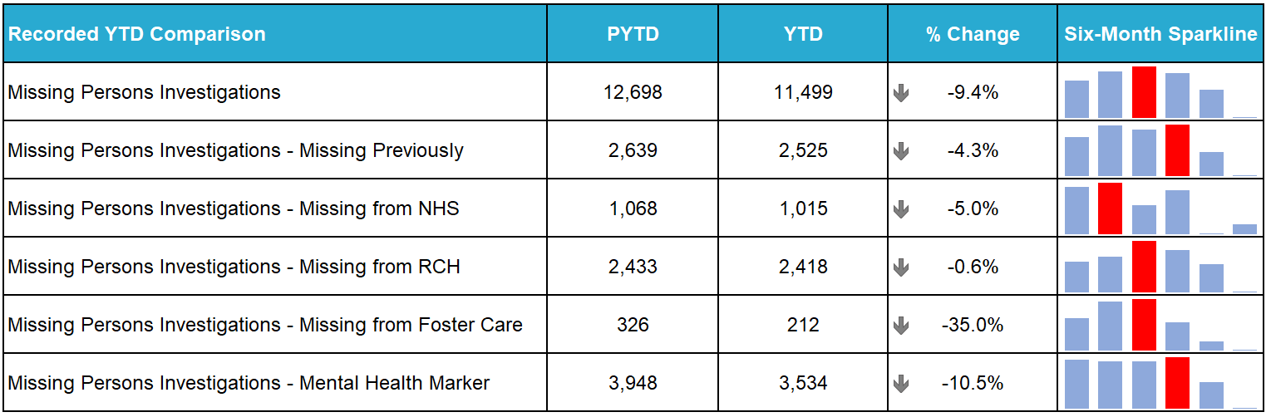
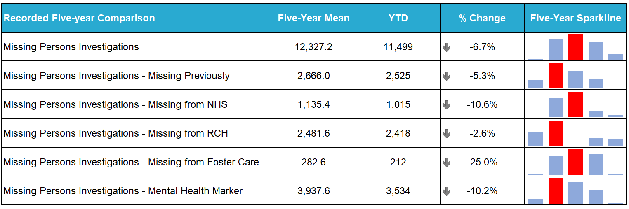
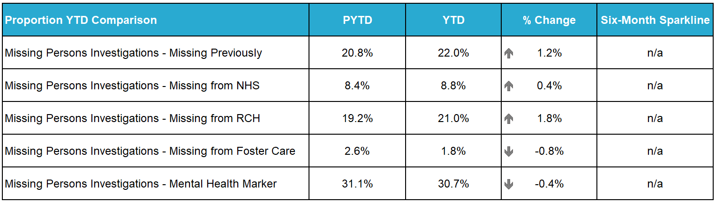
The number of missing person investigations has significantly decreased by 1,199 (down 9.4%) compared to the same period last year. The number of missing persons missing previously and the number of investigations with a mental health (MH) marker have both decreased compared to the same period last year and from the five-year mean. Quarter 3 has recorded the lowest figures for the last three years falling by 13.5% from Quarter 2.
Analysis of missing person incidents recorded by the command-and-control system (STORM) support the wider decreasing trend where, for the corresponding periods, there is decreasing volume of initial and final missing person codes (PW-25’s). This trend is further supported by the reduction of outcomes where the missing person is found deceased.
The notable decreases can be found when considering what ‘type’ of person goes missing. Care Experienced Young Person (413 less, down 12.8%) and Adult (466 less, down 11.1%) are recording the most significant decreases compared to the same period last year. Investigations involving children and care experienced young people have decreased in Quarter 3 where care experience young people recorded the lowest Quarter in the last three years to date with December recording the lowest monthly figures for both groups.
There are many national approaches and local initiatives underway across the different demographics that provides support to missing persons, including approaches that better deliver our response, prevention strategies, support and protection, all underpinned by the aims and objectives laid out within the National Missing Person Framework for Scotland.
Further work is required to better understand this continuing trend, however it is likely that there is no singular strand, approach, or initiative that is contributing on its own. It is most likely that the wide array of local and national approaches and greater adherence and awareness of the joint approaches detailed within the framework are all contributing to these broad outcomes. Consideration must also be given to the work being undertaken across Scotland to deliver effective Mental Health support, and the positive impact this work may be having towards missing persons.
When considering what ‘type’ of person goes missing, children and care experienced young people missing from Renfrewshire and Inverclyde, Dumfries and Galloway, Argyll and West Dunbartonshire, and Lanarkshire all recorded significant increases from the previous YTD. Among the areas where there are increases being recorded, the greatest of which can be seen in Renfrewshire and Inverclyde where the division continue to work to improve recording standards in the division, whilst working with partners to reduce the volume of missing person reports, using a person-centred approach and the available protocols.

Road Safety (Strategic Outcome 1)
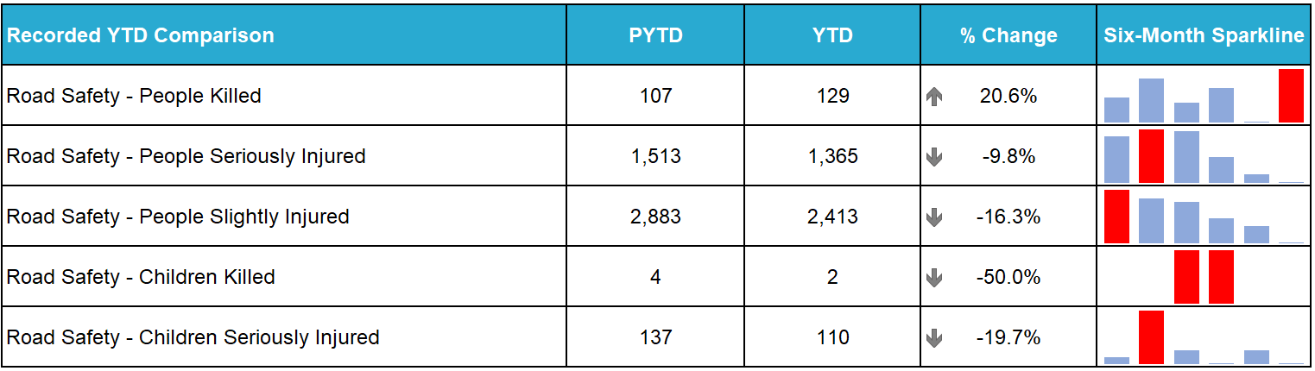
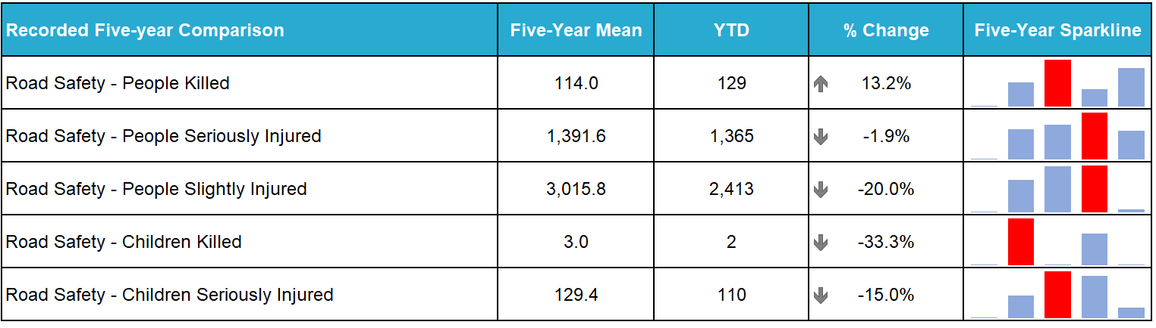
In the current period there has been an increase of 22 road fatalities (up 20.6%) compared to the previous year. The number of children killed has decreased by two, and there have been decreases in the number of people seriously and slightly injured (148 fewer, down 9.8% and 470 fewer, down 16.3% respectively). It should be noted that at the time of writing some of those killed in the current figures are being investigated for medical or other causational factors and may be removed from total figures.
Scottish Government finalised statistics for 2023 show a reduction of 16 in the number of fatalities - 155 in 2023 compared to 171 in 2022, a decrease of 9%. However, there was an increase in serious injuries by 9% over the previous year, and overall casualties rose by 3%.
On 30 October 2024 the Cabinet Secretary for Transport Fiona Hyslop published a statement on the decreased fatality/increased total casualty levels in 2023. This accompanied the release of Transport Scotland’s Reported Road Casualties Scotland 2023 and associated Commentary, from which the above statistics are drawn. The Cabinet Secretary reaffirmed the Scottish Government’s commitment to attaining the 2030 road safety targets.
On 27 November 2024 the Cabinet Secretary launched the National Speed Management Review Consultation. This consultation will run until early March 2025 and will consider the merits of lowering the national speed limit on single carriageways to 50mph. It will also consider whether the speed limits for goods vehicles over 7.5 tonnes should be increased from 40 to 50mph on single carriageways, and from 50 to 60mph on dual carriageways.
Proactive/Preventative Policing – Quarter 3 Campaign Results
During this quarter several campaigns have been resulted, all of which are aimed at proactively preventing fatalities and injuries on Scotland’s roads with a strong focus on protecting Vulnerable Road Users and/or targeting motorists committing Fatal 5 offences.
Fatal 5 Young Drivers Campaign – This campaign ran from 23 September to 06 October and aligned with a National Police Chiefs’ Council UK-wide campaign over these dates, intended to educate and protect young drivers against the risk-taking driving behaviours. During the course of the campaign, officers detected 1,541 Fatal 5 offences, with our Safety Camera Unit colleagues detecting an additional 1,897 speeding offences.
Vulnerable Road Users (VRU) Pedestrian Safety Campaign – Running from 14 to 20 October, this campaign highlighted the predicted statistical peak in pedestrian strike collisions as days shortened and available light diminished. Enforcement took place on high active travel / other routes against risk taking driving behaviour, particularly speeding. Officers were also encouraged to challenge pedestrians placing themselves at heightened risk, through device distraction when crossing etc., and where appropriate to interact sensitively with pedestrians around the topic of their clothing visibility. A total of 171 speeding offences were detected by officers, with an additional 587 Safety Camera Unit detections.
Operation Drive Insured – Between 11 and 17 November, there were a total of 364 offences of failing to insure against third party risks detected across Scotland during this UK wide education, engagement and enforcement campaign. This campaign was run in partnership with the NPCC and Motor Insurers’ Bureau.
There are several ongoing campaigns at this time:
Driver Engagement North, which initially launched in the Highlands and Islands and has since been extended to the rest of the North of Scotland, sees participants using a desktop driving simulator to assist older road users and their families make informed choices about their fitness to drive safely. The project has evaluated well and further funding has now been secured from Transport Scotland to expand Driver Engagement into the East and West of Scotland.
Fitness to Drive Matters sees us working with our partners and older road users to reduce numbers killed or seriously injured in collisions. Funding has been secured from Transport Scotland’s Road Safety Framework Fund to cover 100 assessments in the North of Scotland.
The New Driver Early Intervention Scheme is being rolled out nationally and partners, such as Scottish Fire and Rescue Service, have adopted the scheme to deliver it as part of their work. The scheme is aimed at 17-25 year-olds to positively influence this vulnerable group of road users, whilst providing a reminder of their responsibilities towards themselves and other road users. Several local authorities have adopted the scheme for delivery to modern apprentice/skills and employability students. Empowering young people with information allows them to make informed decisions when starting their driving careers, with a view to improving road safety for all.
Ongoing Operations
There are also several ongoing operations:
Operation TUTELAGE: This is a UK-wide initiative aimed at reducing the number of uninsured drivers. A Criminal Justice led initiative, uninsured vehicles are identified using Automatic Number Plate Recognition (ANPR) to generate ‘Insurance Advisory Letters’ to registered keepers to inform them that an offence has occurred. From launch in 2021 to 16 December 2024 a total of 42,856 letters have been issued in Scotland. The compliance rate is 83.2%.
Operation TRAMLINE: Police Officers are deployed on busy commuter routes in vehicles that drivers would not typically associate with police, such as lorry tractor units and minibuses. This provides high vantage point observation of driver behaviour with the aim to engage, educate and enforce legislation in respect of the Fatal 5, in particular distraction offences such as using a handheld mobile phone.
Operation CLOSE PASS: This operation sees a Community Police cyclist and supporting Road Policing officers deploy to monitor driver behaviour in the vicinity of cyclists, particularly when carrying out passing manoeuvres. Drivers passing too closely, or otherwise placing the cyclist at risk, are predominantly provided with guidance during a ‘chat on the mat’ but may also be issued with a fixed penalty or reported to the Procurator Fiscal, depending on the presenting circumstances.

Stop and Search (Strategic Outcome 1)
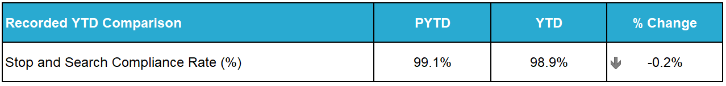
28,982 stop and search incidents were recorded by Police Scotland during the period. This includes 1,123 searches under warrant. The number of searches recorded this year was 21.3% more than last year and 7.3% fewer than the five-year mean.
25.2% of searches recorded during the period were positive – this is a decrease in the positive rate from this period last year of 4.7 percentage points and a decrease of 9.0 percentage points from the five-year mean positive rate. 5,770 searches led to the recovery of drugs, 685 recovered weapons and 618 recovered stolen property. Of the searches that recovered weapons, 97 involved weapons being recovered from 12-15 year olds, and a further 70 from 16-17 year olds.
42 of the searches that recovered weapons were conducted for a care & welfare reason, and a further nine were conducted for the protection of life search reason.
During the April to September period, 27,803 stop and search records were audited for compliance. An audit involves the records being reviewed by line managers and thereafter quality control checked by the National Stop and Search Unit to ensure their adherence to the Stop and Search Code of Practice introduced in May 2017. A further 570 records have been returned to local management for further details and are awaiting responses.
Of the stop and searches audited this year, 24,961 (89.8%) were deemed compliant and recorded correctly on the stop and search database. A further 2,539 (9.1%) were compliant with the code of practice but required amendment to their details to ensure they were appropriately recorded.
303 (1.1%) records were deemed as not recordable under the code of practice or recorded in error and deleted from the database. The typical reasons for deletion include where a person is searched after being arrested, as a result of a duplicate record or where no physical search of a person has actually taken place.
It should be noted that the total number of records audited for compliance will be lower than the total number of searches raised during the period due to the timescales required to fully review all records.
More information about stop and search statistics as well as stop and search data files can be found on the Police Scotland website: Stop Search Data.

Criminal Justice (Strategic Outcome 2)
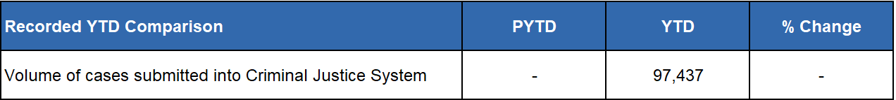
The number of cases is now being provided from the single National Case Management system. The structure and components of the new system represent a significant upgrade. This year’s figures will serve as a baseline for future reporting and data will be available for comparison from the next reporting year. 30,839 cases were recorded during Quarter 3.

Police Custody

Arrested Persons
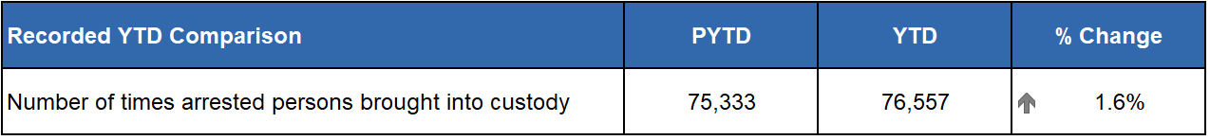
Custody throughput continues to rise steadily, with this being the eleventh consecutive quarter where it has risen. The continued increase in arrests on warrant may account for some of this increase, with 1,114 additional warrant arrests this YTD in comparison to the 2023/24 YTD.
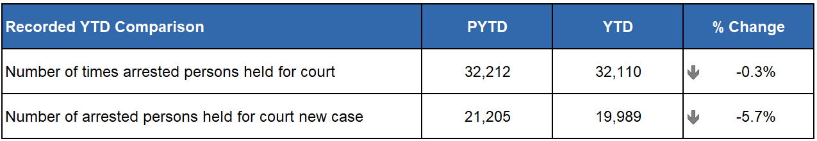
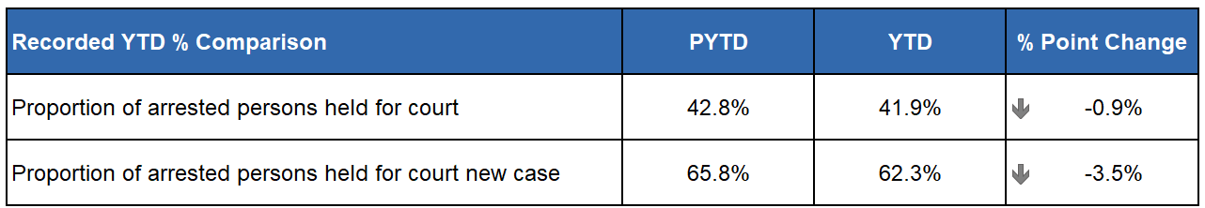
The number of persons held for court has modestly decreased, after seeing a 1% increase at the end of Quarter 2. Workshops are ongoing and will continue into Quarter 4 targetting CJSD Custody Supervisors to reduce the gap between the numbers being held for court and the number for whom remand is given.
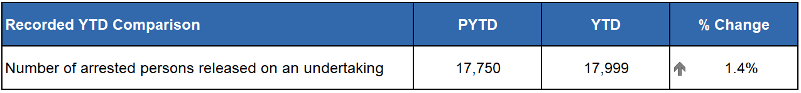
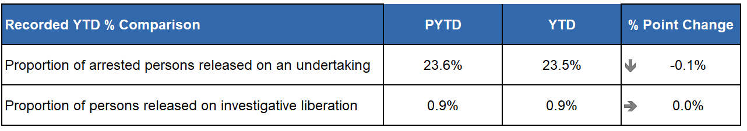
The use of undertaking remains fairly static with the use of investigative liberation continuing to marginally rise as a percentage of total throughput. There has been a rise throughout each quarter of the YTD, which demonstrates the increased use of this investigative tool.

Children brought into Police Custody / Held for Court
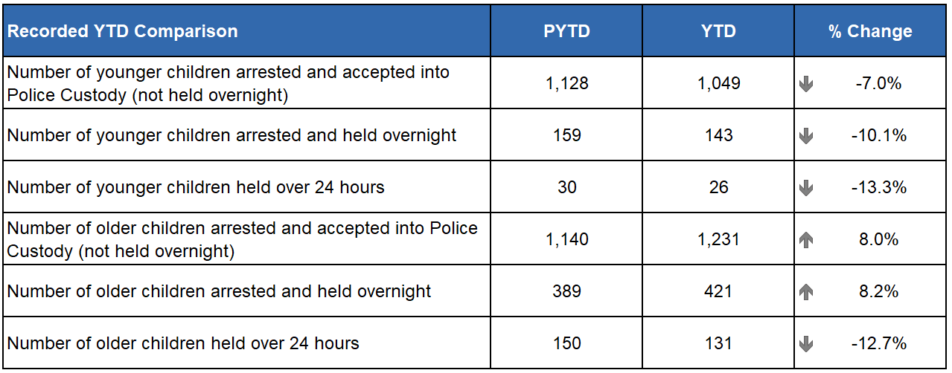
The number of younger children being brought and accepted into custody has decreased across all measures. There has been an increase in older children arrested and accepted into custody which will be monitored as we move into Quarter 4. There is a significant decrease however in the number of older children held over 24 hours, showing a desire to not have older children in our care for any longer than is necessary.
An element of the Children’s Care and Justice (Scotland) Act 2024 (CCJ Act) which continues to be implemented in stages, and in line with the United Nations Convention on the Rights of the Child (Incorporation) (Scotland) Bill (UNCRC) will see all under 18s being treated as children through the criminal justice journey. This phase of CCJ Act implementation will likely become live throughout 2025 and will impact how this data can be reported in the next financial year.

Police Direct Measures
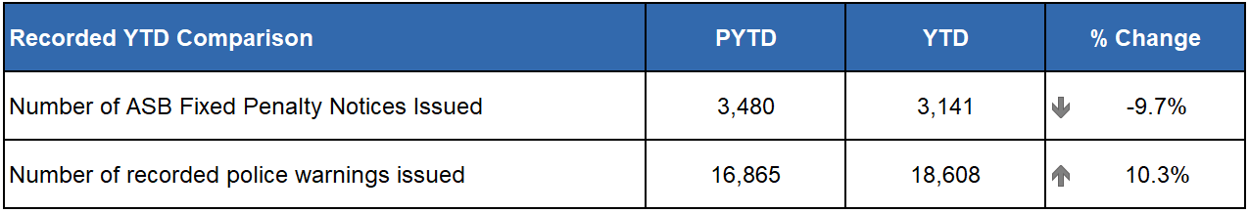Recorded Police Warnings (RPWs) continue to reflect a continued upward trend in use, with 1,743 more issued in this YTD against the same period last year. This is however a slight decrease in use since the Quarter 2 period where there was a 12.1% rise. In comparison the use of antisocial behaviour (ASB) Fixed Penalties continue to fall, reflecting the narrower range of offences covered.

Vulnerability
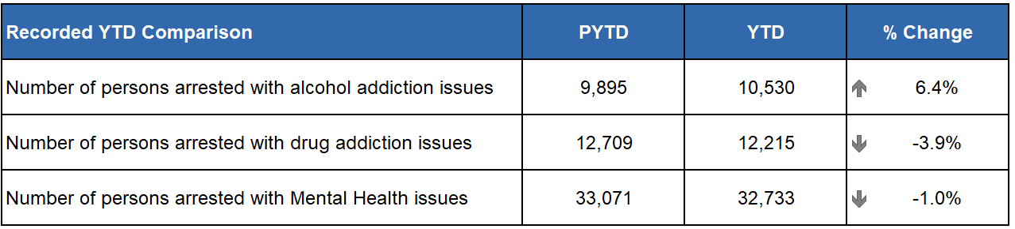
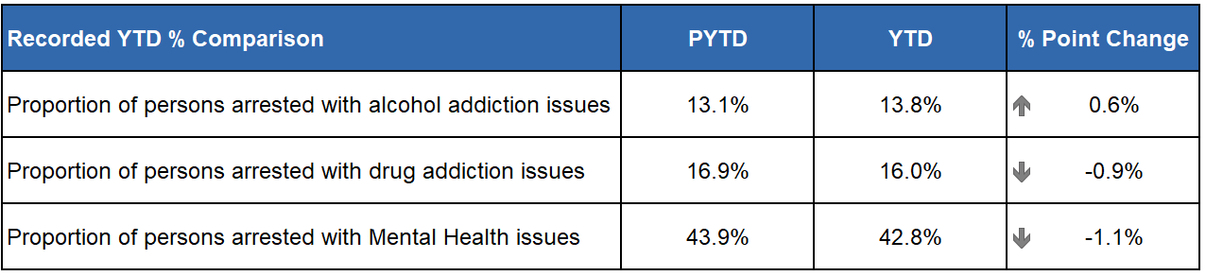
Vulnerability figures for current or historic alcohol addiction issues continue to rise quarter on quarter however this is the smallest increase from the previous year recorded in the last two years, which may indicate its rate is slowing. Drug and mental health issues remain largely steady.
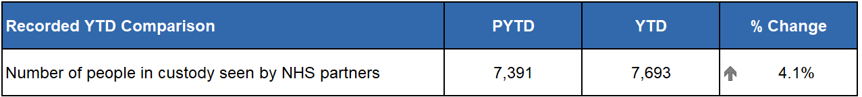
Since consecutive decreases over the first two quarters of the reporting year, it is encouraging to see a small increase in Quarter 3, indicating improved recording and highlighting to NHS partners regarding referral requirements of individuals in our care.
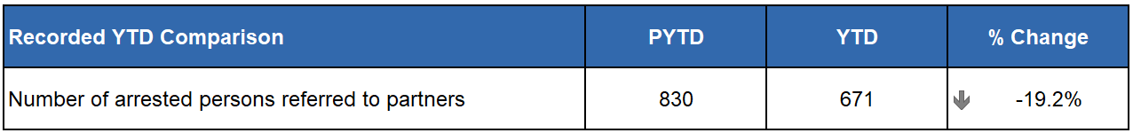
Quarter 3 has seen a small but steady increase from Quarter 2, however is overall almost a fifth down on the same time last year. The past few months has seen much time being spent engaging with existing partners and also working with three local authorities to create email-only arrest referral pathways to allow support for those who live in areas that have no custody centre within their local authority. Part of the re-launch also involves continuing working with front line colleagues raising awareness of both local and national services on offer.

Productions
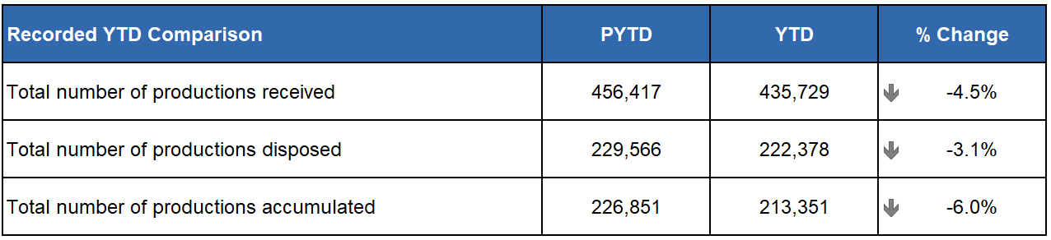
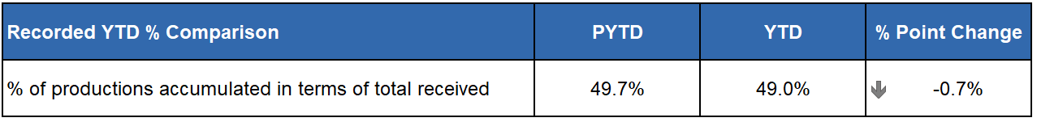
Ongoing audits and reviews of all local temporary stores continues. This has resulted in clear outs and increased numbers of productions lodged in bulk from these stores. Disposal team recruitment is ongoing using additional investment as is the recruitment to fill Production Management Officer (PMO) posts.

Public Confidence and Experience of Policing (Strategic Outcome 3)

Experience of contact and determinants of user satisfaction
User experience is high and stable, with no change in reported satisfaction on the previous quarter. Overall, 70% of respondents were satisfied or very satisfied with their overall experience. Our breakdown of the contact touchpoints below demonstrates high and stable levels of satisfaction. Ease of contact 75% (up two percentage points); Treatment by staff member during initial contact 86% (up one percentage point); Staff understanding what they needed 87% (down one percentage point); Police providing the appropriate response 65% (down one percentage point); Treatment by officers who attended the incident 82% (down one percentage point); and Being adequately informed about progress 51% (no change) when compared to Quarter 2.
Positive experiences are correlated most strongly with receiving an appropriate response, satisfaction with attending officers and feeling adequately informed about case progress. Respondents tell us their experience was positive because contact was ‘easy’ with quick answer times using 101/999; service advisors and attending officers taking the time to listen to and understand their needs, bringing empathy and compassion to interactions.

Factors influencing confidence in local policing
Quarter 3 saw a small decrease in public confidence (down 4 percentage points) to 50%. We know that confidence is closely affected by how policing is experienced and perceived locally. In Quarter 3, 80% (down four percentage points from the previous quarter) of survey respondents reported feeling very safe or fairly safe in their area; 61% (down five percentage points) agreed that local police are friendly and approachable; and 30% (down five percentage points) agree local police listen to local concerns.

Public trust score and predictors
Results have remained relatively stable, between 75%-80% since the Trust Index survey was introduced in June 2022. The Trust Index score in December 2024 was 75%, four percentage points lower than the previous quarter
Most people continue to feel Police Scotland upholds its core values of Respect (64%), Human Rights (66%), Fairness (64%), and Integrity (67%). There is however, a statistically significant decrease in fairness and respect compared to this time last year.

Vision 2030: Supported Victims

Call Handling (Strategic Outcome 2)
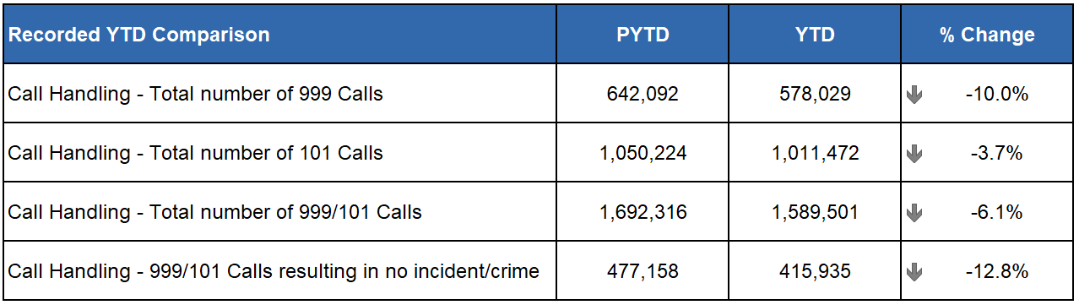
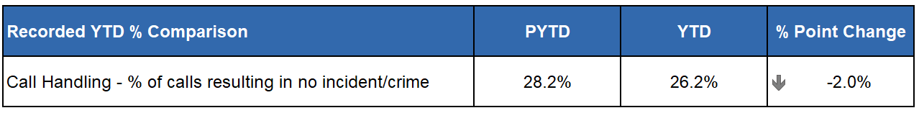
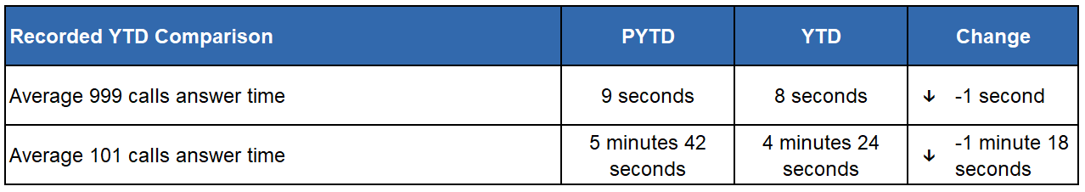
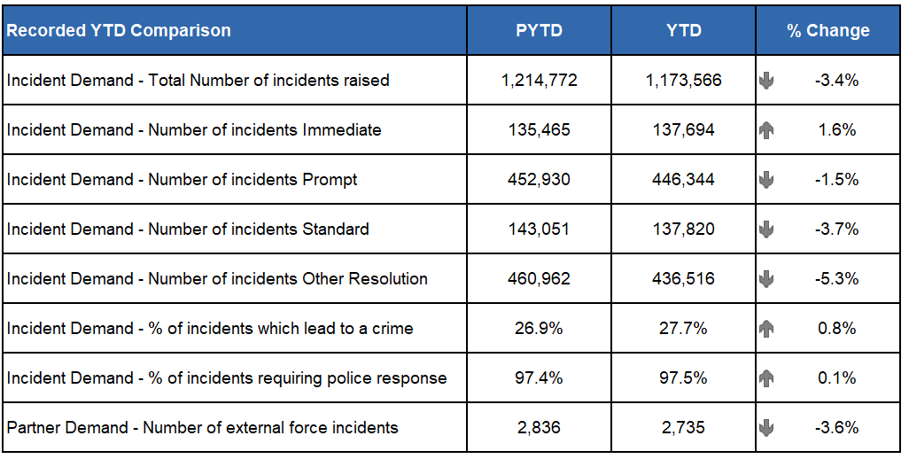
During the reporting period Police Scotland received a total of 1,692,316 calls, a decrease of 6.1% when compared to the same period last year. Of these calls, those routed via 999 decreased by 10.0% when compared to the same period last year (down from 642,092 to 578,029). The volume of 101 calls received also decreased by 3.7% (down from 1,050,224 to 1,011,472).
The handling of 999 calls remains our highest priority. Police Scotland aim to achieve an average speed of answer for 999 calls within 10 seconds, a standard for all 44 Police Forces across Scotland, England and Wales. During the reporting period Police Scotland achieved an average answer time of eight seconds which is one second quicker than the same period last year.
Of note, Police Scotland experienced significant increase in 999 calls during 2023 which continued until November. Several factors contributed to this increase including extreme weather (both good and inclement), various large-scale events, changes to legislation relating to XL Bully dogs and, most significantly, an update to the Android operating system that caused mobile telephones using the operating system to inadvertently call 999.
This resulted in many thousands of accidental and dropped 999 calls. Additional contacts were subsequently generated as members of the public sought advice and guidance. As such, comparisons to 2023 are set against what was a historically high level of demand in 2023 for Police Scotland and all UK Forces.
When compared to the same reporting period in 2022, 999s have seen an increase of 3.1% for Police Scotland (up from 560,838 to 578,029). This increase is similar to the UK average where a 7.0% increase has been noted.
Several factors impacted demand during this reporting period including our traditionally higher volume months being within this reporting period. Events such as high profile football matches, music festivals, parades, public demonstrations, beach events, and public holidays took place. During June, July, and August, extended periods of warm sunny weather with lighter evenings caused increases in call volumes. Also, within this reporting period was the usual inclement weather experienced in October, November, and December and events such as Operation MOONBEAM, the festive period, and Hogmanay which cause known increases in call volumes and can impact our average speed of answer time.
In April 2024 the Hate Crime and Public Order (Scotland) Act 2021 came into effect. While having a significant impact on demand across Police Scotland in general, the new Act had a minimal impact on call handling demands due to the facility to report Hate Crime online.
Positively, the average answer time for 101 calls decreased by 1 minute 18 seconds to 4 minutes 24 seconds. It is important to note that it is the same Service Advisors who handle all 999/101 calls and ContactUs Emails. When there is a surge in 999 calls, we will re-prioritise Service Advisors from Non-Emergency (101) calls and emails as we aim to answer the 999 calls under 10 seconds. Therefore, there is a direct link between any increase in 999 volumes and the average speed of answer for 101 – non-emergency calls.
Our call volumes and trends continue to be monitored closely to ensure that we are prepared for any unexpected changes in demand and maintain average speed of answer times within targets.

Service Demand – Additional Contact Methods
C3 Division handles additional contacts such as incoming calls from other partner agencies and alarm calls. There have been 91,141 of these types of contact for this reporting period, representing a small decrease of around 1.0% in emergency service partner calls and a decrease of around 13.6% in total alarms calls when compared to 2023.
Emergency service partner calls are received via dedicated numbers from Scottish Fire and Rescue, Scottish Ambulance Service, Mountain Rescue, Coast Guard, Mental Health Pathway (NHS 24), OmniCrash, and Oil Industry Agency. The reason for such calls varies and each is dealt with by a Service Advisor in the most appropriate manner.
A total of 36,114 calls were received in response to Media Appeals (Option 1 on 101). The percentage of these calls to 101 remains consistent at 3.5% for the reporting period which is the same for the same period last year.
A total of 187,006 calls were received for Incident Updates (Option 3 on 101). The percentage of these calls to 101 remains consistent at 18.5% for the reporting period compared with 18.1% for the same period last year.
Efforts continue to signpost callers to more appropriate methods of contact, including via “Contact Us – email facility” and the online reporting facilities via the force website.
“Contact Us” emails and online reports, for some crime types, can be completed online. Each one of these reports is assessed by a Service Advisor using the Threat Harm Risk Investigation Vulnerability and Engagement (THRIVE) model.
The use of “Contact Us” emails has seen a slight increase in demand different to the reduction in call volumes. Police Scotland received 151,922 emails in this reporting period, a 0.9% increase compared to the same period last year (up from 147,902 to 151,922). Emails are assessed the same way as calls using the THRIVE assessment.
Despite this there was an overall 5.1% reduction of contacts handled by the C3 Division when compared with the same period last year.

Vision 2030: Thriving Workforce

Complaints about the Police (Strategic Outcome 3)
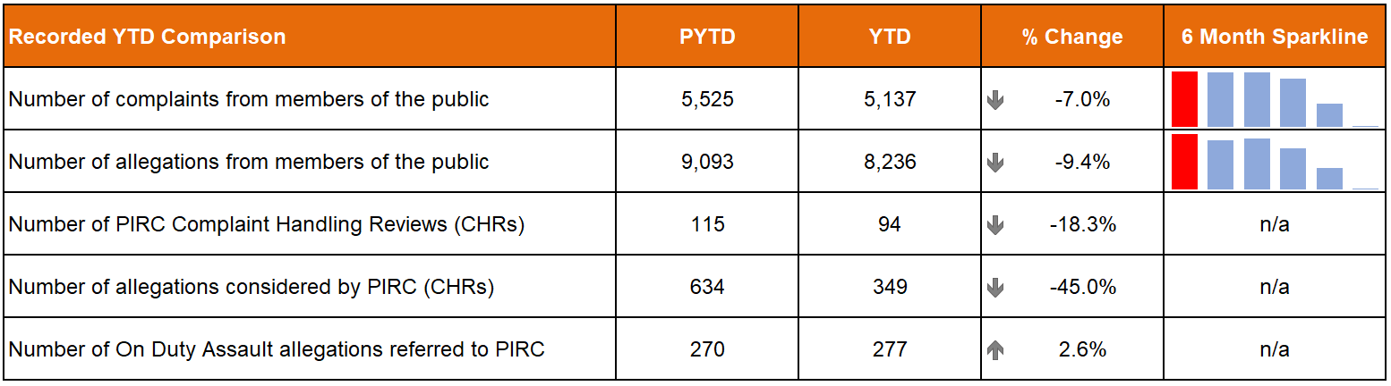
The total number of complaints from members of the public are down 7.0% (388 fewer complaints) on last year whilst allegations are down 9.4% (857 fewer allegations) on the same period. The six month sparklines show that the most complaints and allegations were received in July 2024 (643 complaints and 1,111 allegations respectively).
The Professional Standards Department (PSD) has resolved 2,536 complaints (49.4%) by Frontline Resolution (FLR) compared with 52.1% in the same period last year. This includes early resolution and subsequent resolution by PSD / specialist officers.
PIRC submitted 94 Complaint Handling Reviews (CHRs) to Police Scotland for consideration during this period. This notionally equates to 1.8% of all complaints.
There were 277 allegations of On Duty Assault referrals made to PIRC during this period (up 2.6% on last year). Of those, 64 are subject to the Police Investigations & Review Commissioner (PIRC) investigation (23.1%). However, as of 01 January 2025, 55 of these referrals are awaiting a decision from PIRC regarding possible investigation. The remaining 158 cases have been marked as no investigation by PIRC.
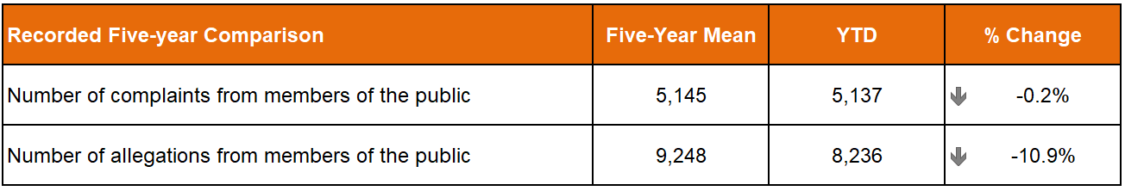
The total number of complaints from members of the public are down 0.2% (eight fewer complaints) on the five-year mean whilst the total number of allegations are down 10.9% (1,012 fewer allegations) compared to the same period.
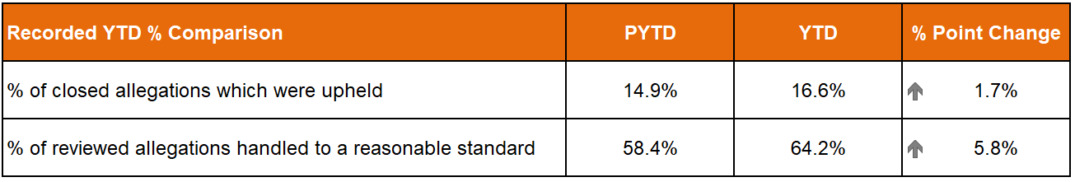
There were 2,302 allegations attached to completed complaint investigations (criminal and non-criminal) with 16.6% of these being upheld.
The 94 CHRs received from PIRC considered 349 allegations, with 224 (64.2%) assessed to have been handled to a reasonable standard. This is an increase of 5.8 percentage points from the same period in 2023/24. These CHRs included 109 recommendations.

C3 Complaints and Allegations (Strategic Outcome 2)
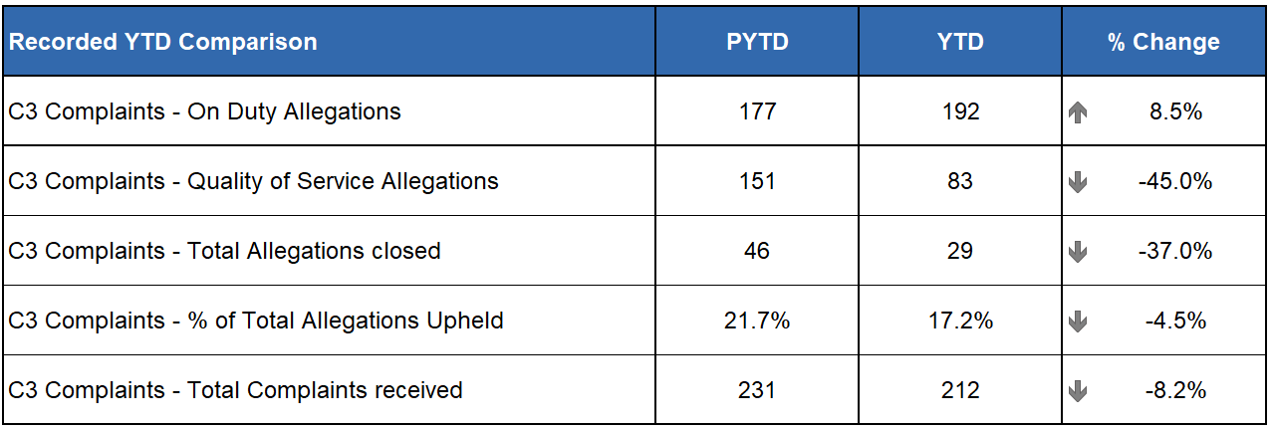
In total, 75.5% of complaint cases received YTD for C3 Division were Frontline Resolved by the PSD National Complaints Assessment and Resolution Unit (NCARU). This rate rises to 75.9% when early and subsequent resolution by PSD or Specialist officers are included. These figures demonstrate that most complaints against C3 Division during this period have been non-criminal and non-serious in nature, with a majority resolved through simple explanation, apology or assurance.
The volume of complaints against C3 Division has decreased by 8.2% YTD, with a total of 212 received compared to 231 received PYTD. Decreases are visible in the North (down 10.3%, 35 cases) and West (down 18.0%, 100 cases). However, an increase was registered in the East (up 10.0%, 77 cases).
Incivility (145) remains the most common allegation type. This volume represents a 9.8% increase from the same period in 2023/24, accounting for an additional 13 allegations. Also of note is a reduction in Service Delivery allegations (down 60.6%), accounting for 60 less allegations compared to the same period in 2023/24. This reduction is assessed to be a key influence in the overall decrease in complaints received against C3 nationally.

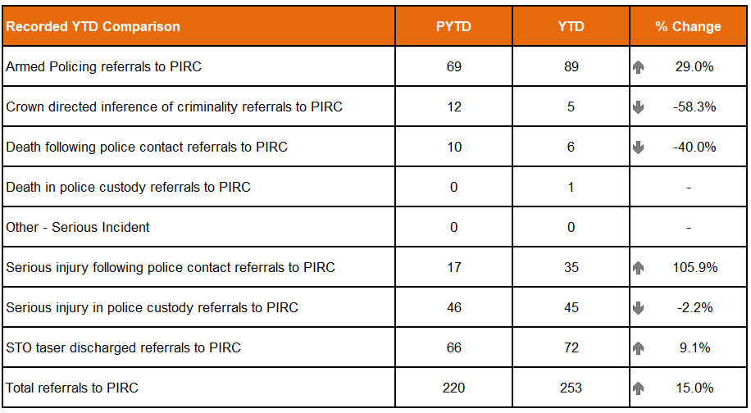
Statutory referrals to PIRC facilitate independent and transparent scrutiny in relation to serious incidents involving the police. Police Scotland made 253 referrals (up 15.0%, 33 more referrals on PYTD) to PIRC resulting in 18 investigations (7.1%). The percentage resulting in an investigation is however down 6.5 percentage points on last year.
Referrals have increased compared to the PYTD for armed policing (up 20 referrals), death in police custody (up one referral), serious injury following police contact (up 18 referrals) and serious injury in police custody (up six referrals).
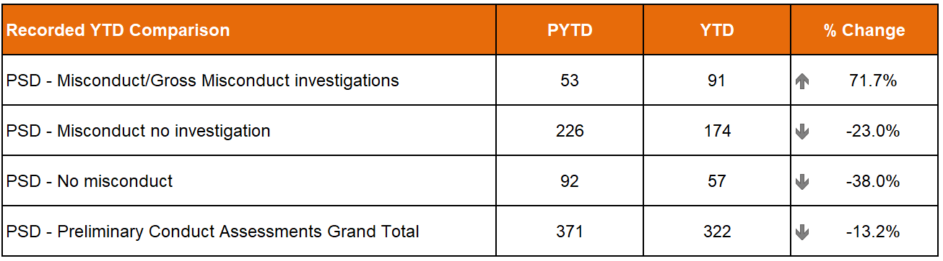
There were 322 preliminary conduct assessments undertaken YTD which is down 13.2% (49 fewer assessments) on the same period last year. 91 assessments have required a misconduct/gross misconduct investigation, this is up 38 investigations (71.7%) compared to last year. The remaining assessments resulted in either misconduct – no investigation (174) or no misconduct (57).

PSD Disseminated Learning during this Quarter
PSD is committed to promoting a culture of organisational and individual learning. In the last quarter, PSD has disseminated learning from a variety of incidents. The following learning outcomes are of particular note:
Following XL Bully incidents, OSD are developing the existing dangerous animals protocol to include procedures for contacting local a veterinary surgeon, or other appropriate authority, to attend such incidents and provide viable options for the safe management of dangerous animals.
After a serious injury following police contact investigation, it was recommended to ensure staff are aware of the established process for accessing and reviewing CCTV for ongoing incidents, in particular during those incidents occurring outwith normal operating hours.

Assaults on Police Officers and Police Staff (Strategic Outcome 4)
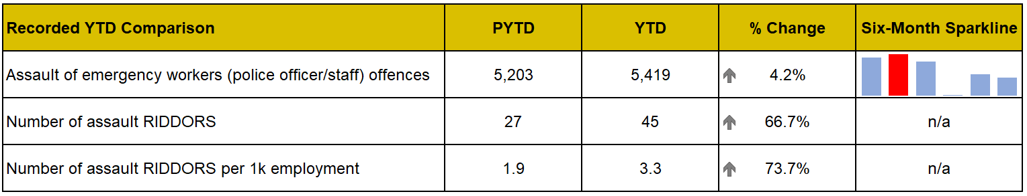
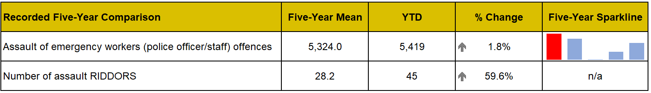
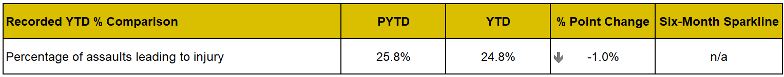
In Quarter 3 YTD there have been 5,419 assaults on officers / staff this is an average of 20 assaults per day and an increase of 4.2% (216 more) compared to the previous year. Assaults on officers and staff have also increased compared to the five-year mean (up 1.8%, 95 more). Additionally, the injury rate (24.8%) on officers / staff has remained similar to the previous year, decreasing by 1.0 percentage point. The assault repeat injury rate (7.0%) on officers / staff remains slightly up compared to the previous year (6.8%) increasing by 0.2 percentage points.
However, despite the injury and repeat injury rate being relatively low, Police Scotland has seen a notable increase (66.7%, 18 more) in RIDDOR (Reporting of Injuries, Diseases and Dangerous Occurrences Regulations) reportable assaults, compared to the previous year.
The locus types of public place and private / domestic accounted for 76% of all assault RIDDORs. Private / Domestic seen the largest increase in assault RIDDORs increasing by nine compared to the previous year.
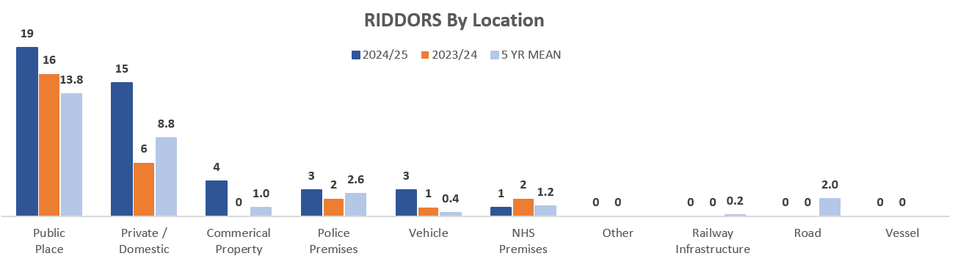

People and Development (Strategic Outcome 4)

Prioritise Wellbeing (People Strategy Objective 1)

Absence
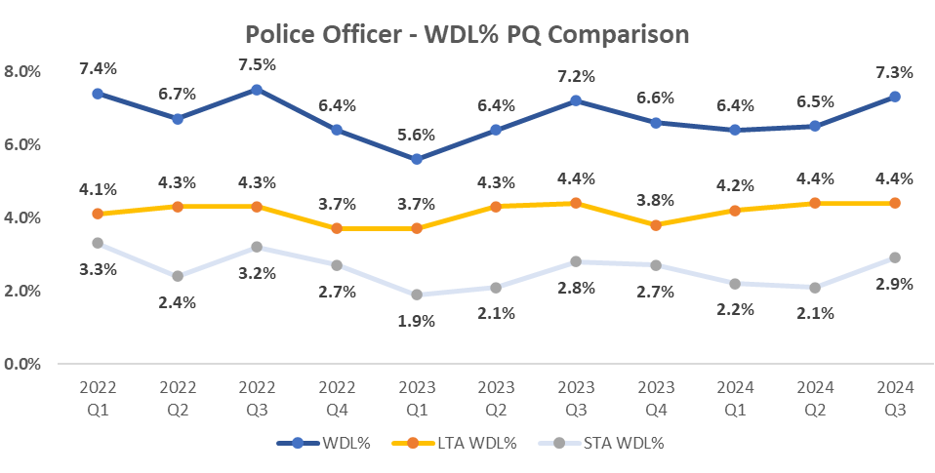
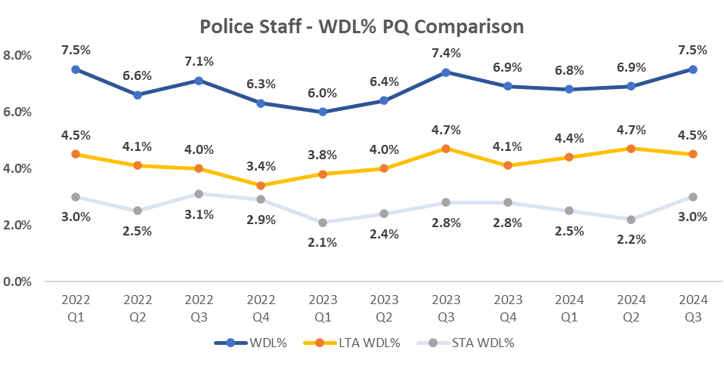
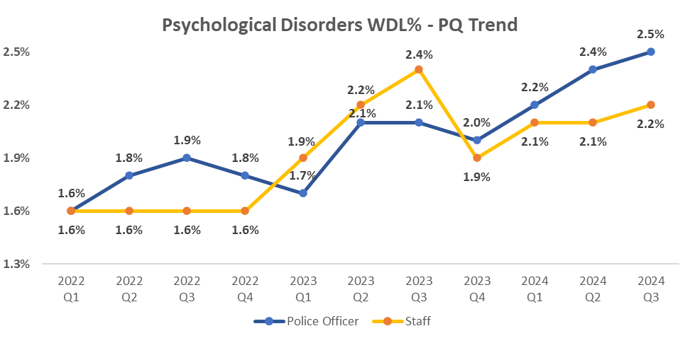

Managing absence
This quarter records a 0.8 percentage point increase in working days lost (WDL) for Police Officers and 0.6 percentage point increase for Police Staff in comparison to last quarter. This increase is because of an increase in short term absences, contributing the largest factor is a 0.4 percentage point increase in the respiratory illnesses' absence category. This spike in WDL% is to be expected in Quarter 3 when comparing to quarterly trends over previous years and is linked to cold and flu absences.
In Quarter 3, the top three reasons for long-term absence (LTAs), for both employee types, are Psychological Disorders, Musculo-skeletal and Miscellaneous.

Supporting our workforce’s wellbeing
Since April 2024 we have new and improved contracts in place for our occupational health (OH) and employee assistance programs (EAP).
Early data tells us that our new occupational health provision has received 3,501 service requests. Over half of these (55.6%, 1,947) were for advice to support the management of absence, attendance at work or understand an employee's capability to work. Performance data tells us that over 80% of these calls were successfully completed.
Since April we have had 1,287 contacts with our employee assistance programme, with 3,529 sessions of support offered in a variety of formats.

Ensuring our officers with duty modifications are meaningfully deployed
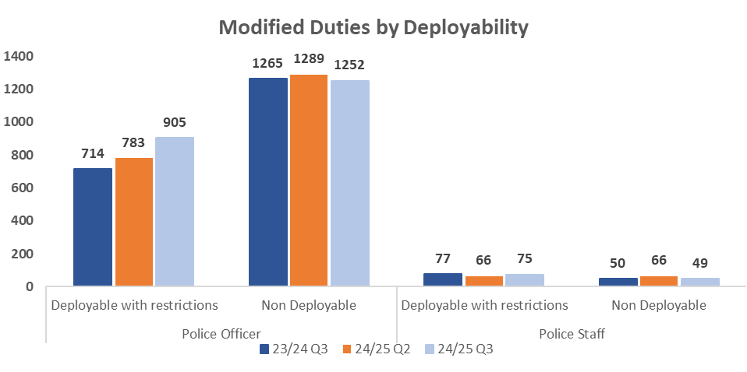
In Quarter 3, the number of officers with duty modifications had increased to 2,149 officers (compared to 2,072 in Quarter 2). Given the aging population of our workforce, it is not unusual to see a rise in requirements for reasonable adjustments. We continue to bed-in our duty modification process which is designed to support the enablement of our workforce into meaningful work.
We can see that in Quarter 3 the percentage of officers who are deployable with modifications also increased from 37.8% (783) in Quarter 2 to 40.8% (905). This increase in deployability continues to demonstrate and build on the early positive impact of our work in this area with our National Duty Modifications Panel.

Building our pipeline of leaders
We have listened to feedback via promotions workshops, surveys and consultation, and recognise that MyCareer is no longer the best route for colleagues to apply for promotion. Piloting for the first national police promotions panel for 2025, the inspector to chief inspector process, MyCareer will no longer act as the gateway to promotion and will be replaced by an application form. This will allow us to refocus MyCareer back to its intended purpose which is a mechanism to have good quality, structured, and valuable discussions between colleagues and line managers to reflect on the past period, celebrate success, and talk about the colleague’s aspirations.
For those newly promoted we are further developing our signature People Management Development Programme. Phase one is currently delivering to just under 3,000 sergeants and staff equivalents and continues to evaluate very highly. This will be extended for superintendents through to executive level colleagues, including staff grade 11- 14, totalling 240 in the near future. A programme for all remaining ranks and grades (totalling just over 1,500 people) will follow once we have trained our cadre of sergeants and staff equivalents.

Finance (Strategic Outcome 5)

Maintaining a Balanced Budget / Financial Sustainability
The 2024/25 budget was approved by the Board at the Authority meeting held on 21 March 2024.
The budget report highlighted the key budgeting assumptions that are sensitive to change, and which could result in a material change to the 2024/25 budget. The overall financial position will continue to be monitored and reported throughout the remaining part of the year.

Revenue
The Quarter 3 forecast is reporting an overall breakeven funding position, after a contribution of £2.5m from Reform to support overall pay award pressures.
There are a number of significant offsetting variances that form part of the Quarter 3 forecast. The main overspends of £32.3m relate to pay award pressures (£20.5m), an increase in expenditure (£7.0m) relating to bids approved by the Revenue Investment Group (RIG) predominately supporting overtime, staffing divisional uplifts, workforce modernisation, learning training & development, and other items; and additional non-pay costs (£4.8m) - third-party payments (£3.2m) and supplies & services (£1.6m).
Against the above overspends, the main underspends (£29.8m) relate to one-off benefits (£8.9m), Police Staff pay costs (£7.2m) and Police Officer pay costs (£7.1m) as both are running below the budgeting assumptions; over-recovery of income (£4.3m) and reduction in other costs (£2.3m).
The forecast position will be closely monitored along with any threats and opportunities that materialise throughout the remainder of the financial year. At the end of Quarter 3 we are reporting a £10.0m YTD underspend against budget, which is in line with our expectations to fund in-year pay award pressures.

Capital
The capital forecast at Quarter 3 (excluding IFRS16 transactions) is £65.3m. When combined with IFRS16 capital, the overall position is a £3.3m (fully funded) forecast overspend against budget.
Capital Investment Group previously approved an overallocation of investment to be managed across financial years to mitigate the potential risk of slippage. This has been reflected in the Quarter 3 forecast where appropriate. These actions will allow effective management of slippage over the remaining months of the financial year.
Committed and uncommitted spend will continue to be monitored throughout the remaining part of the year. The YTD capital spend at period 9 (December) is under budget by £12.0m (net of slippage).

Reform
The reform forecast at Quarter 3 is £0.2m over budget position (fully funded). The forecast includes £2.5m to support organisational pay award pressures. The full year budgeted slippage target of £5.5m has been fully achieved.
Committed and uncommitted spend will continue to be monitored throughout the remaining part of the year. The YTD capital spend at period 9 (December) is under budget by £0.4m (net of slippage).

Environmental
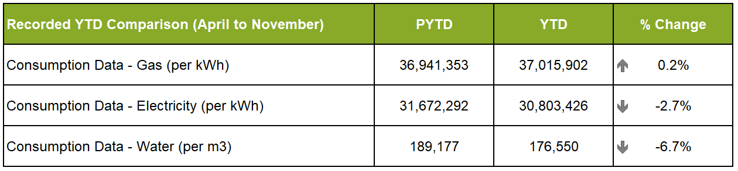
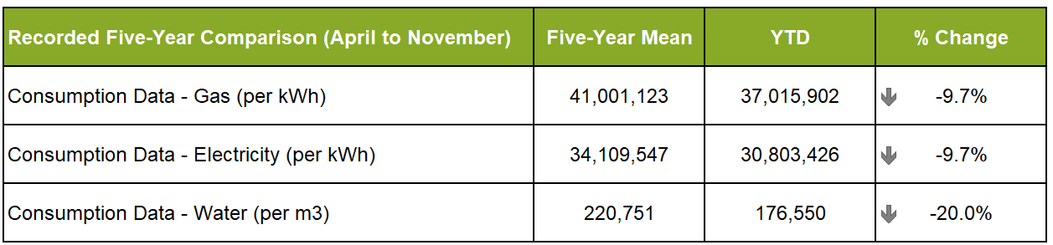
We continue to see a reduction in electricity consumption in comparison with the same time last year, and a more significant reduction against the five-year mean. This points to a long-term reduction driven by previous and current Estate rationalisation and upgrade of electrical infrastructure and office equipment.
Gas consumption has increased slightly against the same time last year. However, this is a very small increase and may be eradicated in the full data set comparison. Conversely, we continue to see a reduction in consumption against the five-year mean. This reflects the work done on reducing estate footprint and continuing improvement of heating and hot water infrastructure across the portfolio.
We continue to see a reduction in water consumption across the two time periods. This is likely due in part to the same driver of estate rationalisation, infrastructure improvement and low occupancy levels within some buildings.
In addition, our Net Zero Plan is now complete, and we will publish this as soon as possible. We will also be in position later in Quarter 4 to provide benchmarking information, as per the SPA Board request last year. This information will be provided in the form of a CIPFA generated report, and will benchmark Police Scotland against a number of other forces in the UK.

Fleet
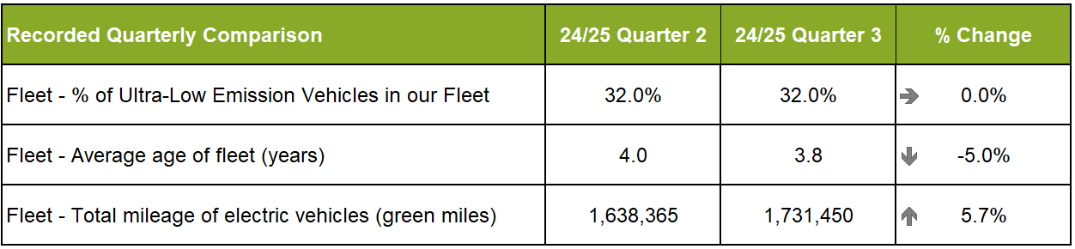
Police Scotland is working towards implementing the move to an Ultra-Low Emission Fleet (ULEV) as part of the Scottish Police Authority approved Fleet Strategy. In Quarter 3 2024/25, 1,158 ULEV vehicles make up 32% of Police Scotland’s overall fleet. 46% of the unmarked fleet are ULEV.
The total mileage of electric vehicles (green miles) during Quarter 3 2024/25 was 1,731,450. This has increased from 1,638,365 in Quarter 2 2024/25 and is up 5%.
The current average Fleet age for Police Scotland fleet is 3.80 years. This fluctuates from one day to the next as it is a live figure taking on the day, considering vehicles awaiting to be replaced and sold. This will reduce as new vehicles are introduced to the fleet and if the level of capital investment on the fleet is maintained in future years.

Appendix
Local insights are provided within this report that include disaggregated data. The following is a key to each of the 13 local policing divisions included in these comparisons:
North Region | East Region | West Region
A – North East | C – Forth Valley | G – Greater Glasgow
D – Tayside | E – Edinburgh | U – Ayrshire
N – Highland & Islands | J – The Lothians & Scottish Borders | Q – Lanarkshire
 | P – Fife | L – Argyll & West Dunbartonshire
 |  | K – Renfrewshire & Inverclyde
 |  | V – Dumfries & Galloway
Crime and incident data is included within this report, illustrated in bar charts with sparklines, to show trend data where appropriate.
The period with the highest volume of crimes/incidents is highlighted in red in the bar chart sparkline. The six-month sparklines cover the period July to December 2024 whilst the five-year sparklines cover Quarter 3 YTD from 2020/21 to 2024/25.
All data is classed as Management Information and is not considered official statistics. All data is sourced from Police Scotland internal systems. Disaggregated data is available in Police Scotland Management Information publication.

Notes
Detection rate comparison used for Group 2 Sexual Crime. Proportion comparison used for Group 2 Sexual Crime – Recent and Group 2 Sexual Crime – Non-Recent.
Detection rate comparison used for Rape Crime. Proportion comparison used for Rape Crime – Recent and Rape Crime – Non-Recent.
Recent crimes of Group 2/Rape are defined as being reported less than 365 days from the day committed. Non-Recent crimes of Group 2/Rape are therefore any reported 366 days or more from the day the crime was committed.
Police Scotland has moved to a new single national crime recording system (National Unifi), which is capable of recording domestic related crimes. Previously, due to limitations in legacy crime recording systems, domestic crime was recorded and counted in the Vulnerable Person Database. From 01 April 2024, all crime data (including domestic abuse) now comes from the same system. Please refer to the Quarter 1 SPA Performance Report for an example of the differences in methodology.
Due to changes in Hate Crime legislation introduced on 01 April 2024, direct comparisons to previous years should not be made and are for illustrative purposes only.
The complete Quarter 3 utilities (Gas, Electricity and Water) data is not yet available and so we have provided information based on the April to November of Financial Year 2024/25 with a comparison over the same time period for previous years. Considering this, all figures provided should be taken as indicative, until the Quarter 3 data set is complete.

