| Police Scotland logo | Freedom of Information Response Our reference: FOI 24-1629  Responded to: xx July 2024 |
| --- | --- |

Your recent request for information is replicated below, together with our response.

**Please can you provide me with details of the purchase of the Plasan Sandcat.  Please tell me:**

1. **When was it purchased?**

The vehicle was purchased on 28/03/2022 and came into service with Police Scotland on 04/05/2022.

1. **How much was paid for it?**

£282,240.55

**3) Any paperwork associated with the justification/rationale for the purchase of this vehicle**

**4) All correspondence about the purchase of the vehicle.**

**6) How many officers have received training on how to operate it, when was this training and how long does the training last before they have to refresh the training?**

*Questions 3, 4 and 6 have been answered together to avoid repetition.*

In terms of Section 16 of the Freedom of Information (Scotland) Act 2002, I am refusing to provide you with the information sought. Section 16 requires Police Scotland when refusing to provide such information because it is exempt, to provide you with a notice which:

(a) states that it holds the information,

(b) states that it is claiming an exemption,

(c) specifies the exemption in question and

(d) states, if that would not be otherwise apparent, why the exemption applies.

Where information is considered to be exempt, this letter serves as a Refusal Notice that information is held and an explanation of the appropriate exemption(s) are provided below.

The following exemptions are considered to be applicable:

Section 31(1) - National Security and Defence

The security of the United Kingdom is of paramount importance and Police Scotland will not disclose information if it would impact on National Security, law enforcement and the health and safety of the community.

This information, if disclosed, may assist terrorist organisations and others to identify, with some accuracy the options available to Police Scotland.

Disclosure would assist them to take steps to prepare for such deployment which would provide them with a tactical advantage when planning or perpetrating their terrorist plans

and activities and cause the maximum impact of destruction and disruption.

This is a non-absolute exemption and requires the application of the public interest test.

## 35(1)(a)&(b) – Law Enforcement

Information is exempt information if its disclosure under this Act would or would be likely to prejudice substantially the prevention or detection of crime and the apprehension or prosecution of offenders.

Public safety is of paramount importance and disclosure of this information would allow criminals the ability to assess the capability of Police Scotland.

Disclosure of this information would enable criminals to build a picture of resources and capabilities and as such would allow them to conduct their criminal activities.

To disclose this information into the public domain would compromise the effective delivery of operational law enforcement. If disclosed, the requested information could be used to calculate how and where those police resources are allocated. Those with criminal intent would then be able to accurately assess the resources available to Police Scotland in the future.

This is a non-absolute exemption and requires a public interest test.

## Public interest test:

It is acknowledged that public accountability would favour disclosure, given that the information concerns the efficient and effective use of resources by the Service. Likewise, disclosure of the information would inform the public debate on the issue of policing and would contribute to the accuracy of that debate.

However the applicability of the exemption(s) listed above, the need to ensure the effective conduct of the service in relation to National Security, the prevention and detection of crime and the public safety considerations involved in the delivery of operational policing clearly favour non-disclosure of the information requested.

It is assessed that on balance the public interest on this occasion favours non-disclosure of this information.

**5) Who authorised the purchase of the vehicle?**

Authorisation was provided by Chief Constable Iain Livingston and the Scottish Police Authority (SPA)

**7) How much has been spent on the maintenance/upkeep of the vehicle since it was purchased?**

To date, the maintenance costs for this vehicle total £12.50.

**8) Any images of the vehicle police Scotland has?**

The information requested is provided below:

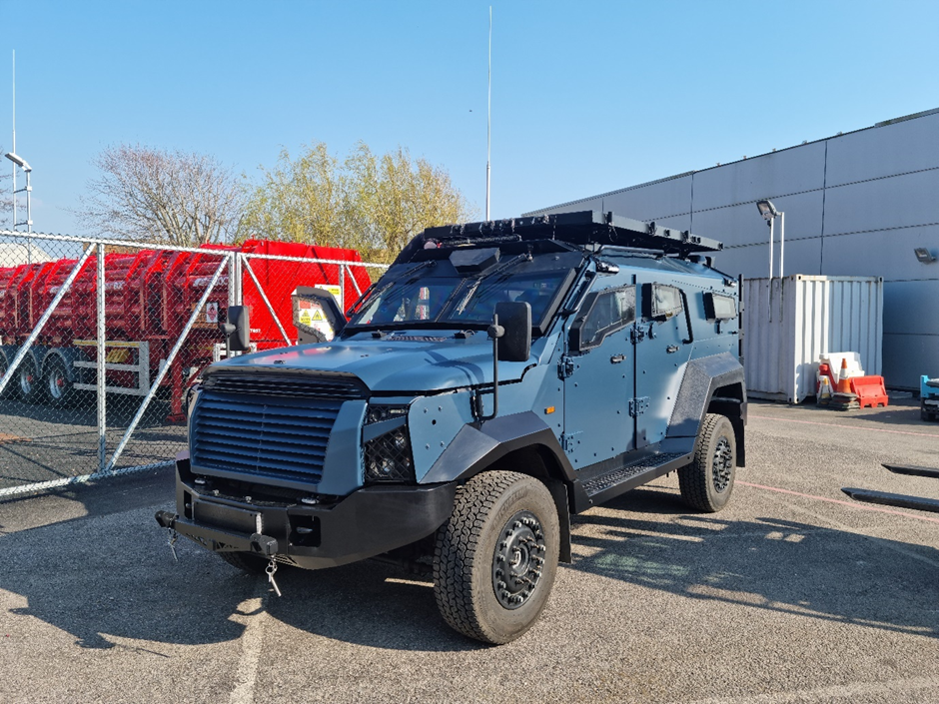

If you require any further assistance please contact us quoting the reference above.

You can request a review of this response within the next 40 working days by [email](mailto:foi@scotland.police.uk) or by letter (Information Management - FOI, Police Scotland, Clyde Gateway, 2 French Street, Dalmarnock, G40 4EH). Requests must include the reason for your dissatisfaction.

If you remain dissatisfied following our review response, you can appeal to the Office of the Scottish Information Commissioner (OSIC) within 6 months - [online](http://www.itspublicknowledge.info/Appeal), by [email](mailto:enquiries@itspublicknowledge.info) or by letter (OSIC, Kinburn Castle, Doubledykes Road, St Andrews, KY16 9DS).

Following an OSIC appeal, you can appeal to the Court of Session on a point of law only.

This response will be added to our [Disclosure Log](http://www.scotland.police.uk/access-to-information/freedom-of-information/disclosure-log) in seven days' time.

Every effort has been taken to ensure our response is as accessible as possible. If you require this response to be provided in an alternative format, please let us know.