Freedom of Information Response
Our reference: FOI 23-1394
Responded to: 16th June 2023
Your recent request for information is replicated below, together with our response.

Can you please advise me of the date when the 20 mph speed zone was introduced at Springholm Primary School in Dumfries & Galloway.
Local road speed limits are not set by Police Scotland.
As such, in terms of Section 17 of the Freedom of Information (Scotland) Act 2002, this represents a notice that the information you seek is not held by Police Scotland.
You may wish to contact Dumfries and Galloway Council.

How many people have been charged with speeding in the 20mph speed zone at Springholm Primary School from being introduced till today 27/05/2023.
As outline above, we do not hold the date at which the speed zone was introduced and so we are unable to respond to this question. However, data for speeding offences within the Castle Douglas and Crocketford multi member ward more generally are available online.
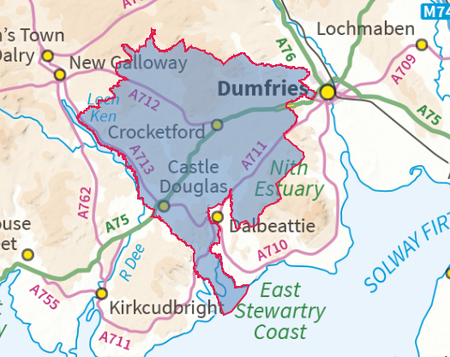
Having reviewed the data for the wider area for 2021/22 and 2022/23 year to date, there are no recorded speeding offences. Data for the remainder of 2022/23 (plus older data going back to 2013) will be published in the next few weeks.

If you require any further assistance please contact us quoting the reference above.
You can request a review of this response within the next 40 working days by email or by letter (Information Management - FOI, Police Scotland, Clyde Gateway, 2 French Street, Dalmarnock, G40 4EH). Requests must include the reason for your dissatisfaction.
If you remain dissatisfied following our review response, you can appeal to the Office of the Scottish Information Commissioner (OSIC) within 6 months - online, by email or by letter (OSIC, Kinburn Castle, Doubledykes Road, St Andrews, KY16 9DS).
Following an OSIC appeal, you can appeal to the Court of Session on a point of law only.
This response will be added to our Disclosure Log in seven days' time.
Every effort has been taken to ensure our response is as accessible as possible. If you require this response to be provided in an alternative format, please let us know.

