Freedom of Information Response
Our reference: FOI 24-0065
Responded to: 31 January 2024
Your recent request for information is replicated below, together with our response.
Could you please provide me with the shoplifting statistics for Glasgow City Centre (or the G1 postcode) for the past 5 years?
Could these figures be provided in a yearly breakdown?
The information sought is publicly available:
Crime data - Police Scotland
The information is therefore held by Police Scotland but I am refusing to provide it in terms of section 16(1) of the Act on the basis that the section 25(1) exemption applies:
“Information which the applicant can reasonably obtain other than by requesting it […] is exempt information”.
You can search the data by ‘shoplifting’ for all relevant offences and the relevant ward is Anderston/ City/ Yorkhill.
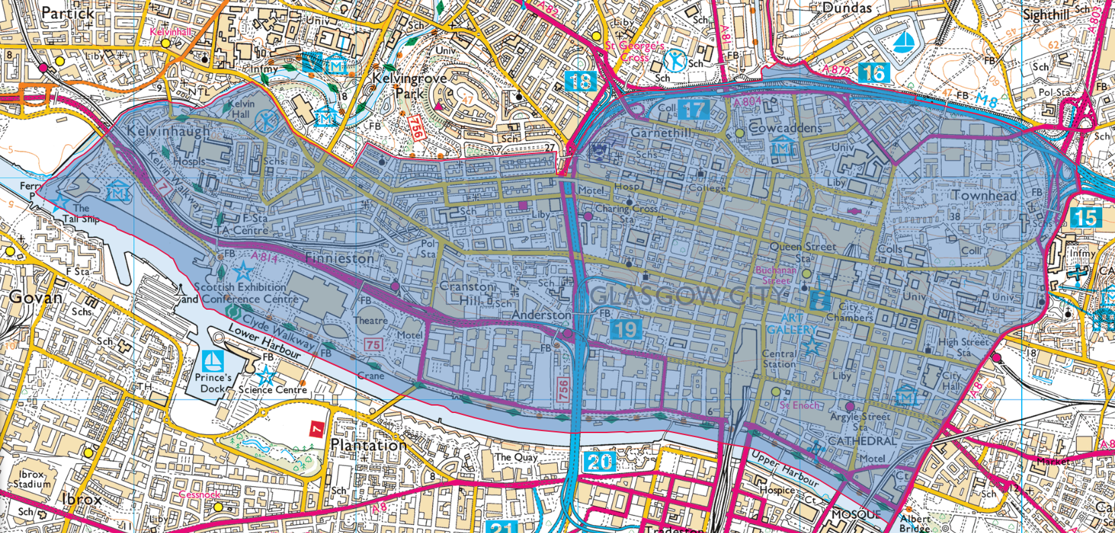

If you require any further assistance, please contact us quoting the reference above.
You can request a review of this response within the next 40 working days by email or by letter (Information Management - FOI, Police Scotland, Clyde Gateway, 2 French Street, Dalmarnock, G40 4EH). Requests must include the reason for your dissatisfaction.
If you remain dissatisfied following our review response, you can appeal to the Office of the Scottish Information Commissioner (OSIC) within 6 months - online, by email or by letter (OSIC, Kinburn Castle, Doubledykes Road, St Andrews, KY16 9DS).
Following an OSIC appeal, you can appeal to the Court of Session on a point of law only.
This response will be added to our Disclosure Log in seven days' time.
Every effort has been taken to ensure our response is as accessible as possible. If you require this response to be provided in an alternative format, please let us know.

