 | Freedom of Information Response  Our reference: FOI 25-0974  Responded to: 07 April 2025
Your recent request for information is replicated below, together with our response.
The below request is a follow-up to the response provided to FOI-0867.
It sounds from your response that you do collect similar data. If this is open data, please can you point me to where this is? I went to the Crime Data page and was a bit overwhelmed.
You said “In Scotland there is a specific crime of possessing or using a knife or bladed article in a school”, so please can I modify my request to ask for 5 years worth of this specific data?
FOI Q: For the years 2020, 2021, 2022 and 2023 and 2024 the number of offences involving possessing a knife or bladed article in a school?
It sounds like my other questions would incur a rejection on cost grounds. But if I could get data on the question above that would be appreciated.
As previously advised, the information sought is held by Police Scotland, but I am refusing to provide it in terms of section 16(1) of the Act on the basis that the section 25(1) and 27(1) exemptions apply:
“Information which the applicant can reasonably obtain other than by requesting it is exempt information”
Information is publicly available at Crime data - Police Scotland​ and will be updated in next few weeks
I can, however, provide the following instructions to help you locate the required information:

Click on data then filter to bring up filter arrows on each column:
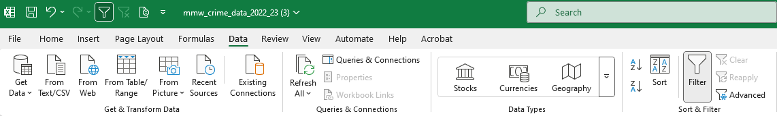

Then click the arrow at the top of column E, Crime type, and type school into the search field, then ok.

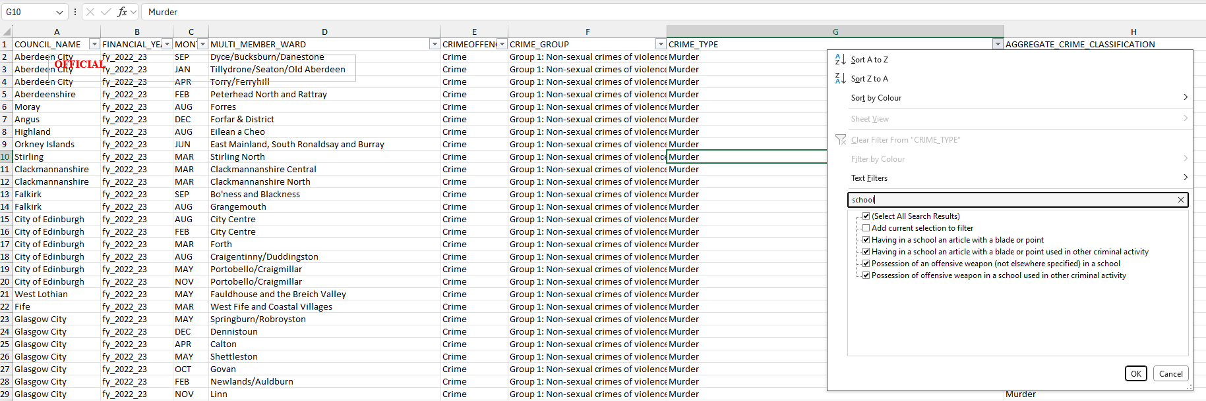

If you require any further assistance, please contact us quoting the reference above.
You can request a review of this response within the next 40 working days by email or by letter (Information Management - FOI, Police Scotland, Clyde Gateway, 2 French Street, Dalmarnock, G40 4EH). Requests must include the reason for your dissatisfaction.
If you remain dissatisfied following our review response, you can appeal to the Office of the Scottish Information Commissioner (OSIC) within 6 months - online, by email or by letter (OSIC, Kinburn Castle, Doubledykes Road, St Andrews, KY16 9DS).
Following an OSIC appeal, you can appeal to the Court of Session on a point of law only.
This response will be added to our Disclosure Log in seven days' time.
Every effort has been taken to ensure our response is as accessible as possible. If you require this response to be provided in an alternative format, please let us know.

