Freedom of Information Response
Our reference: FOI 23-2242
Responded to: 04 October 2023
Your recent request for information is replicated below, together with our response.

The number of enforcement actions taken by Police Scotland against wheeled-vehicle riders (such as bicycles/scooters/skateboards) for riding on pavements or pedestrian areas, in the City of Edinburgh, in the five most recent reporting years.
Following clarification with you, you advised:

if a smaller area is essential, could you answer about just the central area of the city, which includes the area bounded by Princes Street, George Street and Queen Street?
In response to your request the Analysis and Performance Unit (APU) aimed to extract data based on the mapped area below, the area contained within the purple line.
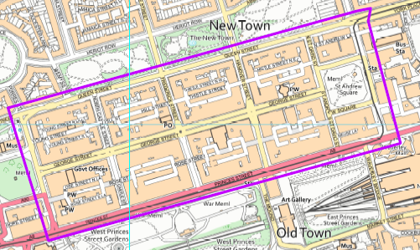

Unfortunately, regardless of this smaller area, in response to this question, I regret to inform you that I am unable to provide you with the information you have requested, as it would prove too costly to do so within the context of the fee regulations.
As you may be aware the current cost threshold is £600, and I estimate that it would cost in excess of this amount to process your request.
As such, and in terms of Section 16(4) of the Freedom of Information (Scotland) Act 2002 where Section 12(1) of the Act (Excessive Cost of Compliance) has been applied, this represents a refusal notice for the information sought.
By way of explanation, there is no straightforward method to extract the information required. Any offence that took place within the area specified may or may not have included an unmotorised wheeled vehicle, for example a pedal cycle riding on a pavement, with enforcement action taken. This means that to determine the information you require, each record would need to be manually assessed to discover if an unmotorised vehicle was involved and if any enforcement action was taken.
I can advise that within the area specified and within the time frame requested 3,015 relevant records have been identified. With a highly conservative estimate of 5 minutes per record this would equate to an excess of 251 hours to complete.
Police Scotland have assessed that the £600 cost limit within the Act equates to 40 hours of work and so this part of your request would breach the cost threshold.
To be of assistance I can advise that there are three specific offences relating to bicycles/tricycles. The offences are: Dangerously riding a bicycle or tricycle, Carelessly or inconsiderately riding a bicycle or tricycle, Drunk when riding a bicycle. I can advise that between 2018 and 2023, there are 5 such offences recorded.
Should you wish to significantly reduce the time period of your request it may be that some information could be provided to you, however it is worthy of note that the time period may have to be significantly narrow that this would mitigate any meaningful comparative data.

To report separately on motorised (eg electric, petrol) and unmotorised wheeled vehicles, where this information is recorded.
Likewise in respect of motorised vehicles, there is no way to determine whether motorised vehicle was on a pavement without manually assessing each offence as such, and in terms of Section 16(4) of the Freedom of Information (Scotland) Act 2002 where Section 12(1) of the Act (Excessive Cost of Compliance) has been applied, this represents a refusal notice for the information sought, in line with the explanation above.
Again, should you wish to significantly reduce the time period of your request it may be that some information could be provided to you, however it is worthy of note that the time period may have to be significantly narrow that this would mitigate any meaningful comparative data.

The number of collisions recorded by Police Scotland between pedestrians and wheeled vehicles (motorised and unmotorised) on pavements or pedestrian areas in the City of Edinburgh in the five most recent reporting years.
In terms of Section 17 of the Act, I can confirm that the information you have requested is not held by Police Scotland.
By way of explanation, there is no function to extract whether an incident specifically occurred on a pavement or within a pedestrian area.
To be of assistance, I can advise that between 01 January 2018 and 31 August 2023, within the area identified, there were 44 road traffic collisions that included a pedestrian.
I can advise that I have viewed the contributory factors for each occurrence and there is no specific note of a pavement or pedestrian area.
If you require any further assistance, please contact us quoting the reference above.
You can request a review of this response within the next 40 working days by email or by letter (Information Management - FOI, Police Scotland, Clyde Gateway, 2 French Street, Dalmarnock, G40 4EH). Requests must include the reason for your dissatisfaction.
If you remain dissatisfied following our review response, you can appeal to the Office of the Scottish Information Commissioner (OSIC) within 6 months - online, by email or by letter (OSIC, Kinburn Castle, Doubledykes Road, St Andrews, KY16 9DS).
Following an OSIC appeal, you can appeal to the Court of Session on a point of law only.
This response will be added to our Disclosure Log in seven days' time.
Every effort has been taken to ensure our response is as accessible as possible. If you require this response to be provided in an alternative format, please let us know.

