Perth and Kinross Local Policing Plan

Contents
Perth and Kinross Local Policing Plan 1
Foreword 3
Introduction 5
Police Scotland’s strategic objectives 8
Local policing delivery context 9
Local priorities 11
Local objectives and activity 13
National Strategic Outcome 1 13
Threats to public safety and wellbeing are resolved by a proactive and responsive police service 13
National Strategic Outcome 2 16
The needs of local communities are addressed through effective service delivery 16
National Strategic Outcome 3 19
The public, communities and partners are engaged, involved and have confidence in policing 19
National Strategic Outcome 4 20
Our people are supported through a proactive working environment, enabling them to service the public 20
National Strategic Outcome 5 21
Police Scotland is sustainable, adaptable and prepared for future challenges 21
Governance and performance 24
Equality, diversity and inclusion 24
Engaging with us 26

Foreword
As the Divisional Commander for Tayside, I am delighted to introduce our Perth and Kinross Local Police Plan for 2023-2026. The plan outlines how we intend to deliver policing services over the next three years and highlights the outcomes we aim to achieve over that period.

Our plan is based on our local and national priorities and strategic outcomes, those of our partners and the views of Perth and Kinross’ communities on what matters to them. In the challenging environment we currently operate in, constructive partnerships and close relationships with our communities are crucial to ensuring that we can deliver successfully against the priorities highlighted in this Local Police Plan.

In Tayside Division we will focus our efforts on those who cause the most harm within our communities, whilst maximising opportunities to reduce offending and prevent crime occurring in the first place. With the support of our partners, we will promote the highest standards in public protection and ensure the safety of the most vulnerable within our communities. We remain committed to continuous improvement in order to provide the highest level of service to our communities. To do this we will use our local policing teams supported by specialist support from national divisions in Police Scotland.

This plan will remain flexible and will
adapt to the changing needs of
our communities over the next
three years, delivering a service
that generates confidence in
policing and one that creates a
safer Fife for us al
This plan will remain flexible and adaptable to the changing needs of our communities over the next three years, delivering a service that provides trust and confidence.

We will report our performance against this plan through regular presentation to the Perth and Kinross Council Housing and Social Wellbeing Committee.

This plan will remain flexible and will
adapt to the changing needs of
our communities over the next
three years, delivering a service
that generates confidence in
policing and one that creates a
safer Fife for us al
I am proud to be the Divisional Commander for Tayside Division and look forward to delivering on this Local Policing Plan for Perth and Kinross.
Chief Superintendent Phil Davison, Local Police Commander, Tayside Division

Introduction
Spread across 2500 square miles, Perth and Kinross encompasses the city of Perth along with the towns of Pitlochry, Aberfeldy, Blairgowrie, Auchterarder, Crieff and Kinross.

Perth and Kinross is now home to diverse and multi-cultural communities and while the majority of the population is concentrated in Perth and these main towns, there is also a significant rural population located in and around over 100 settlements of all sizes.

The diversity of landscape and urban/rural mix in Perth and Kinross can bring challenges as well as opportunities to work with partners and local communities to deliver a policing service tailored to the needs of local residents.

We recognise everyone in our communities has something to offer and we benefit from the dedicated and selfless work of volunteers, including Special Constables and younger members of our local communities who have joined our Police Scotland Youth Volunteers. Both contribute fully in areas such as crime prevention and community engagement.

We continue to work with our partners to address current needs and demands in our communities. In addition to crime prevention and investigation, we continue to work collaboratively to assist with concerns in our community, including mental health concerns, poverty concerns and substance use, in order to ensure Perth and Kinross remains a safe place to live, work and visit where everyone can live life well.

National strategic alignment
Since April 2013, the Police and Fire Reform (Scotland) Act 2012 has required Divisional Commanders to produce and publish a Local Policing Plan (LPP) for each local authority area.

The content and character of Local Police Plans are determined by Local Area and Divisional Commanders in negotiation with local authorities, who are each responsible for approving their respective Local Police Plan.

This Local Policing Plan for Perth and Kinross is supportive of the priorities in the Perth and Kinross Community Plan 2017-2027 and the local outcome improvement plan published by Perth and Kinross Community Planning Partnership. Outlined within this document are our priorities for policing and outcomes, which, when achieved, will contribute to the Community Plan and the strategic vision for Perth and Kinross. These priorities and outcomes were identified through a number of sources and processes which include:

• Police Scotland Strategic Assessment 2022/23 for Tayside Division which details threats that impact on Policing at both Divisional and Local Authority level.
• Community consultation
• Perth and Kinross Community Plan 2017-2027
• Police Scotland Annual Police Plan 2022/23
• Joint Strategy for Policing (2020) – Policing for a safe, protected and resilient Scotland

Information has also been obtained through direct engagement and community consultation including:
- Direct contact with victims of crime
- Consultation responses to Police Scotland’s Your Police survey
- Consultation with locally elected members and community representatives
- Engagement with partners and local businesses
- Direct consultation with members of the public

All of these sources have provided critical information in identifying what is important to the diverse communities within Perth and Kinross and as such we have structured our resources to meet these demands.

In this plan we will provide some context on our communities and the local authorities we work alongside, the consultation, considerations taken into account in forming the plan and finally the priorities identified and how we seek to address these in the coming years.

Police Scotland’s strategic objectives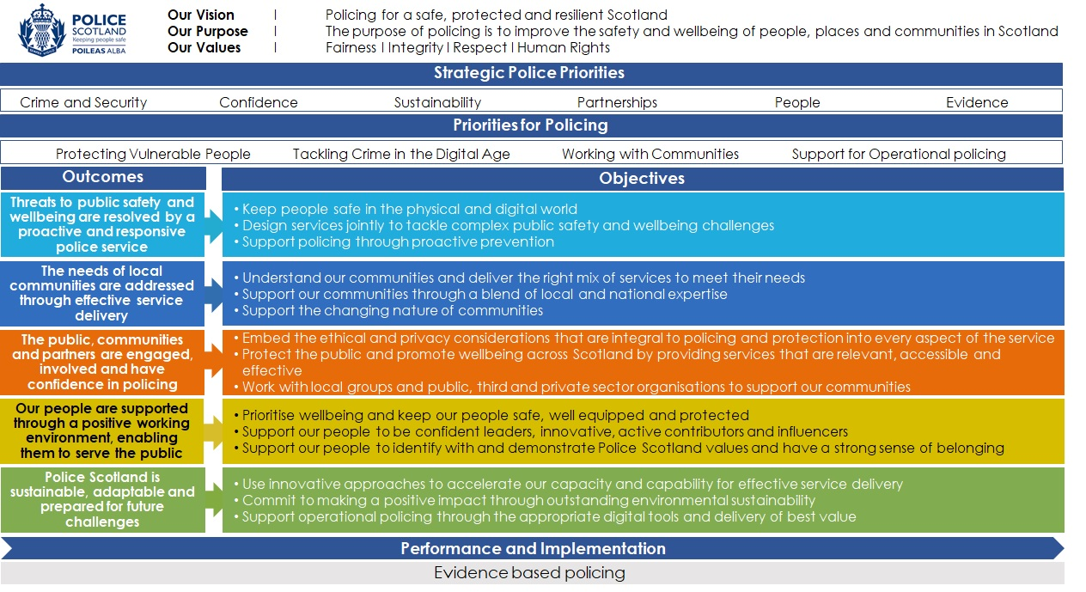

Local policing delivery context
The people and communities of Perth and Kinross are served by officers who deal with a wide range of policing responsibilities, including anti-social behaviour, road safety and acquisitive crime (including motor vehicle crime, housebreakings, online frauds and theft by shoplifting). Along with our partner agencies, local officers regularly assist vulnerable people in our communities, including missing people and people of all ages who may be at risk of harm.

The Local Area Commander has responsibility for the overview of the operating model and delivery of local policing on a day to day basis. This model remains locality based, with six police stations in operation in Perth and Kinross. All officers are issued with mobile devices which allows them to carry out the majority of their role remotely, ensuring an optimum coverage of our county.

The Local Area Commander has access to a vast number of local and national resources, including local Response and Community officers, Detective Officers (including those who are specialist in domestic abuse and sexual offences), Road Policing Officers, Mountain Rescue Teams, Wildlife Liaison Officers and our local Partnerships, Interventions and Preventions Team.

All our teams work closely on a daily basis with statutory and third sector partners, contributing towards our collective goal of maximising the positive difference we make to the people who live, work and visit Perth and Kinross.

Local priorities 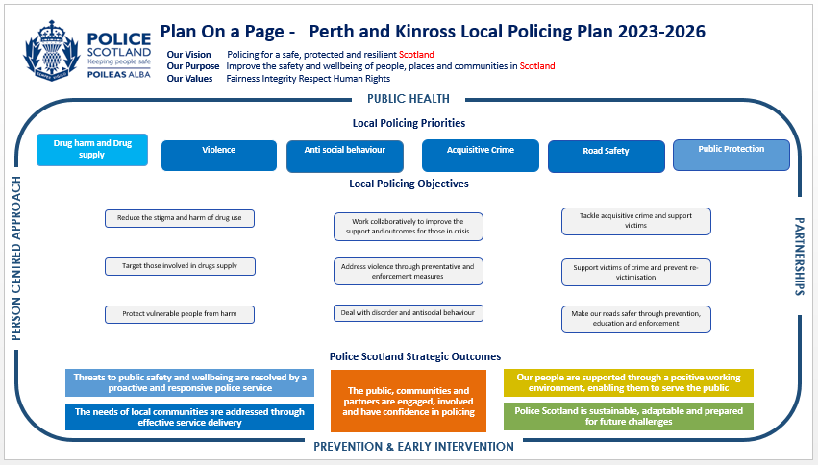
Local objectives and activity

National Strategic Outcome 1

Threats to public safety and wellbeing are resolved by a proactive and responsive police service

National Policing Objective: Design services jointly to tackle complex public safety and wellbeing challenges

Local Priority/Activity: Reduce the stigma and harm of drug use
Key milestones:
- Develop our approach and response to identified victims of cuckooing
- Continue to support partners and promote the Non-Fatal Overdose Pathway
- Deliver cuckooing and county lines awareness sessions to partner agencies to educate and encourage information sharing
- Alongside partners, continue to support the custody referral scheme to signpost and assist people with problem drug use whilst in police custody
- Continue to promote uptake of Naloxone by members of the public and extend the carriage of Naloxone to local officers in Perth and Kinross
Update expected: Y1 Q1, Q3, Y2 Q1 Q3, Y3 Q1 Q3
Performance measures and insights:
- How well does Tayside Division identify and support people at risk of harm?
- Continuing evaluation of the Non-Fatal Overdose Pathway

National Policing Objective: Use all available information and intelligence to address policing priorities

Local Priority/Activity: Target those involved in drugs supply
Key milestones:
- Deliver local policing initiatives to tackle those dealing drugs and exploiting those with vulnerabilities, making best use of legislation and enforcement to detect offenders.
- Target the production, cultivation and supply of illegal drugs
Update expected: Y1 Q1, Q3, Y2 Q1 Q3, Y3 Q1 Q3
Performance measures and insights:
- How well does Tayside Division tackle drug dealing?

National Policing Objective: Support policing through proactive prevention

Local Priority/Activity: Protect vulnerable people from harm
Key milestones:
- Work with partners to reduce the threat, risk and harm and maximise the safety of persons reported missing
- In partnership, develop the support and promote the pathways available to those affected by the impact of suicide
- Deliver in partnership with Scottish Government, NHS, SAS and Penumbra Distress Brief Intervention (DBI) which provides support for individuals in distress
- Strengthen partnership relationships to improve the support and outcomes for those in crisis

Update expected: Y1 Q4, Y2 Q4, Y3 Q4.
Performance measures and insights:
- How effective are the processes in place to ensuring that people are safeguarded?
- DBI Training, awareness and guidance is in place for officers and staff.
- How effective are the measures in improving Police Scotland’s and partners responses to vulnerable and repeat missing persons?

National Policing Objective: Support policing through proactive prevention

Local Priority/Activity: Support victims of crime and prevent re-victimisation
Key milestones:
- Promote the ‘Keep Safe Initiative’ to provide a safe place for victims of crime or those who find themselves in distress
- Work with partners to improve public confidence to report incidents of harm and abuse, including the promotion of third party reporting systems
- Promote and deliver ‘Bystander Training’ to prevent offences of a sexual nature and hate crimes
- Support ‘Choices for Life’ programme to educate young people on online safety and dealing with peer pressure
- Work with Victim Support Scotland to provide support and information to those affected by crime
Update expected: Y1 Q4, Y2 Q4, Y3 Q4.
Performance measures and insights:
- How effective are the processes in place to ensure that victims are supported?

National Strategic Outcome 2

The needs of local communities are addressed through effective service delivery

National Policing Objective: Support our communities through a blend of local and national expertise

Local Priority/Activity: Address violence through preventative and enforcement measures

Key milestones:
- Work collaboratively to identify and target violent offenders using all appropriate tactical options to prevent offending, including proactive bail checks and executing warrants relating to violent offenders
- Promote preventative programmes in schools including Violence Against Women and Girls, ‘No Knives Better Lives’ and ‘Fearless’
- Work in partnership with Perth and Kinross Council, Social Work and SFRS to identify those involved in ASB, in both rural and urban areas and work collaboratively to provide focused prevention and diversionary activity
- Work with partners to support victims of domestic abuse and gender based violence
- Alongside the National Domestic Abuse Task Force, proactively target domestic abuse offenders
- Conduct high visibility patrols and engage with partner agencies, local residents and businesses to identify intervention opportunities and prevent and detect antisocial behaviour in particular alcohol related criminality
- Develop night time economy plans with licensed premises and promote ‘Bystander Awareness Training’
Update expected: Y1-3 Quarterly
Performance measures and insights:
- How effective are the diversionary activities provided?
- Evaluation of Bystander Awareness inputs
- Victims of domestic abuse and women and girls at risk of violence are safer and confident that the police are responsive to their needs
- How well does Tayside Division identify and support people at risk of violence?

National Policing Objective: Support our communities through a blend of local and national expertise

Local Priority/Activity: Deal with disorder and antisocial behaviour

Key milestones:
- Work in partnership with Perth and Kinross Council, Social Work and SFRS to identify those involved in ASB and work collaboratively to provide focused prevention and diversionary activity.
- Conduct high visibility patrols and engage with partner agencies, local residents and businesses to identify intervention opportunities and prevent and detect antisocial behaviour in particular alcohol related criminality.
- Develop night time economy plans with licensed premises and promote ‘Bystander Awareness Training’
Update expected: Y1-3 Quarterly
Performance measures and insights:
- How effective are the diversionary activities provided?
- Evaluation of Bystander Awareness inputs
- How well does Tayside Division respond to complaints of antisocial behaviour and disorder?

National Policing Objective: Support our communities through a blend of local and national expertise

Local Priority/Activity: Tackle acquisitive crime and support victims

Key milestones:
- Work collaboratively to identify and target offenders using all appropriate tactical options to prevent offending, including proactive bail checks and executing warrants to recover stolen property
- Work with partners and communities to raise awareness of crime trends and provide effective prevention opportunities
- Continue to promote Neighbourhood Watch and Rural Watch
- Use of Police Scotland Youth Volunteers to deliver crime prevention advice to communities
- Through the National Acquisitive Crime Board, understand and tackle the prevalence of cross-border offenders
- Jointly work with partners including Victim Support Scotland to support victims and raise awareness and impact of acquisitive crime
Update expected: Y1-3 Quarterly
Performance measures and insights:
- How effective are the processes in place to prevent acquisitive crime?
- How well does Tayside Division identify and support victims of acquisitive crime?

National Policing Objective: Support the changing nature of communities

Local Priority/Activity: Make our roads safer

Key milestones:
- Support and contribute to the Tayside Road Safety Partnership
- Facilitate high-visibility patrolling with a focus on high risk areas
- Deliver educational inputs through the New Driver Scheme and Rider Refinement programme
- Undertake speeding initiatives to support community concerns in relation to road safety
- Work in collaboration with road safety partners on local/national initiatives and campaigns
Update expected: Y1-3 Quarterly
Performance measures and insights:
- Have road traffic collisions decreased?
- Have deaths and injuries from road traffic collisions decreased?
- Has high-visibility patrolling influenced driver behaviour?
- Findings from the evaluation of the Rider Refinement programme

National Strategic Outcome 3

The public, communities and partners are engaged, involved and have confidence in policing

National Policing Objective: Protect the public and promote wellbeing across Scotland by providing services that are relevant, accessible and effective

Local Priority/Activity: Enable and support effective engagement and communication with the public

Key milestones:
- Deliver the Tayside Division Communication Strategy to enhance public engagement and identify and respond to concerns and issues affecting the local area
- Identify new and emerging ways to provide warnings and information to the public about areas of concern or safety
- Increase engagement with all of our local communities
- Continue to work with academia to look at innovative ways to reach seldom heard communities
Update expected: Y1-3 Quarterly
Performance measures and insights:
- How well are we engaging with the public?
- Feedback from members of the public, community groups and partners

National Strategic Outcome 4

Our people are supported through a proactive working environment, enabling them to service the public

National Policing Objective: Prioritise wellbeing and keep our people safe, well equipped and protected

Local Priority/Activity: Protect, support and empower our people

Key milestones:
- Promote the availability of wellbeing tools to benefit colleagues
- Launch the Your Safety Matters – Police Assaults Group to reduce the impact and number of officer assaults regionally
- Deliver the Tayside Communication Strategy to develop the way we communicate with our people, share good practice and recognise and acknowledge good work
Update expected: Y1-3 Q2, Q4
Performance measures and insights:
- How well are we supporting and empowering our people?
- How well is Tayside Division improving the wellbeing of our officers and staff?
- What impact is the Your Safety Matters – Police Assaults Group having on the safety of our people?

National Policing Objective: Support our people to be confident leaders, innovative, active contributors and influencers

Local Priority/Activity: Support colleagues’ performance and development

Key milestones:
- Overview of progress and benefits for our people
- Continue to develop and deliver local development forums to be able to listen and engage with our people
- Recognise the everyday contribution that our people make and focus on individual performance, development and personal training needs through MyCareer

Update expected: Y1-3 Q2, Q4
Performance measures and insights:
- How well are we supporting our people?
- How effective is our workforce development?
- Our leaders are invested in and supported to sustain and enhance the positive relationship they have with their people.
- Our people feel aligned and connected to activity within the Division.

National Strategic Outcome 5

Police Scotland is sustainable, adaptable and prepared for future challenges
National Policing Objective: Use innovative approaches to accelerate our capacity and capability for effective service delivery

Local Priority/Activity: Seek out shared learning and training opportunities with partners

Key milestones:
- Alongside local partners, continue to support the Tayside Leadership Academy Programme
- Develop the work of our Domestic Abuse Champions, Hate Crime Champions and Local Contest Liaison Officers to share learning and best practice
Through the Local Resilience Partnership, develop the testing and exercising of plans to ensure we are fully prepared for all types of emergencies
- Capture and embed the learning from post-incident reviews, ICRs/SCRs and inspection findings to improve our local practices

Update expected: Y1-3 Quarterly
Performance measures and insights:
- How effective is Police Scotland at continuous improvement and workforce development?
- How effective is Police Scotland at sharing learning with partners?
- Evaluation of the Tayside Leadership Academy experience

National Policing Objective: Commit to making a positive impact through outstanding environmental sustainability

Local Priority/Activity: Embed environmental responsibility into current and future planning and estate management

Key milestones:
- Promote the new cycle to work scheme and the work of the Tayside Cycling for Wellbeing group to encourage cycling within and to the workplace.
- Increase the use of the division’s ULEV vehicles.
- Engage with local partners to explore opportunities for enhanced collaboration and sharing of premises
- Support the work of the Community Planning Partnership Climate Change Working Group.
Update expected: Y1-3 Q1, Q3
Performance measures and insights:
- Increase in the use of the Cycle to Work scheme
- What progress has been made in terms of collaboration and what percentage of the divisional estate is co-located with our partners.
Governance and performance

Effective scrutiny and oversight are key to ensuring that policing retains the trust and confidence of the communities of Scotland. We pride ourselves on transparency and accountability and as such, have created comprehensive and robust arrangements for the governance of this plan.

The Scottish Police Authority (SPA) is the body with overall formal responsibility for scrutiny and holding Police Scotland to account for delivery of the priorities set out in the National Policing Plan. Tayside Division’s performance against the national priorities is monitored centrally by the National Analysis and Performance Unit, who compile a wide variety of analytical products to support operational policing activity at tactical and strategic levels.

Performance in relation to the identified policing objectives and outcomes is monitored and reviewed at the Tayside Division monthly Tasking and Delivery Meeting.

Reports are also produced to allow scrutiny by the Perth and Kinross Council Housing and Communities Committee.

Equality, diversity and inclusion
Police Scotland promotes equality and diversity, both externally and internally, striving to exceed the requirements of the Scottish Public Sector Equality Duty.

Across Police Scotland we are committed to developing and promoting best practice in the advancement of our Equality Outcomes. In order to support this requirement, we embed equality, diversity and human rights in all of our strategies, plans and performance framework. Equality and Human Rights Impact Assessments (EqHRIA) are used to help us to ensure that policy and practices proactively consider the potential impact on equality and human rights. We will ensure that all of strategic plans and activities relating to delivery are assessed to a high standard using relevant evidence in a systematic and structured way.

A code of ethics was introduced in 2013 with the creation of Police Scotland and provides guiding principles that define how we perform our duties. The code of ethics sets out the standards we expect of all our employees and the standards that the public can expect to ensure we provide a professional service to all. Encompassing the values of the service and our commitment to human rights, the code is designed to help us provide positive outcomes and improve the safety and wellbeing of people, places and communities in Scotland. Police Scotland’s values are;
• Integrity.
• Fairness.
• Respect.
• Human Rights.

Tayside Division is continually working to ensure that these values and the code are understood by all our officers and staff and are preserved in all of our decisions and actions.

We are committed to developing and promoting best practice in the delivery of our Equality outcomes. These can be found along with our commitment and duties to equality, diversity & inclusion at: Equality and Diversity - Police Scotland.

This plan will be subject to an Equalities and Human Rights Impact Assessment (EqHRIA) in compliance with the Scottish Public Sector Equality Duty in its final iteration in 2023.
Separate EqHRIAs were undertaken for the activities described in this plan as required.

Engaging with us
Police Scotland Tayside Division – Perth and Kinross
Barrack Street
Perth
PH1 5SF

For more detailed information on how to contact your Local Policing Team please refer to our website at www.scotland.police.uk or through our social media platforms.
We will continue to keep in touch with you to keep you updated on the ongoing work being done to tackle the issues that are affecting life for you and your community: Dial 999 for an emergency that requires urgent police attention.
For non-emergency contact, call 101, the single non-emergency number. If you have information about crime in your area and wish to provide it anonymously, call CRIMESTOPPERS on 0800 555 111.

Police Scotland is committed to continuous improvement in all that we do. If you have something to tell us about our service, please contact us at: Police Scotland Contact page
Further information about our wider engagement can be found in our consultation and engagement hub at: Police Scotland Engagement Hub.
Police Scotland has a number of active social media channels that provide a range of information and insight into policing, both nationally and in your local area. A full list of our social media accounts can be found on our website. Our local channels can be found at:
Twitter: @TaysidePolice
Facebook: Tayside Police Division
Please note that our social media channels are not monitored 24/7 and should not be used for reporting crime. Please dial 999 in an emergency, and 101 in a non-emergency situation.
Inclusive and accessible engagement
We aim to embed accessibility and inclusivity into our services to make them work for everyone.
This Local Police Plan was subject to an Equality and Human Rights Impact Assessment (EqHRIA). A summary of the EqHRIA has been published alongside this Plan. This Local Police Plan can be made available in various alternative formats. For more information, please contact us via our online form: Police Scotland Contact page.
Deaf, deafened, hard of hearing or speech-impaired callers can contact us via Text Relay on 18001101.

